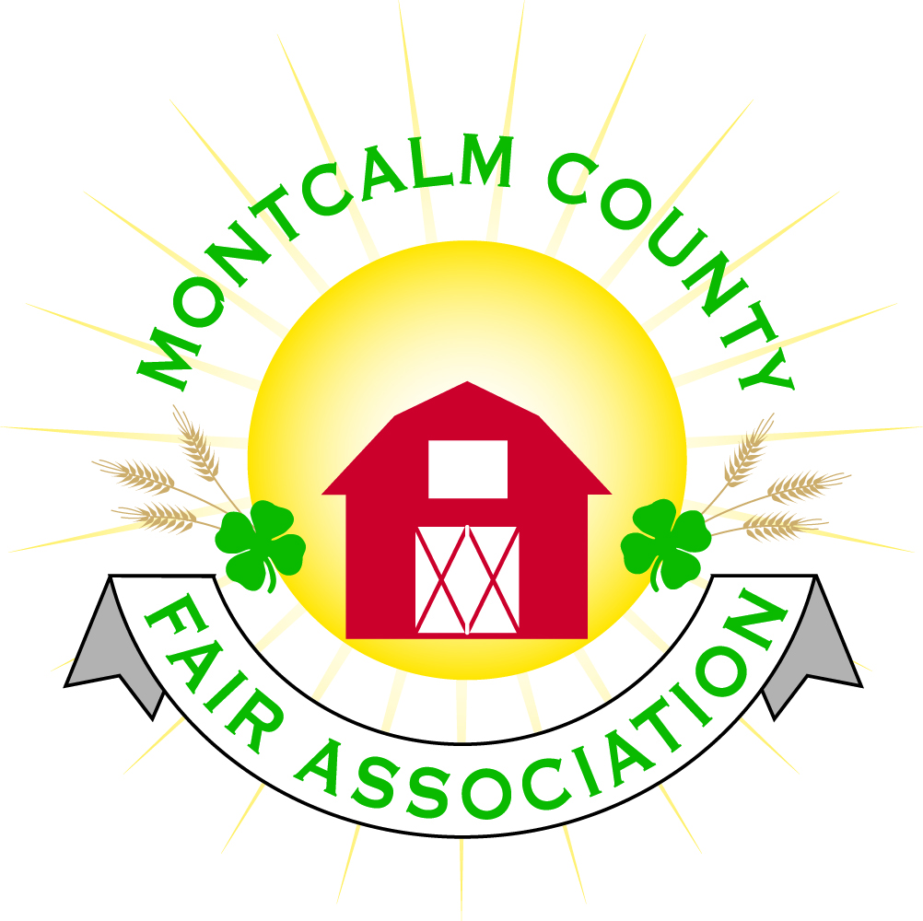
po box 513 • Greenville, MI 48838

Regular Monthly Fair Board Meeting – Monday, March 2, 2020

Meeting called to order at 7:08 p.m. Members present: Todd Hetherington, Jason Nadeau, Mary Newman, Amy Bell, Shaun Hyde, Lee Rasmussen, Brad Heft, Becka Merren, Mike Jensen and Lisa Johnson.
Absent: Melissa Eldridge, Carrie Harkness, Cheryl Strautz, and Jenn Senn and Tammi Janke.

Others present: Tarin Minkel and Melanie Rodenhouse.

Motion to approve agenda, moved by Amy, seconded by Lee, passed.

Motion to approve the minutes from Feb. 3, meeting. Moved by Amy, seconded by Lee, passed.

Financials were presented, motion to place on file by Amy, seconded by Shaun, motion passed.

Tarin brought upcoming activities to everyones’ attention. Exploration days sign up is coming soon, there is going to be a Farm Safety activity and Spring Break activities are in place for 4Hers and other youth to participate in.
She also passed on that the County Commissioners has inquired about using the Ash Building for a training meeting.
March 20 is the 4-H benefit action. The funds from this event go to support scholarships to 4-H camps and other activities. The Youth Livestock committee will be meeting on March 15.

Tarin also updated the board on the purchase and implementation of Sign-up Genius for use during fair. The fair’s portion of the cost is $124.75. We need a list of jobs pre-fair to get them entered into the program. Rachel Velasquez is handling much of the administration of this app. Cafeteria and Ash Building duties will be signed up for on the app.

Rental Committee reports there were 4 events at the Ash Building in Feb. We have 6 upcoming events in March and April. Four contracts for future events were signed in February.

Amy described the transition to Maurer’s for all of the fair and Ash Building’s needs for soap, paper towel, toilet paper, cleaning products etc. Going with just one vendor will be both a time and cost saver.
The paper towel holders are being replaced by a different model. The old holders are being offered to the 4-H concession stand.

Amy then spoke about some horse shows we have been hosting, such as the horse leaders shows that are not covered by the 4-H insurance as was believed. Also a couple of other 4-H club fundraising shows do not have insurance.
While our insurer does not require us to have our renters to have additional insurance, he also advocates for additional layers of insurance protection between the fair association and events that are put on on the grounds.

All of the other horse shows on the grounds do have their own insurance that they provide the fair association with.

The horse leaders shows in particular can not afford to purchase their own insurance or to purchase the $250 per event rider on the Fair’s insurance.

Amy presented the fair with a proposed liability waiver that all participants in the 4-H Horse Leader shows would have to sign before participating. This would provide the additional layer of liability coverage for the Fair Association.

Motion made by Mike Jensen and seconded by Mary Newman to implement the liability waiver, (copy attached) at all of the horse leader shows. Every participant will sign one at every horse leader show they participate in at the Montcalm County Fair Grounds. Motion passed.

Amy discussed checking out the thermostats and other areas in an attempt to discover why we were using so much propane this year. Todd mentioned Mike Tronsen would be available in a week or so to check out the furnaces.

Amy also mentioned that several fairs are requiring additional vaccinations for horses before being allowed to show. This was highly recommended by presenters at MAFE. The horse leaders have discussed and as of this time going with language stating that it is advised that participants get the vaccines, but they will not be requiring it this year.

Amy reported on some unexplained/ strange activities going on at the grounds that have been caught on our surveillance cameras. Adding a sign out front that the grounds are under video surveillance was suggested. Lisa bolunteered to pass on the film of suspicious activities to the Sheriff.

With the construction going on on M-91 this summer Jen Senn has checked on the cost of fair directional signs for out on the road. Belief is it might be less costly as they are already doing the work.
The question is do we want signs, how many and where.

Jason Nadeau moved that we find out the cost of the signs and then make a decision on how many to go with, The motion was supported by Lee Rasmussen and passed unanimously.

Lisa discussed that she had someone to make portable signs for the fair but that she needed 20 skids to make them. Jason volunteered to provide the skids.

Mike Jensen reported on the camping committee meeting and proposed changes to the campsite sponsorship contract. Discussion of the proposed changes ensued and additional changes were suggested. An updated contract reflecting the items discussed will be presented at the next fair board meeting.

The Danish Festival wants an answer on whether the fairgrounds can host the Danish Festival Fireworks Show. The Hot Air Balloon show is also still interested in having their event at the grounds. Parking and security concerns were discussed with the need for bodies to do the work.
Amy Bell moved and Mark Jensen seconded a motion to not hold the fireworks or hot air balloon shows at the fairgrounds in 2020. Motion passed.

Discussion ensued on our choices for a carnival for the 2020 fair. Amy will be bringing information on an alternative to the April meeting.

Lisa and Mary reported that they met and discussed some updated changes to our sponsorship options. The plan is to jump into working on procuring sponsors in the next couple of weeks.

Brad Heft reported on checking on having the TSC stage at the fairgrounds again. It was agreed in general that if it was no or low cost we would love to have them return.

Meeting adjourned .

Next meeting April 6, at 7 pm

