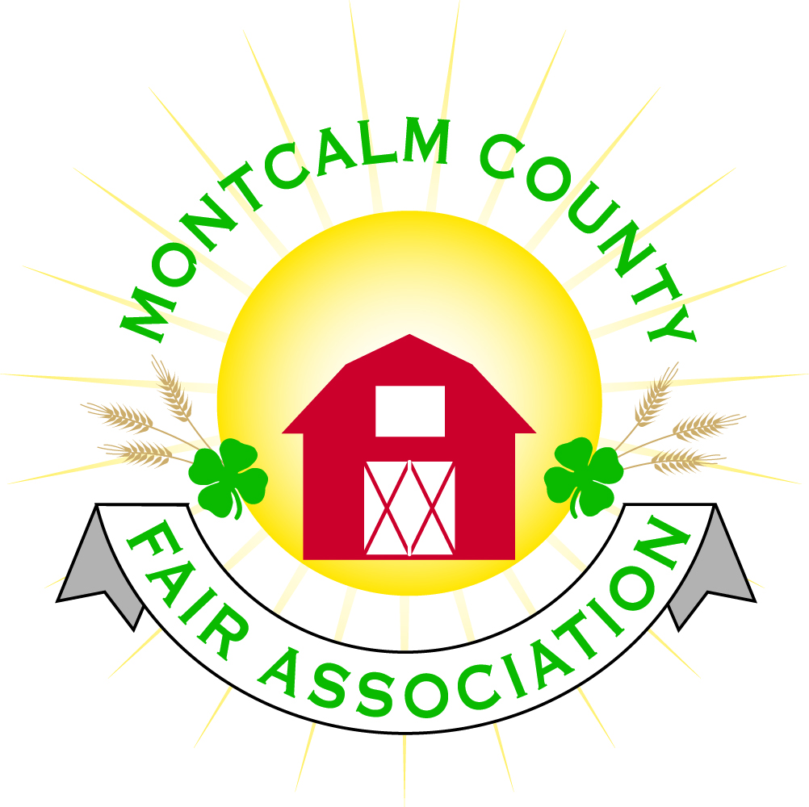
po box 513 • Greenville, MI 48838

Montcalm County Fair Association Board Meeting
December 04, 2017 Ash Building
Montcalm County Fairgrounds, Greenville, MI

The meeting was called to order by President Melissa Eldridge at 7:02pm.
Board members present were;
Melissa Eldridge, Brian Plank, Jennifer Senn, Roger Coles, Jason Nadeau, Todd Hetherington, Lisa Johnson, Amy Bell, Melanie Rodenhouse Lee Rasmussen, Holly Esterling, Brad Heft, Carrie Harkness,
Absent:
Shaun Bartolo, Mike Tronson,.
Others present were:
Kadren Grawburg, Mary Gee, Sherry Brown, Shari Potter

Motion by Roger Coles, support by Lee Rasmussen to approve the Secretary’s minutes from the November meetings. Motion carried.

Motion by Todd Hetherington, support by Brian Plank to put the financials on file. Motion carried.

Extension Office:
- End of year report was turned in by Kadren to MSU
- Not much to report for the month of December

Executive Committee:
- Shaun Bartolo has officially resigned from the Board – committee to appoint a person to fill position:
  - Possible nominations
    - Patty Tally
    - Contact Melissa Eldridge for additional nomination
- MAFE – January 11-14, 2018 held in Grand Rapids
- 2-hour service – Jason Nadeau presented his suggestions for guidelines.
  - All kids that have an exhibit are required at least 2 hours of fairground improvements
    - Cloverbud members are excluded
  - Required hours may begin the Monday following fair week for the following year.
  - All service must be completed by the Friday before the start of fair
  - Fair Clean-ups at the fairgrounds count, watch for dates starting in March weather permitting
  - Fundraisers or club benefits do not count toward the 2 hours. All hours must be from the fairgrounds.
  - All members will be required to check in prior to starting their hours with leader or Jason Nadeau to get project ideas (i.e. things that need to be done)
  - Exhibitors who do not complete service hours will not be allowed to enter any exhibits.
  - Clubs may designate an area that they wish to oversee – please contact Jason with your ideas.
  - Projects that need completed for 2018:
    - Mowing all areas
    - Weed Eating around buildings and fences
    - Mulching & Pulling weeds in landscaping
    - Painting
    - Power washing
    - Rock picking in arenas
    - Trash pick-up in all areas
    - Campground cleanup (Brush trimming/Removal, Raking, Mowing)
    - Bath house & restroom in Ash Building – Cleaning
  - Discussion on using Sign-up Genius and Showorks to track member involvement
- Discussion about maintenance needs during fair week
  - Suggestion to assign club duties

Buildings, Grounds & Construction Committee:
- Roger – DNR Has been contacted to meet in regards of the handicap access in the bleacher
  - Need pictures of Bleachers to send to DNR
- Bath house update – plumbing is in.
  - Progress report sent in for grant – MI Dept. of AG. -
- Camping reservations to be online

Budget & Audit Committee:
- Discussion on when to start. Lisa would like to start in January 2018.
  - Discussion of finding an outside source to help
  - Deadline was set March 1st, 2018

Judges:
- Waiting for a response for Rabbit Judges & Dog Judges
- Suggestion to have a 2-year judge’s contract for small animal
- As a rule, there must be a minimum of 3 entries in a species to have the show – Livestock Committee passed in November meeting

Concessions & Grandstand:
- A few Concessions contracts have been received for 2018 fair
- Grand stand events
  - West MI Pullers Assoc. have contacted Amy & Lisa and have a strong interest in being part of our fair.
    - Todd Hetherington - Invitation to come to the January meeting and make a presentation
  - Jim Troller has contacted Lisa to meet regarding Demolition Derby and possibly another event
    - Combine Derby???
    - Jason, Lisa, Melissa, & Todd to meet with Jim to discuss options
  - Possibility of having the High School Rodeo Association - 2019
    - Lisa mentioned that a lot of our sponsors participate in the rodeo.
    - Carrie will contact and get more information
  - Contract with Maple Leaf carnivals ends this year
    - Lisa would like to contact another vendor to explore other options

Fairbook:
- Fairbook has been sent for proofreading waiting for a response
- Showorks – Schedule a meeting to get 2018 fair setup and Enter fairbook changes

Awards/Trophies:
- NA

Rental Committee:
- Amy Bell was voted as the chairperson
- Monthly report was presented by Amy
  - Rental Income brought in - November - $2,645.00
  - Mom 2 Mom Sale was cancelled due to lack of participation
  - Upcoming scheduled events
    - December – (3) local company holiday parties & 1 wedding
    - January – Crystal Raceway Banquet
  - 2017 there were a total of 49 rentals booked
  - 2018 currently there is 22 rentals booked with $14,008.75 in deposits paid.
- Amy presented a list of building maintenance needs was given to Lee to present to the Building and Grounds committee.
- Request for transfer of funds to purchase some approved improvements and needs for the Ash building – Lisa to get this done
- A motion was made by Brian Plank and supported by Amy Bell to approve $1,000.00 petty cash placed on Debit card for Shari to utilize. Receipts to be turned into Lisa so Lisa knows how much to replenish petty cash. – Motion carried
- Amy is going to explore options to receive credit card payments for rentals
- Discussion on horse show grounds rental charges
- Reminder that committees need to run activities for approval through Sheri before confirming dates.
- Commercial refrigerator in kitchen needs to be replaced by Thursday December 7th. Need to have replacement for wedding scheduled this weekend. Carrie is checking with AGA Marvel
  - UPDATE – AGA Marvel does not carry Commercial equipment. Carrie is checking with another source – Delfield Refrigeration in Mt. Pleasant.

Marketing Committee:
- A meeting was setup but low attendance
- February 10th – Euchre Tournament – tentative
- Would like to send out a fundraising update newsletter by the end of year
- Fair Theme
  - Suggestions came in via e-mail from North Central
  - Request for fair theme will be sent out in the next newsletter

New Business:
- Lowell Fair Request for information – Brian Plank
  - John Schutt requested a fair budget to build our new fairgrounds
  - Lisa volunteered to reach out to John

Next Meeting Date – 01/08/2018
Motion to adjourn meeting at 8:58PM by Lee Rasmussen, Supported by Jason Nadeau

Respectfully submitted by Holly Esterling, Secretary

