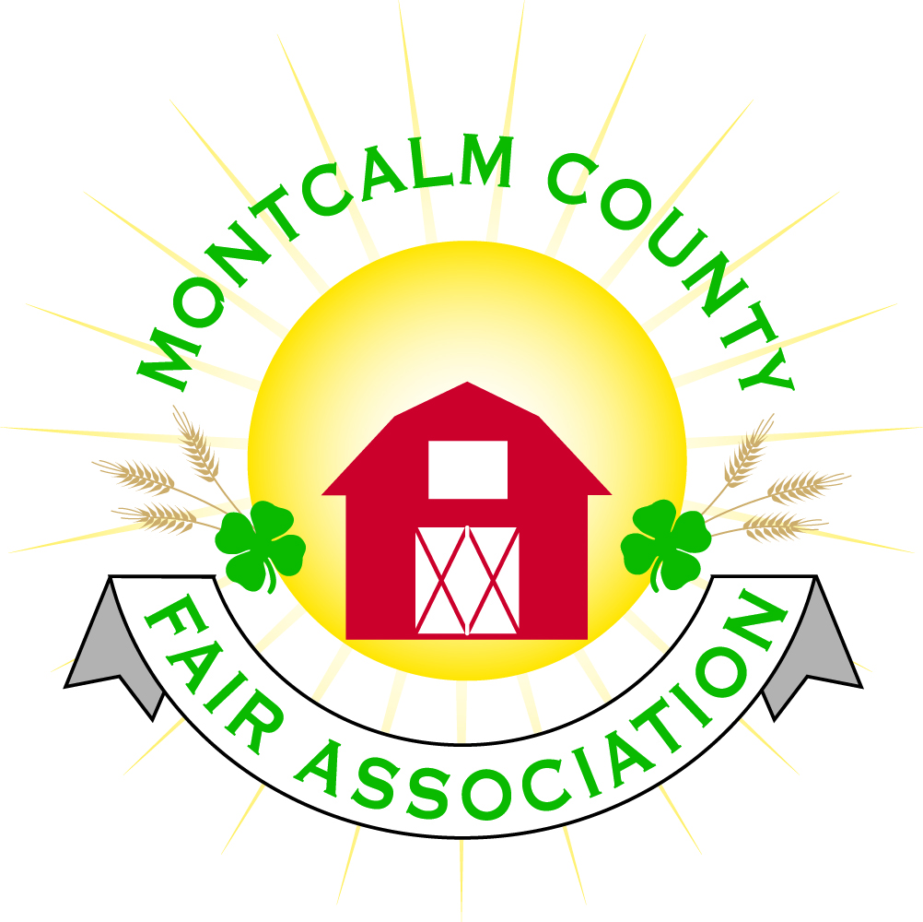
po box 513 • Greenville, MI 48838

Montcalm County Fair Association Board Meeting
January 07, 2018 Ash Building
Montcalm County Fairgrounds, Greenville, MI

The meeting was called to order by President Melissa Eldridge at 6:10pm.
Board members present were;
Melissa Eldridge, Brian Plank, Jennifer Senn, Roger Coles, Mike Tronson , Todd Hetherington, Lisa Johnson, Amy Bell, Melanie Rodenhouse Lee Rasmussen, Holly Esterling, Brad Heft, Carrie Harkness,
Absent:
Jason Nadeau
Others present were:
Kadren Grawburg, Mary Gee, Rachelle Croy

Motion by Lee Rasmussen, support by Jennifer Senn to approve the Secretary’s minutes from the December meetings. Motion carried.

Motion by Lee Rasmussen, support by Melanie Rodenhouse to put the financials on file. Motion carried.

Extension Office:
- Increase in enrollment this year
- Superintendents – approval to use existing members that wish to continue - Approved
- Leadership conference and Winterfest – There are a few 4H members attending
- Discussion on mileage for Extension
- The small animal committee exploring dates for rabbit show, small animal workshop and a poultry show

Executive Committee:
- Motion to increase our Liability Insurance Policy Coverage to $2 Million Policy for board members and Employees (Volunteers) by Lisa Johnson, Motion withdrawn for further fact gathering and entertaining other quotes

Buildings, Grounds & Construction Committee:
- Pictures have been sent to DNR to move forward with the Handicap bleachers
- Bath house – Has been put on hold due to weather – construction will resume in Spring with a May 31st, 2018 project completion date.
  - Need an additional $60,000 more to meet cost
- Well testing in the Ash building needs to be done quarterly, the fairgrounds need to be 2x per year.
- Amy was looking for update on her list of needed repairs
  - Painting
    - Go out for quotes
  - Breaker panel needs to be properly labeled
    - Mike Tronsen to complete
- Gutters Quotes –
  - ABC Gutters – Complete 376’ gutter and (8) downspouts w/ 5’ extensions - $5,024.00
    - 20-year warranty
    - More information is needed
- Floor Sealing Quotes -
  - Parker Painting and Insulating to seal with epoxy sealer on the East wing $17,325.00
  - More quotes needed
- Motion made by Lee Rasmussen to replace the exterior Fluorescent fixtures to LED Fixtures. Support by Melanie Rodenhouse – Motion carried
- Lee is going to install a solar motion light at the entry gate to fairgrounds

Budget & Audit Committee:
- Working to get with Sandy to got through Audit. Will be complete before January 25th

Judges:
- Contracts are coming in.
- Kadren to look into Rabbits and Poultry judges

Concessions & Grandstand:
- 3 Concessions contracts have been received for 2018 fair
  - Need to update contract
- Grand stand events
  - West MI Pullers Assoc.
    - Need a 35’ x 20’ area with run off area
    - $6,500 – Mod Trucks, Mod Tractors
    - $7,500 – Mod Trucks, Mod Tractors, Semis
    - 2 ½ hour show
    - Pit side allow 2 people per entry additional will pay
    - Friday or Saturday Was preferred.
  - Jim Troller has contacted Todd to meet regarding Demolition Derby and possibly another event
    - Contract has expired after 2018 – would like to do another 3 years
    - Demolition Derby – Night of Destruction - $5,000
      - Booked currently for Saturday night
    - Proposal for Sunday night - $4,000
      - Trailer Race
      - Figure 8 Minivans
  - Super Kicker
    - Bull Riders - $8,500
    - Bull Riders – Barrels – $8,800
    - Full Rodeo – $11,500
      - 3-year contract - $11,000
- Motion made by Melanie Support by Amy Bell for the following grand stand schedule for 2017 - Motion Approved
  - Troller Trailer Race & Minivans
    - Sunday Night
  - Antique Tractor Pulls
    - Monday Night
  - Poor Man Pullers
    - Tuesday Night
  - W. MI Pullers association
    - Friday Night
    - Alternate Rodeo
  - Troller Demolition Derby – Night of Destruction
    - Saturday Night
- Carnival – Maple Leaf
  - Proposed to bring their own food vendors
  - Melissa to meet at MAFE

Fairbook:
- Fairbook is complete

Awards/Trophies:
- Amy Nora is donating trophies

Rental Committee:
- Proposing to increase Ash building rental fees to be discussed at February meeting See attached contracts
- Motion made by Amy Bell to increase the camping rate from $25/night to $30/night – Supported by Todd Hetherington – Approved
- Amy is going to get pricing on our website
- New pricing would start November 2018
- New Fridge installed – Yeah!!
- CC payments for Rentals –
  - The Square – The startup fee with a chip reader
    - 2.75% for swipe/chip
    - 3.5% for over the phone transactions plus a $.15 charge per transactions
  - Rentals would be run into a separate account
  - Motion by Amy Bell to utilize the Square for Ash building rentals, Support by Brian Plank - Approved

Marketing Committee:
- No Meeting yet tentative to meet this month

New Business:
- 4-H council would like to change the food auction to become a small exhibit/Food Auction Michelle Nightingale sent proposal
  - 1:00pm entry deadline
  - Exhibitors would be allowed to sell one or the other
  - Suggestion to educate the kids to get buyers
  - Motion from Brian Plank to support Council to move forward with auction support by Carrie Harkness – Approved
- Fill in Open board position
  - Motion by Brian Plank support by Lee Rasmussen to bring Amy Homich back onto committee - Approved
  - Melissa to contact Patty Tolly to participate on other committees
- Rachelle Croy – Horse leaders Treasurer - Presented the horse leaders proposal for managing the rentals of the horse area.
  - Area’s to include but not limited to –
    - Horse Arena’s
    - Horse stalls
    - Camping (When needed, Pass through FB)
  - Horse Leader’s Responsibilities –
    - Repairs
    - Clean-up – Horse area only, not camping
    - Security
    - Empty Trash into Dumpsters
    - Manure pit
    - Contracts, phone calls, payments, etc.
    - Porta Jons
  - Fairboard responisbilties
    - Provide tractor
    - Provide electricity
    - Provide liability insurance
  - Flat fee paid to the Fairboard for rental
    - $50 – 75 per rental day
  - Discussion:
    - Concern was brought up regarding Horse trailers w/ living Quarters utilizing electrical hookups at the barns and not being charged.
      - Horse leaders would have a member on grounds who would monitor this
      - The Horse Leader member would be on the grounds when exhibitors arrive and through out the show to supervise parking, camping, and stall rental
        - Suggested that the member be given free camping privileges
    - Discussion was made regarding the flat rate being paid to Fairboard. Suggested that maybe go with a Percentage of profit instead.
    - Discussion of Manure removal – Rachelle is going to look into some options
  - Motion was made by Lee Rasmussen, Support by Carrie Harkness to accept the Horse leader’s proposal with the change from flat rate to a percentage to be 25% of profit to Fairboard and 75% of profit to Horse leaders. This would be a trial year with a review before end of Fiscal year – Motion carried
  - Motion was made by Brian Plank , Support by Amy Bell to setup a separate account under the Agricultural Committee for the Horse area rentals – Motion Carried
  - Horse Leaders to coordinate with Rental committee in regard to rental dates as to not cause conflict with Weddings and other activities.
- Campsites
  - Open March 1st. Changes will be followed:
    - Online registration only
    - Can only reserve one site per transaction.

Next Meeting Date – 02/05/2018
Motion to adjourn meeting at 8:39 PM by Brian Plank, Supported by Lee Rasmussen

Respectfully submitted by Holly Esterling, Secretary

