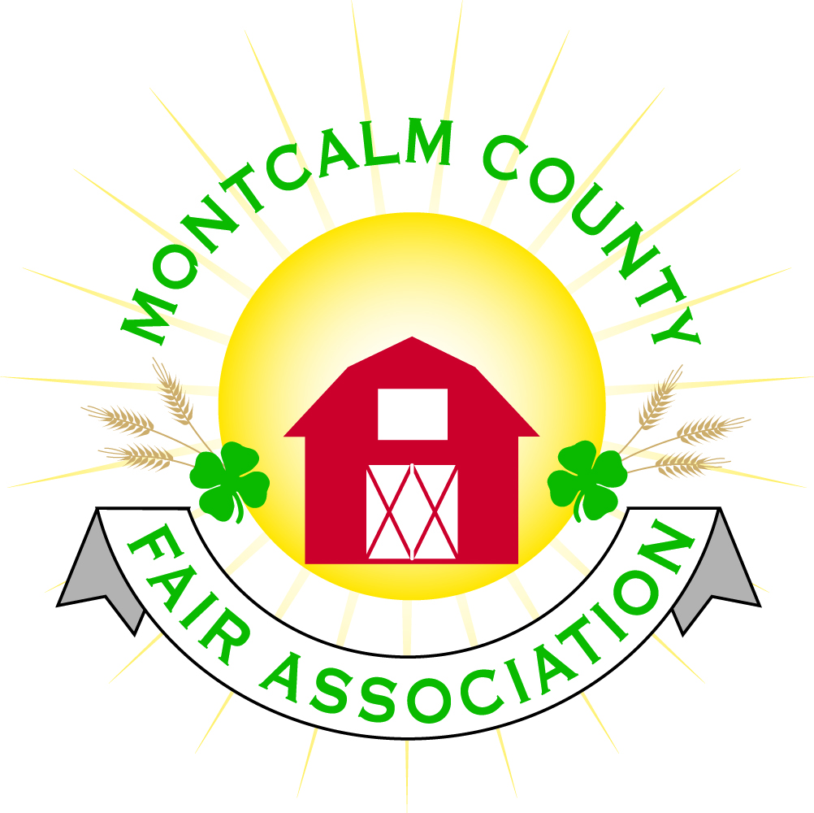
po box 513 • Greenville, MI 48838

Montcalm County Fair Association Board Meeting
February 05, 2018 Ash Building
Montcalm County Fairgrounds, Greenville, MI

The meeting was called to order by Vice President Brian Plank at 7:05pm.
Board members present were;
Jason Nadeau, Brian Plank, Roger Coles, Mike Tronson , Todd Hetherington, Lisa Johnson, Melanie Rodenhouse Lee Rasmussen, Holly Esterling, Jennifer Senn, Brad Heft, Carrie Harkness, Amy Homich
Absent:
Melissa Eldridge, Amy Bell,
Others present were:
Sheri Potter, Kim Thompsen, Mary Gee

Motion by Roger Coles, support by Lee Rasmussen to approve the Secretary’s minutes as addended from the January meeting.
Addendum stated as follows:
- Motion was made by Brian Plank, Support by Amy Bell to setup a separate account under the Agricultural Committee for the Horse area rentals. This will operate under the Fair Association Tax ID #. Melissa Eldridge, Amy Bell & Rachelle Croy, to be signers on the account – Motion Carried.
-Motion carried.

Motion by Todd Heatherington support by Mike Tronsen to put the financials on file. Motion carried.

Extension Office:
- Breakfast & Auction is March 24th
- Livestock Committee enforcing all the pig showmen must be PQA certified. Terin is still certified to give this class until April 31st.

Executive Committee:
- Swearing in of Amy Homich
Buildings, Grounds & Construction Committee:
- Discussed water issue behind building. Postponing the gutters. Scope of work to fix is being sent out for bids.
- List of age appropriate jobs for the service work
- Working with rental committee to decide who gets to drive the tractor. Need to have designated people.
- Minor repairs in the building – Lee Rasmussen and Amy Bell have volunteered to paint the main entrance and fix drywall.
  - Cost of purchasing paint - $350 – Satin Finish – 2 colors
  - Motion by Mike Tronsen to purchase paint and supplies at Jerry’s Paint Store up to $650.00. Support by Todd Hetherington – Motion Carried
- Moving forward with Handicap access at the bleachers.
  - Specs have been received. A quote and drawings could be received by end of February.
- Bath house is on schedule – payments have been made towards purchased materials that are in storage and progress billing for completed work. May 31st deadline is still obtainable per General Contractor.
Rental Committee:
- Report presented by Melanie Rodenhouse.
  - There was $655.00 in rentals for January from Crystal Motor speedway banquet
  - Upcoming events
    - Flat River Ducks Unlimited Banquet - $682.50
    - Lakeview Sports Booster Banquet - $682.50
    - 4H Pancake breakfast fundraiser - $50.00
  - Shari received 8 signed contracts and gave 6 facility tours
- Recommendation from rental to increase rental rates starting in November 2018 – Recommendation approved
- Shari met with Chad Kaminski with GR Bride/WMWA (West Michigan Wedding Association) to discuss hosting a bridal show at the Ash building.
- Committee approved to join the WMWA with a standard membership fee of $250. – This will help promote the venue
- Committee approved to participate in a wedding giveaway at the February 24,2018 GR Bridal Show at the Delta-plex in Grand Rapids
- Committee approved to advertise venue on The Knot website at no cost.
- Working with buildings and grounds committee to get painting and drywall repairs done in main lobby also to get outdoor lighting fixed on Ash building
Budget & Audit Committee:
- The committee met – Lisa, Sandy, and Jay met and completed an audit. Sent a copy of the audit onto Melissa Eldridge.
  - Motion by Carrie Harkness to table the presentation of the audit to review current audit and have Jay and Sandy present the findings. Supported by Roger Coles - Motion Carried
  - Jay to e-mail findings to board members and present at the next meeting
Judges:
- Jenn still needs sheep judge number
- Recommendations for Dairy and Rabbit.
- Looking for ½ day judge for horses.
- Contracts have been Received from 4 horse judges, 2 dog judges,
Concessions & Grandstand:
- Presented by Melanie – We do not need any more food vendors
- Grandstand events are updated on
  - Sunday – Troyer’s demolition – Start time at 5:00pm –
  - Monday – Antique Tractor pulls
  - Tuesday – Poor man pullers
  - Wednesday - Pro-Am Horse show
  - Thursday – Livestock Sale
  - Friday – MWTA Truck pulls
  - Saturday – Demolition Derby
- Football coach from Greenville High School will have parents and team members will cover the parking.
Fairbook:
- Fairbook is completed
Showorks:
- Motion by Jenn Senn and support by Lee Rasmussen to approve $250.00 to send a member of the Showorks committee to Cody, Wyoming to workshop amended by Amy Homich to increase the amount to $500.00 Supported by Lisa Johnson. Further funds to be petitioned to Livestock committee, Council, Horse leaders,
  - Support – 6
  - Oppose – 4
  - Motion carries
Awards/Trophies:
- Holly presented options of different awards that would be offered for Sweepstakes showmanship, Best of Breed, Versatility, Supreme Champion, Best of show, Leadership & 4-Her of the year.
- Board agreed if committee maintains within budget the decision of awards would be at the descression of the awards committee.
Marketing Committee:
- Presented by Amy Homich – Going to be meeting 6:00 prior to fairboard meeting.
- Bath-house fundraising
  - Update $60,000 short of needed funds
  - Brick campaign is being promoted – letter has been revised and is going to be sent out to 4H families
  - Looking into local grants
  - Lisa noted that she has potentially sold 15 campsites. Potential buyers have been given until February 15 to pay their $500 initial payment. This could generate $22,500 over a 3-year period
- Fair Sponsorship discussion and update:
  - 2017 fair raised $35,292.50
  - Amy to revise 2018 fundraiser form and Alyssa to make a google doc for sponsorship and letter tracking
  - Tagline for Fair advertising is “No Place like our Fair”
  - Committee came up with these 3 Internal Fair themes - choices at the meeting:
    - 1. Farm. Fresh. Fun – 0 Votes
    - 2. Country Pride, County Wide. – 7 votes
    - 3. Fun for the whole herd. – 3 votes

New Business:
- Kim Thompsen representing the F4EC (Friends of 4H, Extension & Conversation) had questions about what It would cost the Friends of 4H booth at the fairground. Since the fair is non-profit we can not offer them a free booth for political views.
  - Questions was asked in regard to location of booth.
  - An option for promotion was to have a combine derby heat. A combine has been donated for promotion of the cause.

- Building out front by gates
  - Lee Rasmussen proposed Ticket booth by gate – on wheels – steel siding to match buildings

Next Meeting Date – 03/05/2018

Motion to adjourn meeting at 8:39 PM by Lee Rasmussen, Supported by Roger Coles

Respectfully submitted by Holly Esterling, Secretary

