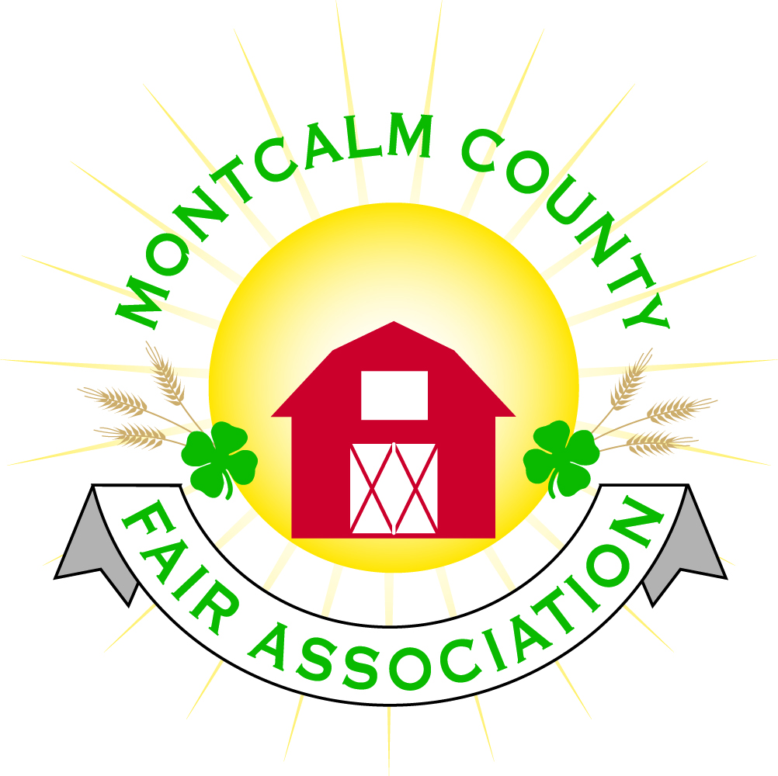
po box 513 • Greenville, MI 48838

Montcalm County Fair Association Board Meeting
April 02, 2018 Ash Building
Montcalm County Fairgrounds, Greenville, MI

The meeting was called to order by President Melissa Eldridge at 7:09pm.
Board members present were;
Melissa Eldridge, Brian Plank, Roger Coles, Mike Tronson , Todd Hetherington, Lisa Johnson, Amy Bell, Lee Rasmussen, Holly Esterling, Jennifer Senn, Brad Heft, Carrie Harkness,

Absent:
Amy Homich, Jason Nadeau, Melanie Rodenhouse

Others present were:
Shari Potter, Mary Gee, Kara Helms – M1063, Shawn & Jill Bortolo, Bill Hendrian, District 8 Coordinator & Patrick Cudney, Associate Director of MSU, Jacob DeDecker, Acting Director of CYI, Pete Frye, Attorney at Law

Motion by Roger Cole, support by Brian Plank to approve the Secretary’s minutes from the February meeting. Motion Carried
Motion by Todd Heatherington support by Carrie Harkness to put the financials on file. Motion carried.

Extension Office:
- Bill Hendrian, District 8 Coordinator & Patrick Cudney, Associate Director of MSU, Jacob DeDecker, Acting Director of CYI
  - Questions regarding how to handle financing and livestock sale if the mileage doesn’t pass.
  - Patrick Cudney addressed to committee confirmed that funds that are raised during the livestock sale due to the members will be dispersed
  - It was confirmed that if the mileage did not pass the funds currently in accounts that have been raised under 4-H intentions would be froze in a trust account to be re-opened when 4-H would be re-instated in our county.
  - Noted that even if the mileage doesn’t pass MSU Extension has worked in other counties with the board of trustees, local schools, and area businesses to established non-county funded offices and programs
  - It was also noted that to help resolve some concerns in regard to funding our counties program for next year if mileage doesn’t pass that there needs to be brainstorming and communications between Fairboard and MSU Extension/4H to help come up with solutions. MSU is willing to help work with us and come ups with comprisable solutions.
Executive Committee:
- Meeting last Sunday March 25 invitation was sent out to Livestock executive committee to brainstorm some solutions in regard to the livestock sale expense account
Budget & Audit Committee:
- No report
Buildings, Grounds & Construction Committee:
- Bath house is progressing, but weather is slowing work
- Water needs to be turned but weather permitting
- Bleachers should have quotes after this week
- Scheduling a meeting this month
Rental Committee:
- March Rentals - $1,012.50
- Upcoming events for April & May total $3,850.00
- 5 Signed contracts in March, attended 1 promotional event (Spring Fling), gave 9 Facility tours
- 2018 Rentals – 39; 2019 Rentals – 5
- A motion by Amy Bell to purchase a computer up to $1,000 for the event coordinator, Carrie Harkness supported, Motion carried.
- Power issue for an outlet located on the South side of the kitchen
- Horse arena 10 paid events and 7 horse leaders events.
- Lawn Care was brought up.
Judges:
- On hold to look for a llama judge pending on registration numbers
Concessions & Grandstand:
- All grandstand events have been contracted.
- 9 food vendors have been contracted.
Fairbook:
- No report
Showorks:
- Looking for volunteers that would like to learn showorks and to assist during fairweek in all areas of the show. You would learn how to run class reports, make changes to entries, and enter placings. Contact Holly, Sherry, or Kadren if interested.
  - Would like to see 3 - 4 Horse leader members trained so that the duties in the announcer’s booth can be alternated between them throughout the week. It is too much of a task for 1 person for the entire week – especially if they have children showing.
  - Livestock auction needs volunteers to help with buyer check-in and check-out.
  - Training for Showorks scheduled for April 22nd – 2:00 – 4:00pm. A laptop is required.
- On line class registration will begin May 12th and close June 3rd.
  - Leaders will be able to approve registrations June 4th – June 10th
  - 4-H Office will be open Tuesday and Thursday for help with registration.
Awards/Trophies:
- Awards from Thompsen Metals needs to be placed early part of April
Marketing Committee:
- Roger Cole – Discussed Buy a brick program

New Business:
- Insurance Bids have been received – Motion made by Carrie Harkness supported by Mike Tronsen to have the executive committee make the decision on the insurance – motion carried.
- Kids Day – Shari Potter
  - Would like to bring Farmer Tom back he would like his hotel and travel expenses - $300.00 Motion made by Carrie Harkness to go ahead and book Farmer Tom, the $300.00 deposit to be funded by the fairboard. Support by Amy Bell, Motion Carried.
- Kara Helms from M1063 WGLM presented a proposal to the board for hosting “Movies under the Stars” at the fairgrounds for 2018.
  - WGLM will act as event coordinator and will provide marketing & Advertising support
  - WGLM Would like the board to waive rental fee in exchange for sponsorship/inclusion in all marketing material
  - WGLM would also offer concession sales opportunity to the various 4H clubs for fund raising
  - Proposed profit split:
    - WGLM – 70%
    - Montcalm Fair Association – 20%
    - Non-profits – 10%
  - Proposed movie nights:
    - June 15
    - July 20
    - Aug 17
    - Sept 14
    - Oct 19 (Halloween Bash also possible on this date)

Next Meeting Date – 05/07/2018 7:00 PM

Motion to adjourn meeting at 8:34 PM by Brian Plank, Supported by Carrie Harkness

Respectfully submitted by Holly Esterling, Secretary

