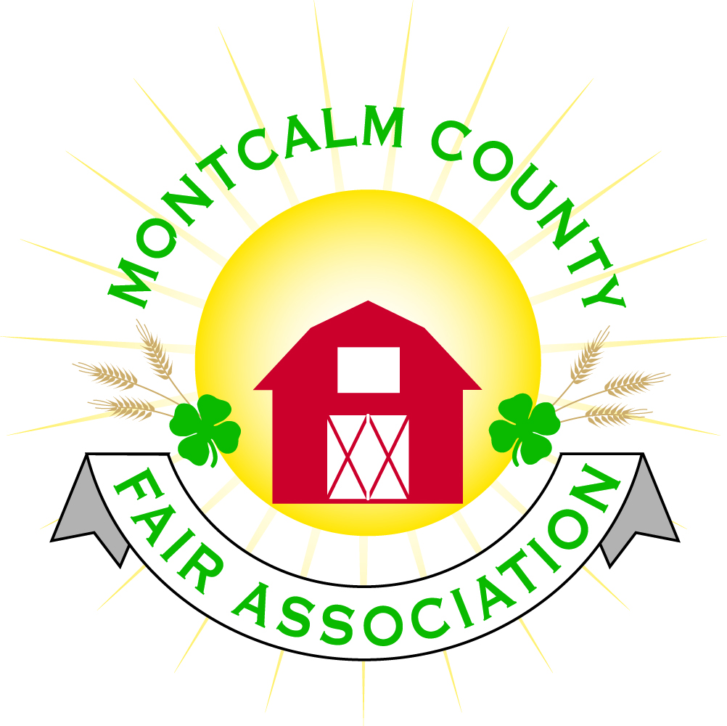
po box 513 • Greenville, MI 48838

Montcalm County Fair Association Board Meeting
May 07, 2018 Ash Building
Montcalm County Fairgrounds, Greenville, MI

The meeting was called to order by President Melissa Eldridge at 7:12pm.
Board members present were;
Melissa Eldridge, Brian Plank, Roger Coles, Mike Tronson , Lisa Johnson, Amy Bell, Holly Esterling, Jennifer Senn, Brad Heft, , Amy Homich, Jason Nadeau, Melanie Rodenhouse, Lee Rasmussen
Absent: Todd Hetherington, Carrie Harkness
Others present were:
Mary Gee, Kadren Grawburg, Captain of mounted division

Motion by Roger Cole, support by Brian Plank to approve the Secretary’s minutes from the February meeting. Motion Carried
Motion by Brian Plank support by Jason Nadeau to put the financials on file. Motion carried.

Extension Office:
- 3 People attended the shooting sports workshop
- Equestrian special needs program is being set up
- Donation from West Michigan Compounding to Montcalm 4H extension to fund county activities.
- Workshop for forestry.
Executive Committee:
- Meeting this evening discussion over the bathhouse and camping.
  - Issue to be able to hook into the drain field due to capacity issues per the health dept and DEQ.
Budget & Audit Committee:
- No report
Buildings, Grounds & Construction Committee:
- Tree needs to be removed on North/East Fence
- Handicap accessible bleachers were discussed. Cost? Report needed next month for a plan on how to get this accomplished.
- Need for handicap parking signs in various locations on the fairgrounds.
- Water is on in the barns and will be on in the concessions
- Need to enforce UTV rules.
- Bid for mowing $3,500 per year - Ross Romano
  - Motion to accept Ross Romano’s proposal made by Jason Nadeau support by Lee Rasmussen – Motion Carried
Rental Committee:
- April Rentals brought in $2,762 (2 weddings and a rabbit show)
- Upcoming events A GHS Senior Tea 2 Weddings, Quinceanera, Dog Show, Field trip.
- There is a total of 35 rentals for 2018.
- Looking into putting together Prom packages for the area schools.
- Issue with messes and damages left after animal shows. Suggestions to not hold any animal shows in the Ash building.
Judges:
- Need to higher a llama/Alpaca judge and a pocket pet judge.
Concessions & Grandstand:
- There are 9 signed food vendors and 4 non-food vendors.
- Grand Stand events are contracted.
Fairbook:
- Motion made for 2019 fair a minimum of 5 exhibitors to compete the week of fair to hold a competitive a show at fair of any species otherwise it will be an exhibition/clinic – Made by Melanie Rodenhouse support by Amy Bell. Motion carried
- November 1st to turn in for fair book changes
Showorks:
- On line class registration will begin May 12th and close June 3rd.
  - Leaders will be able to approve registrations June 4th – June 10th
  - 4-H Office will be open Tuesday and Thursday for help with registration.
Awards/Trophies:
- Thomson Metal awards have been placed
  - Sponsoring the clover buds
- Belt buckle ordered
- Trophies and ribbons to be ordered this week
Marketing Committee:
- Recognition of 2018 sponsorships. Amy presented what we are offering
- Dicastal Sponsor for a scholarship –
- Brick sales are coming in
- A sponsor to put in a 3 pole Flag display with lights.

New Business:
- Captain from mounted division touched base to confirm that they are still providing security again this year. Contract for $1,500.
- Fairboard Members have mentioned to auction off campsite with proceeds going towards bath house. Jen Senn is going to market and put out to everyone.
- For safety purposes no tack, decorations or animals are to be removed before 6:00 am on Sunday.
- Last year superintendents are approved to come back if they desire and approved by their respective committee.

Next Meeting Date – 06/04/2018 7:00 PM

Motion to adjourn meeting at 9:29 PM by Brian Plank, Supported by Lisa Johnson

Respectfully submitted by Holly Esterling, Secretary

