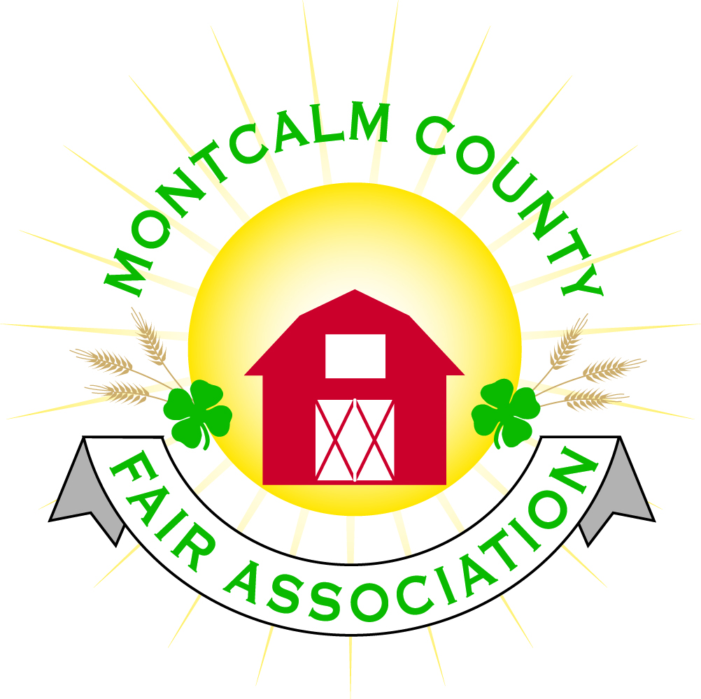
po box 513 • Greenville, MI 48838

Montcalm County Fair Association Board Meeting
August 06, 2018 Ash Building
Montcalm County Fairgrounds, Greenville, MI

The meeting was called to order by President Melissa Eldridge at 7:05pm.

Board members present were;
Melissa Eldridge, Amy Bell, Roger Coles, Lisa Johnson, Holly Esterling, Jennifer Senn, Brad Heft, Melanie Rodenhouse, Lee Rasmussen, Todd Hetherington, Mike Tronson

Absent: Jason Nadeau, Carrie Harkness, Brian Plank, Amy Homich

Others present were:
Mary Gee

Motion by Roger Cole, support by Todd Hetherington to approve the Secretary’s minutes from the July meeting. Motion Carried
Motion by Todd Hetherington support Mike Tronson by to put the financials on file. Motion carried.

Extension Office:
- Kadren was not able to make the meeting – No Report – focus is the August 7th mileage

Executive Committee:
- Nothing to report

Budget & Audit Committee:
- Need to focus on Fiscal Year Audit
- Nothing to report

Buildings, Grounds & Construction Committee:
- Bath house – Holding $15,000 until Punch list is done –
  - Block Sealant still in question
  - Missing faucet
  - Shower water drainage issue
- M-tec – sent a report from the meters that were installed during fair. He also did some various repairs to our septic/drain field system prior to fair - $6,600 was his bill
- Repair privacy wall in Men’s bathroom
- Fall Fairground Cleanup September 22 & 23 – 3:00 – 6:00PM

Rental Committee:
- Month of July – Brought in $4,472 – 4 Events
- August & September projected to bring in $11,640 – 9 events
- 3 signed contracts & 5 facility tours
- Total 38 rentals booked for 2018, 15 rentals booked for 2019
- Horse arenas - approx. income brought in $10,000 gross for this year

Judges:
- Judge recommendations need to be in by November 1st. – To Jenn Senn Please provide addresses, phone numbers & E-mail address.

Concessions, Commercial Exhibits & Grandstand:
- Can’t plan anything until we get a committed carnival for fair week
  - Option to try a year without carnival.
  - Option to go with a different carnival but would have to be a week earlier (start date - June 16th)

Fairbook:
- Changes need to be turned in by October 1st.

Showorks:
- Nothing to report

Awards/Trophies:
- Using a different vendor for buckles
- Option into looking at possibly jackets as an award

Marketing Committee:
- Dicastal was very happy with their sponsorship – Hired 3 new employees, would like to use the facilities
- 49 bricks have been sold
- USDA – apply for grants and loans through them

New Business:
- Late entry – fee or consequences
  - Lisa will get Gratiot County policy and the executive committee will review
- Fair Manager – With the growth of our fair there is a need to have a full-time position to oversee the management of our fairgrounds
  - Roles – Job description
  - Pay
  - Committee – Roger Cole, Amy Bell, Lisa Johnson, Jenn Senn
- Annual Meeting – October 18th Dinner at 6:00pm – Meeting at 7:00PM
  - Anyone that would like to run for fair board need to pay membership dues by September 18th
    - There are 3 positions that will be open
  - By-law changes need to be submitted by September 18th
- Agricultural Committee – falls under the fair association umbrella just like the Horse Leaders Rental Committee.

Next Meeting Date – 09/10/2018 7:00 PM

Motion to adjourn meeting at 8:28 PM By Melissa Eldridge

Respectfully submitted by Holly Esterling, Secretary

