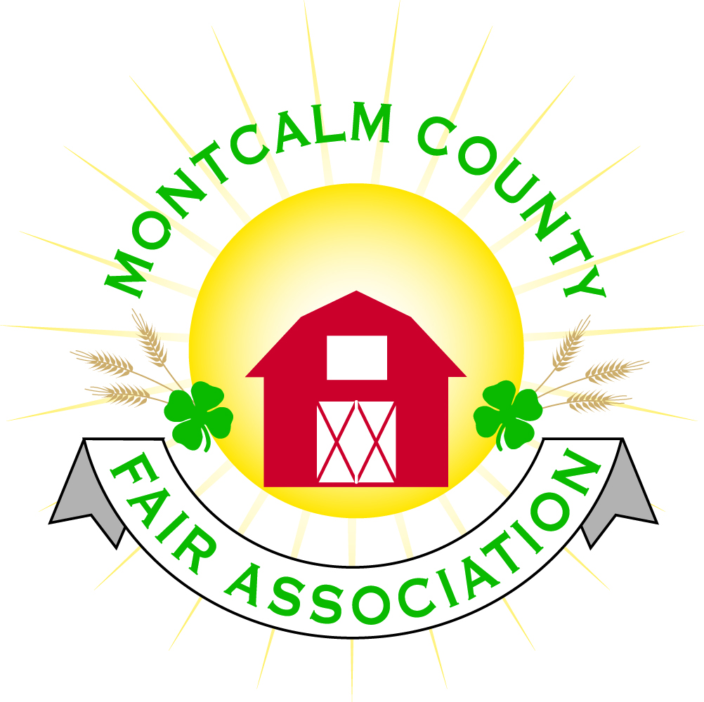
po box 513 • Greenville, MI 48838

Montcalm County Fair Association Board Meeting
September 10, 2018 Ash Building
Montcalm County Fairgrounds, Greenville, MI

The meeting was called to order by President Melissa Eldridge at 7:01pm.

Board members present were;
Melissa Eldridge, Roger Coles, Lisa Johnson, Holly Esterling, Jennifer Senn, Brad Heft, Melanie Rodenhouse, Lee Rasmussen, Todd Hetherington, Jason Nadeau, Carrie Harkness, Brian Plank

Absent: Amy Bell, Amy Homich, Mike Tronson

Others present were:
Mary Gee

Motion by Roger Cole, support by Lee Rasmussen to approve the Secretary’s minutes from the August meeting. Motion Carried
Motion by Todd Hetherington support Carrie Harkness by to put the financials on file. Motion carried.

Extension Office:
- Kadren was not able to make the meeting.
- 4H Coordinstor will be a full-time position and will be open for applications
- 4H secretary will be a full-time position and is currently posted

Executive Committee:
- Meeting prior to board meeting
  - Budget for 2019 was discussed should have one put together before next meeting
  - Melissa would like every board member to send 2 items on a wish list (ie. buildings & grounds) and 2 changes that need to be made regarding policies & Forms
  - Discussion on Late registration form –
    - Proposed: “The fair will except late registration forms under the following terms – A $10.00 charge will be assessed for each calendar day after deadline date. No registration will be excepted after 30 calendar days. Checks will be payable to Montcalm County Fair Association” – Proposal failed
  - Position of fair manager – Roger has committed to helping to put something together.
Budget & Audit Committee:
  - Audit – Melissa has contacted and received a quote of $5,000 review – or could be an excess of $10,000 depending how in depth
    - Motion by Carrie Harkness to proceed with a review and get 3 quotes Support by Lee Rasmussen – Motion Carried

Buildings, Grounds & Construction Committee:
- Bath house – Health department needs to approve the drain system before the DEQ will even look at it.
  - Need to connect the septic from the concession stand into drain field
  - Have proposals to connect – need health department to approve the proposals

Rental Committee:
- Month of August – Brought in $3,595 – 3 Events
- September & October projected to bring in $12,528 – 12 events
- 6 signed contracts & 7 facility tours
- Total 38 rentals booked for 2018, 18 rentals booked for 2019, 1 rental booked for 2020
- Feedback from IBHA – Loved facilities would like to book next year, Bigger rigs had issues getting in and out of sites due to stumps
- Horse leaders’ association is putting together a financial report for this year’s rentals.

Judges:
- Judge recommendations need to be in by November 1st. – To Jenn Senn Please provide addresses, phone numbers & E-mail address.

Concessions, Commercial Exhibits & Grandstand:
- Lisa is willing to double check with carnivals to explore other options – Will have information by October 1st.

Fairbook:
- Motion by Holly Esterling to move show age 8 – 19 as of January 1, support by Jenn Senn – Motion carried
- Changes need to be turned in by October 1st.

Showorks:
- Nothing to report

Awards/Trophies:
- Nothing to report

Marketing Committee:
- Bricks are getting engraved
- Bronze plaques will be engraved with Thanking over $1,000 sponsorship

New Business:
- Bio- Security plan – board to setup a new committee at the November meeting
- Annual Meeting – Postcards and invitations to be sent
  - Meal proceed as normal
  - 3 positions open
    - Nominations – Member by the September 18th – Contact Holly Esterling
  - Nominations for Friend of Fair
  - Recognition of sponsors

Next Meeting Date – 10/01/2018 7:00 PM
Annual Meeting Date – 10/18/18 Dinner at 6:00pm – Meeting at 7:00PM
Fall Fairground Cleanup September 22 & 23 – 3:00 – 6:00PM

Motion to adjourn meeting at 8:53 PM By Jason Nadeau, Support by Todd Hetherington

Respectfully submitted by Holly Esterling, Secretary

