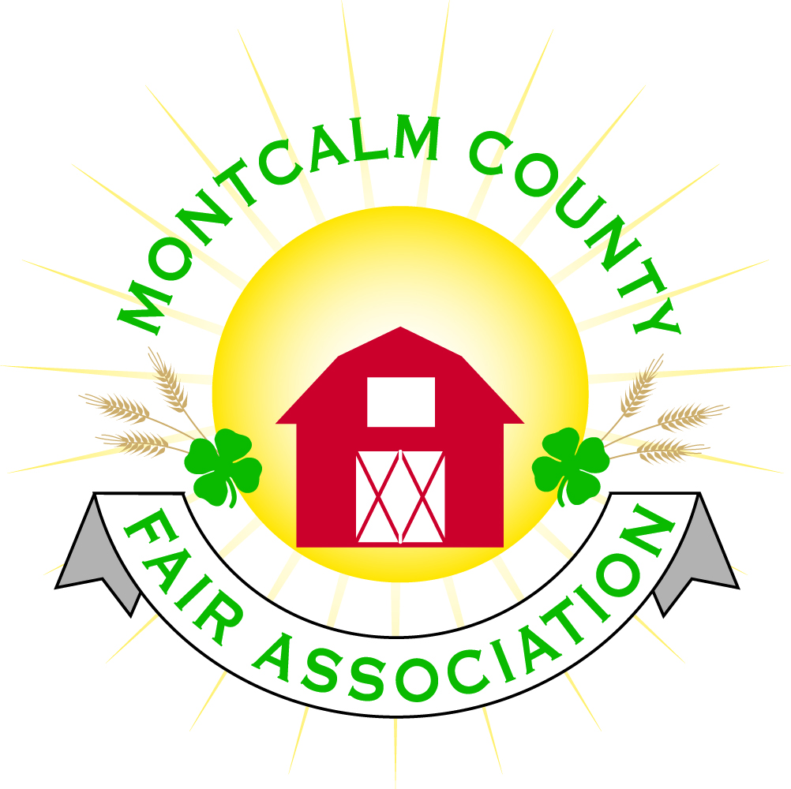
po box 513 • Greenville, MI 48838

Montcalm County Fair Association Board Meeting
October 01, 2018 Ash Building
Montcalm County Fairgrounds, Greenville, MI

The meeting was called to order by President Melissa Eldridge at 7:09pm.

Board members present were;
Melissa Eldridge, Roger Coles, Lisa Johnson, Holly Esterling, Jennifer Senn, Brad Heft, Lee Rasmussen, Todd Hetherington, Carrie Harkness, Brian Plank, Amy Bell, Amy Homich,

Absent: Jason Nadeau, Mike Tronson, Melanie Rodenhouse

Others present were:
Sharri Potter, Patty Tolly

Motion by Lisa Johnson, support by Todd Hetherington to approve the Secretary’s minutes from the September meeting. Motion Carried
Motion by Todd Hetherington support Carrie Harkness by to put the financials on file. Motion carried.

Extension Office:
- Kadren could not be present for the meeting
- Job positions are open - interviews

Executive Committee:
- Nothing to Report
- Board Needs/Wants list
  - Strategic plan
  - Fence
  - Handicap Ramp
  - Fair Manager
  - Grandstand improvement
  - Fundraiser manager
  - Upgrade to Handicap Access/Parking – Drainage
  - Enclosed all-purpose barn
  - Grounds Keeper
  - Accountant/Treasurer

Budget & Audit Committee:
- Budget will be presented at November meeting

Buildings, Grounds & Construction Committee:
- Mike is going to winterize all the waterlines North of the Ash Building this Sunday October 7th.
- Exterior lights are done
- New exhaust fan in Men’s bathroom
- Need to install (2) new lights at the entrance gate
- Melissa is meeting with Al from MTEC to review the flow and maintaining the meters that are in place, and A maintenance plan
- Suggestion to have a main shut off valve for the water in the camping.

Rental Committee:
- Month of September – Brought in $8,910 – 6 Events + 1 Camper
- October & November projected to bring in $7,837 – 9 events
- 3 signed contracts & 7 facility tours
- Total 40 rentals booked for 2018, 20 rentals booked for 2019, 1 rental booked for 2020
- Horse rental - 2018
  - Income - $10,939.50
  - Expenses - $1,192.56
  - 4 shows – Camping Income – $2,565
  - Horse Only Income (minus the camping) – $7,181.94
- Winter Storage needs –
  - Post on Facebook – October 27th
- Closet in West wing needs to be finished

Judges:
- Judge recommendations need to be in by November 1st. – To Jenn Senn Please provide addresses, phone numbers & E-mail address.

Concessions, Commercial Exhibits & Grandstand:
- Carnival – They verbally confirmed for the next 2 years for the same week but no contract
  - Jenn Senn made a motion to set the date of the fair June 23 – 29th 2019, Support by Todd Hetherington, Motion approved

Fairbook:
- Exhibitor agreement – Current Reading “This form to be completed by all youth participating in the Market Livestock sale.” The MCFAAC would like to change the wording to “This form to be completed by all youth participating in animal projects at fair”
  - Motion by Lee Rasmussen to approve the changes as worded support by Carrie Harkness
    - Motion amended by Carrie Harkness for it to read “Each exhibitor must have completed the proper animal certifications per the species shown – EX: PQA & YDBA”
    - Motion approved

Showorks:
- Nothing to report

Awards/Trophies:
- Nothing to report

Marketing Committee:
- 2 sponsorships are still outstanding – Spectrum Health & MCC
- Commitment for Dicastal
- Plans for next year are in the works
- Need someone to head the committee
- Amy agreed to work with new head of committee
- Bath house – working on Plaque for donors and final fundraising
- Need help laying new sponsor bricks for bath house
- Linda Stafford’s daughter would like a personal tour of bath house

New Business:
- Annual Meeting
  - Postcards will be mailed this week
  - Nominations for (5) 3-year positions open
    - Cherryl Strause
    - Melissa Eldridge
    - Jenn Senn
    - Mike Jensen
    - Trent Hilding
    - Shaun Hyde
  - Nominations for Friend of Fair Recognition of sponsors
    - Barb Altizer
    - Ross Romano
    - Bob Nadeau
    - Mary Gee
    - Dean’s Excavating
    - Bill Knapp
  - Approval of agenda

Next Meeting Date – 11/05/2018 7:00 PM
Annual Meeting Date – 10/18/18 Dinner at 6:00pm – Meeting at 7:00PM
Fair Dates – June 23 – 29, 2019

Motion to adjourn meeting at 8:55 PM Called by Melissa Hetherington

Respectfully submitted by Holly Esterling, Secretary

