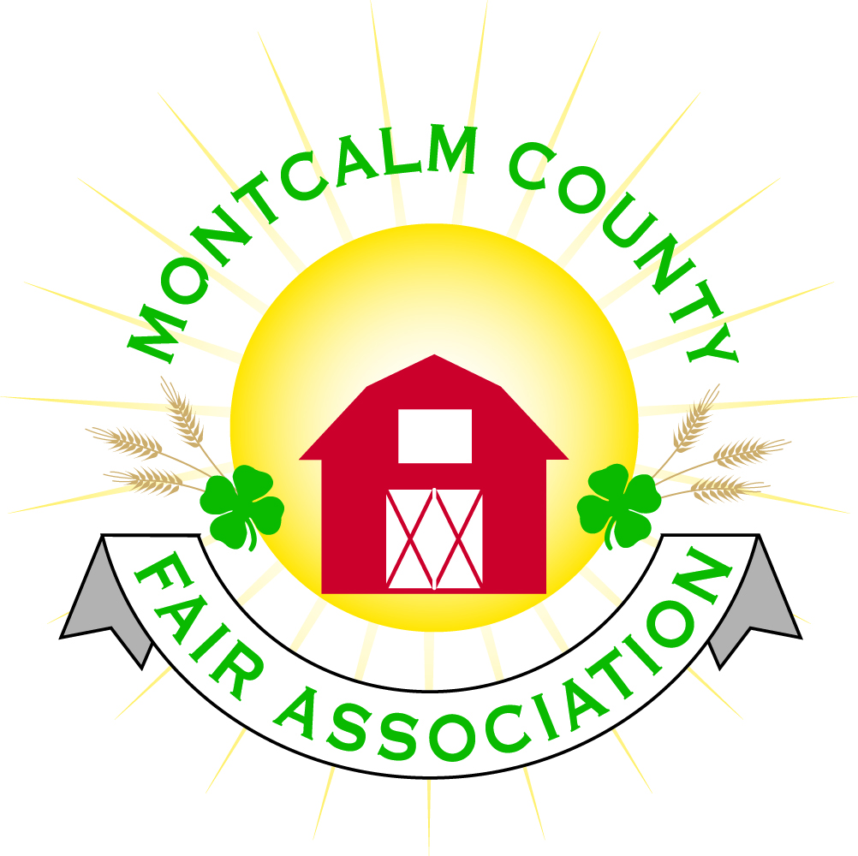
po box 513 • Greenville, MI 48838

Montcalm County Fair Association Board Meeting
November 05, 2018 Ash Building
Montcalm County Fairgrounds, Greenville, MI

The meeting was called to order by President Melissa Eldridge at 7:04pm.

Board members present were;
Melissa Eldridge, Lisa Johnson, Holly Esterling, Brad Heft, Lee Rasmussen, Todd Hetherington, Carrie Harkness, Brian Plank, Amy Bell, Melanie Rodenhouse, Shaun Hyde, Tammi Jahnke, Cheryl Strautz, Jason Nadeau, Mike Jensen

Others present were:
Roger Coles, Sharri Potter, Mary Gee, Kadren Grawburg

Motion by Lisa Johnson, support by Todd Hetherington to approve the Secretary’s minutes from the October meeting. Motion Carried
Motion by Todd Hetherington support Lee Rasmussen by to put the financials on file. Motion carried.

Extension Office:
- Starting November 19^{th,} the extension office will be open full time. Vickie Newcomb has accepted full time secretary position

Executive Committee:
- Swore in new members
- Open Nominations for:
  - President
    - Melissa Eledridge – nominated by Amy Bell support by Carrie Harkness
    - Lisa Johnson closed nominations and cast a unanimous vote – Support by Cheryl Strautz - Approved
  - Vice President
    - Lee Rasmussen nominated Brian Plank support by Amy Bell
    - Cheryl Strautz closed nominations and cast a unanimous vote – Support by Todd Hetherington - Approved
  - 2nd Vice President –
    - Todd Hetherington – nominated by Lisa Johnson support by Lee Rasmussen
    - Carrie Harkness – nominated by Cheryl Strautz support by Brian Plank
    - Carrie Harkness wins the ballot Vote
  - Treasurer –
    - Lisa Johnson – nominated by Todd Hetherington support by Shaun Hyde
    - Cheryl Strautz closed nominations and cast a unanimous vote – Support by Todd Hetherington - Approved
  - Secretary –
    - Holly Esterling – nominated by Todd Hetherington support by Brian Plank
    - Cheryl Strautz closed nominations and cast a unanimous vote – Support by Todd Hetherington - Approved

Budget & Audit Committee:
- 2018-2019 budget was presented by Lisa Johnson. Melanie Rodenhouse moved and support by Todd Hetherington to approve the budget as presented.

Buildings, Grounds & Construction Committee:
- Nothing to report.

Rental Committee:
- Month of October – Brought in $6,289 – 6 Events
- November & December projected to bring in $11,685.50 – 10 events
- 4 signed contracts & 3 facility tours
- Total 42 rentals booked for 2018, 22 rentals booked for 2019, 1 rental booked for 2020
- Repairs needed:
  - Hot water heater needs repaired/cleaned
  - Middle Sink in kitchen is leaking
  - Some minor repairs to walls – some painting to be done
  - Walls in furnace rooms need to be finished – exposed insulation

Judges:
- Judge recommendations should have been turned in. Still missing the horse and small animal recommendations.

Concessions, Commercial Exhibits & Grandstand:
- Lisa received a call from Jim Troller – Was asking regarding our Sunday Show
- Discussion on other options for grand stand events.
  - Rodeo options – Cheryl Strautz to work on options.
  - Combine derby discussion

Fairbook:
- Michelle Nitengale and Melanie Rodenhouse are working on getting it published

Showorks:
- Need to re-evaluate Showorks over the next year. Holly Announced that she will be stepping down after this year. Need to look for someone to take over responsibilities

Awards/Trophies:
- Nothing to report

Marketing Committee:
- Still waiting on payment on some of our sponsors.
- Need a chairperson – Carrie Harkness volunteered but would like help
- Need to have someone to help move 300# of sponsored brick from storage to fairgrounds. – Cheryl Strautz volunteered her husband

New Business:
- 2019 Fair Theme list has been handed over to the Fundraiser/marketing committee chair.
- MCFA Operations Director – Amy Bell presented the job description
  - Carrie Harkness moved to approve the job description and form a committee to come up with the funding of salary - Support by Cheryl Strautz – Motion Carried
- Committee Assignments:
  - Amy Bell suggested that a letter be composed and sent out to our membership requesting help on our committees.
  - Melissa is going to send out an e-mail for committee sign-up
- MAFE –
  - January 10-12th – 2019 Grand Rapids
  - Board has covered badge fees in the past for members to attend.
  - Please Let Lisa know if you would like to attend.

Next Meeting Date – 12/03/2018 7:00 PM
Fair Dates – June 23 – 29, 2019

Motion to adjourn meeting at 8:42 PM Called by Melissa Eldridge
Respectfully submitted by Holly Esterling, Secretary

