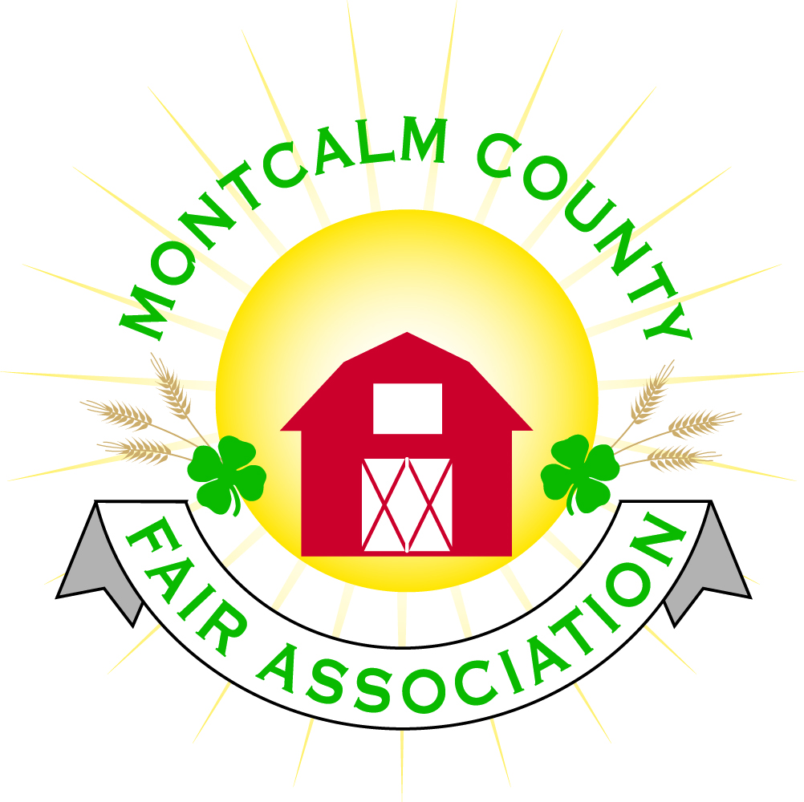
po box 513 • Greenville, MI 48838

Montcalm County Fair Association Board Meeting
December 03, 2018 Ash Building
Montcalm County Fairgrounds, Greenville, MI

The meeting was called to order by President Melissa Eldridge at 7:03pm.

Board members present were;
Melissa Eldridge, Lisa Johnson, Holly Esterling, Brad Heft, Lee Rasmussen, Todd Hetherington, Carrie Harkness, Amy Bell, Melanie Rodenhouse, Shaun Hyde, Tammi Jahnke, Jason Nadeau, Mike Jensen, Brian Plank
Absent: Cheryl Strautz,
Others present were:
Sharri Potter, Kadren Grawburg, Rachelle Croy,

Motion by Todd Hetherington, support by Lisa Johnson to approve the Secretary’s minutes from the November meeting. Motion Carried
Motion by Carrie Harkness support by Todd Hetherington to put the financials as presented on file. Budget & Audit committee will present a revised financial report at the next monthly meeting. Motion carried.

Extension Office:
- New 4H Program Coordinator starts December 17th – Tarin Minkel – Meet & Greet December 19th 6:30 – 8:00 pm at the Dozer Building, Room D303 on MCC campus
- A lot of kids signed up for Winterfest
- Livestock workshop – April 2019
- Small animal workshop – February 2019
- Rabbit Show – April 2019
- Last weekend of January at the MSU pavilion
- 2019 Superintendents & Junior should be presented for approval to the fair board.

Executive Committee:
- 2019 MAFE – Reservations were sent in but haven’t been confirmed yet

Budget & Audit Committee:
- Tammi Jahnke is going to volunteer to help Lisa Johnson put together financial reports and to assist with audits.
- Bill for sponsorship plaque – Lisa is wondering what account to pay – Approved to pay out of the construction account

Buildings, Grounds & Construction Committee:
- Nothing to report.
- Camping permit needs to be renewed. – Permit does not show the additional campsites that were added this year.
- Bills are being sent out to sponsors who purchased a campsite for their 2nd $500.00 payment. Discussion has been brought up in regard to putting term limits on the lifetime campsite sponsorship.
- Sponsor bricks are in #1 Shower stall.

Rental Committee:
- Month of November – Brought in $4,591.00– 5 Events
- December & January projected to bring in $8,392.00– 6 events
- 2 signed contracts & 3 facility tours
- Total 42 rentals booked for 2018, 22 rentals booked for 2019, 1 rental booked for 2020
- Repairs needed:
  - Hot water heater needs repaired/cleaned - Fixed
  - Middle Sink in kitchen is leaking - Fixed
  - Some minor repairs to walls – some painting to be done
  - Walls in furnace rooms need to be finished – exposed insulation
- Horse arena rental
  - $4,254.24 – Fair board - Profit
  - $5,386.46 – Horse Leaders - Profit
  - 25% + the camping
  - Motion Carrie Harkness to accept the proposed financials split from 2018 horse rentals – Support by Tammy Jahnke – Motion Passed
  - Motion by Holly Esterling Support by Carrie Harkness to have the horse leaders to continue managing the horse area rentals for 2019 –Keep percentage the same – 25% + 100% camping for the fair association with 75% going to Horse leaders – Motion Carried
    - Meet in February to cover expenses and changes

Judges:
- Contracts to be sent out to contacted judges

Concessions, Commercial Exhibits & Grandstand:
- Motion by Lisa Johnson support by Todd Hetherington to sign contract with Carnival for 2019 fair. – Motion Carried
- Grandstand events tabled until January meeting

Fairbook:
- Will be posted on website by Friday.

Showorks:
- Discussion over whether to continue with Showorks and is the software able to be utilized. Does the software offer what our association needs?
- Need more volunteers to learn software
- Holly announced that she will not continue as the Showorks administrator after this fair season – suggested maybe a role for fair manager or fair association needs to explore another option for fair management software.

Awards/Trophies:
- Holly Would like to meet with all superintendents/show managers prior to fair to go over awards and their dispersal during shows.

Marketing & Fundraising Committee:
- Marketing and Fundraising will be split out into separate committees
- Carrie would like to reach outside the Greenville areas to recruit more sponsors
- Will be adding some youth members into the Fundraising Committee.
- Discussion of having a youth board.

New Business:
- Dave from Poorman Pullers Association expressed interest in being a part of the 2019 fair. - $300 for the event – Tuesday night
- Committee assignments - Recruit other members
- Need to improve on communication from Board to association members.
- 120-day report was presented by Melissa. – Motion by Todd Hetherington Support by Lee Rasmussen to approve the report as presented. Motion Carried.

Next Meeting Date – 01/07/2018 7:00 PM
Fair Dates – June 23 – 29, 2019

Motion to adjourn meeting at 9:03 PM Called by Melissa Eldridge

Respectfully submitted by Holly Esterling, Secretary

