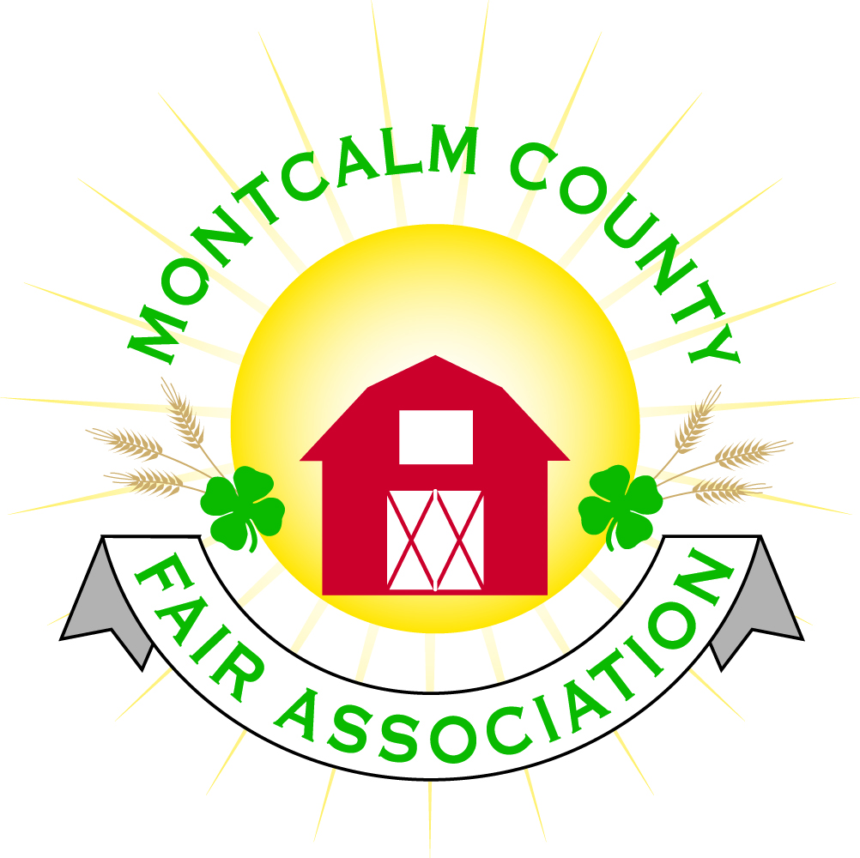
po box 513 • Greenville, MI 48838

Montcalm County Fair Association Board Meeting
January 07, 2019 Ash Building
Montcalm County Fairgrounds, Greenville, MI

The meeting was called to order by President Melissa Eldridge at 6:58 pm.

Board members present were;
Melissa Eldridge, Lisa Johnson, Holly Esterling, Brad Heft, Lee Rasmussen, Todd Hetherington, Carrie Harkness, Amy Bell, Melanie Rodenhouse, Shaun Hyde, Tammi Jahnke, Jason Nadeau, Mike Jensen, Brian Plank
Absent: Cheryl Strautz
Others present were:
Sharri Potter, Tarin Minkel, Mary Gee, Jim Trollard

Motion by Shaun Hyde, support by Lee Rasmussen to approve the Secretary’s minutes from the December meeting. Motion Carried
Motion by Lee Rasmussen support by Todd Hetherington to put the financials as presented on file. Motion carried.

Extension Office:
- Tarin passed out the 4H family newsletter to the board.
- Would like help or interest in a program orientation
  - Small animal committee suggested to offer an orientation to new members/family
- Carrie Harkness suggested a monthly youth spotlight in the newsletter

Executive Committee:
- Nothing to report

Budget & Audit Committee:
- Tammi Jahnke presented this month’s financial reports with assistance from Lisa, they were able to simplify and classify the reports.
- Motion made by Todd Hetherington to reimburse Lisa Johnson for $970.00 from MAFE Fees, Support by Carrie Harkness. Motion Carried.

Buildings, Grounds & Construction Committee:
- Nothing to report.

Rental Committee:
- Month of December – Brought in $6,697.50– 5 Events
- January & February projected to bring in $3,770.50– 4 Events
- 2 signed contracts & 3 facility tours
- 23 rentals booked for 2019, 1 rental booked for 2020
- Repairs needed:
  - Some minor repairs to walls – some painting to be done – Schedule for February
  - Walls in furnace rooms need to be finished – exposed insulation
  - Consumers Energy came in and replaced fluorescent lamps with LED in the bathrooms, kitchen, & office.
- January 23rd @ 7:00 PM committee meeting

Judges:
- Judges are being contacted and scheduled

Concessions, Commercial Exhibits & Grandstand:
- Need volunteers to oversee the management of this area – Amy Bell is stepping down
- Suggestion to open concession area up to craft/merchant vendors
- Need electricity on the South West corner of the horse barn – exterior.

Fairbook:
- Fairbook is posted

Showorks:
- Holly & Mary Gee met to brainstorm some ideas to help simplify beef and livestock registrations and animal check-in
- Need to setup 2019 fair.

Awards/Trophies:
- Nothing to report

Marketing & Fundraising Committee:
- Would like to get more youth involved by forming a youth committee.
- 2019 Fair Theme
  - Country Nights and Carnival Lights

New Business:
- Jim Trollard from Unique Motorsports confirmed the contract for Saturday evenings event (Demolition Derby) of fair. Presented some options for Sunday evenings events.
  - Combine derby – hard to get participants – Cost would be high
  - Figure eight trailer race – drivers’ interest in the area – Regular show with trailer racing/ Figure Eight derby - $4,500 to include combines would increase to $7,500 –
  - Suggested that if we could rent or have access to Skytrack to move debris quickly off track
- Discussion on grandstand events:
  - Sunday - ? (Figure 8 trailer races???)
  - Monday – Antique Tractor pulls
  - Tuesday – Mini Modified Tractor Pulls
  - Wednesday - ?
  - Thursday – Livestock Sale
  - Friday - ? (Rodeo??) – Mike Jensen is looking into a group
  - Saturday – Demolition Derby
  - Motion made by Brian Plank to contact Jim Trollard regarding Sunday’s event and negotiate at MAFE terms of a contract – And pursue information on Rodeo for Friday, Support by Lee Rasmussen. Motion Carried.

Next Meeting Date – 02/04/2019 7:00 PM
Fair Dates – June 23 – 29, 2019

Motion to adjourn meeting at 8:54 PM Called by Melissa Eldridge

Respectfully submitted by Holly Esterling, Secretary

