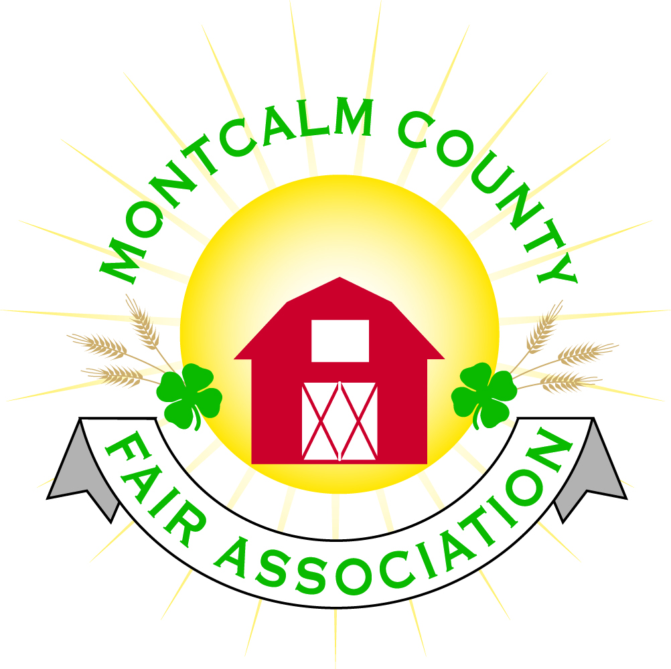
po box 513 • Greenville, MI 48838

Montcalm County Fair Association Board Meeting
February 04, 2019 Ash Building
Montcalm County Fairgrounds, Greenville, MI

The meeting was called to order by President Melissa Eldridge at 6:58 pm.

Board members present were;
Melissa Eldridge, Lisa Johnson, Holly Esterling, Brad Heft, Lee Rasmussen, Cheryl Strautz, Carrie Harkness, Amy Bell, Melanie Rodenhouse, Shaun Hyde, Mike Jensen, Brian Plank
Absent: Todd Hetherington, Tammi Jahnke, Jason Nadeau
Others present were:
Sharri Potter, Tarin Minkel, Rachel Croy, Racheal Valesquez – Ranch Hands

Motion by Brian Plank, support by Carrie Harkness to approve the Secretary’s minutes from the January meeting. Motion Carried
Motion by Brian Plank support by Lee Rasmussen to put the financials as presented on file. Motion carried.

Extension Office:
- Tarin presented Superintendent qualifications and expectation
  - Superintendents workshop

Executive Committee:
- Met tonight in regards to discuss an incident that happened at the 2018 fair over a youth that had a physical altercation – Todd Hetherington had addressed issue with student at fair – a letter has been drafted in regard to this – a meeting with youth, parent, Tarin and 2 Fairboard members to discuss that the youth will be allowed to show in still exhibits but not allowed to show in livestock exhibit.
- Marketing/Fundraising really looking for youth involvement and adult involvement to help on this committee – Please contact Carrie Harkness – A budget of $35,000 - $50,000 to cover operating cost of fair.
- Fair Manager position – need to move forward – Melissa and Lisa have committed to go over financials to come up with funding ideas.

Budget & Audit Committee:
- Melissa touched base with Tammi Jahnke in regard to the audit/review – committed to have something set by March meeting

Buildings, Grounds & Construction Committee:
- Camping – Open on March 1st. – there are 47 sites sold (Sponsored) already
  - Discussion over what happens if you do not pay per the terms noted
    - “If you do not pay with in X# Years you will relinquish the sponsorship”
- Lee Rasmussen is the new Chairperson of the Buildings, Grounds, & Construction
- Melanie presented an option from the Horse Leaders on how to eliminate the tent at fair – Adding a lean to on the Northside of the horse barn
- A conversation in regard to drainage

Rental Committee:
- Formed a subcommittee – Horse Rental committee
- Month of January – Brought in $1,695.00 - 1 Events
- February & March projected to bring in– 5 Events
- 2 signed contracts & 2 facility tours
- 29 rentals booked for 2019, 1 rental booked for 2020
- Repairs needed:
  - Some minor repairs to walls – some painting to be done – Schedule for February 17
- Horse area has 17 events booked
  - 4H events (6)
  - 11 paid events
- A contract written to clearly spell out what /whose responsibilities and how funds/monies are utilized.
- Danish Festival would like to host the balloon launch event –
  - Insurance liability from each balloonist
  - Touch base with Montcalm County Fire Department
  - Would like to see campground advertising
  - Donation a free balloon
  - Concessions

Judges:
- Beef judges are signed.
- Needing judges list from a couple areas. Need to have phone numbers when sending recommendations.

Livestock/Agriculture – Bio-Security:
- Need members to form committee
- Plan to make it happen – Financial and man power
- Tarin – would like to be a part as far as an educational
- Lisa volunteered to get together a sample plan
- Suggested to include the superintendents
- Cheryl Strautz/ Shaun Hyde volunteered to help advise the plan

Concessions, Commercial Exhibits & Grandstand:
- Rodeo – Shane Ingstram – Flying Star Rodeo – Reed City
  - $11,500 to put on a 7-event rodeo
  - Bulls, Barrels, Calf roping, Team roping, Calf Scrabble,
  - We need to provide Hay for rodeo stock
  - Sanctioned IPRA 2nd, Mid-state First
  - Paid for by Sponsorship
  - Motion made by Brian Plank, support by Lee Rasmussen to contract Flying Star Rodeo for Friday night grandstand event. Motion Carried
- Grandstand events:
  - Sunday - Figure 8 trailer races
  - Monday – Antique Tractor pulls
  - Tuesday – Mini Modified Tractor Pulls
  - Wednesday -?
  - Thursday – Livestock Sale
  - Friday – Rodeo
  - Sunday– Demolition Derby

Fairbook:
- Nothing to report

Showorks:
- Meeting at the end of the month.

Awards/Trophies:
- Meeting tomorrow

Marketing & Fundraising Committee:
- Youth interest – have had a good response – Carrie would like to meet with Youth and have a presentation for them when meeting with potential sponsors

New Business:
- None to report
Next Meeting Date – 03/04/2019 7:00 PM
Fair Dates – June 23 – 29, 2019

Motion to adjourn meeting at 9:09 PM Motion by Brian Plank to and support Lee Rasmussen

Respectfully submitted by Holly Esterling, Secretary

