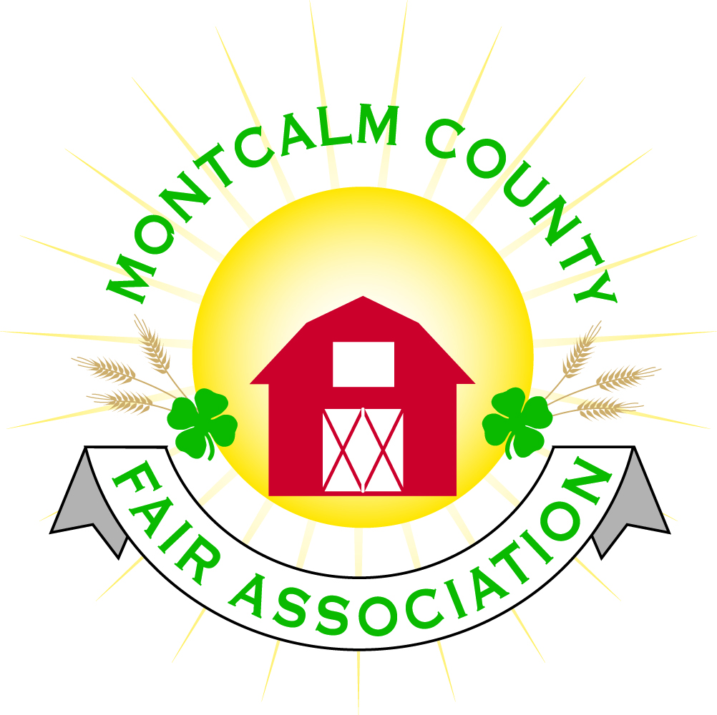
po box 513 • Greenville, MI 48838

Montcalm County Fair Association Board Meeting
March 04, 2019 Ash Building
Montcalm County Fairgrounds, Greenville, MI

The meeting was called to order by President Melissa Eldridge at 6:59 pm.

Board members present were;
Melissa Eldridge, Lisa Johnson, Holly Esterling, Brad Heft, Lee Rasmussen, Carrie Harkness, Melanie Rodenhouse, Mike Jensen, Tammi Jahnke, Todd Hetherington, Jason Nadeau, Shaun Hyde, Brian Plank,
Absent: Cheryl Strautz, Amy Bell
Others present were:
Sharri Potter, Tarin Minkel

Motion by Carrie Harkness, support by Lee Rasmussen to approve the Secretary’s minutes from the January meeting. Motion Carried
Motion by Carri Harkness support by Tammi Jahnke to put the financials as presented on file. Motion carried.

Extension Office:
  - March newsletter was sent out Friday
  - Pig necropsy on March 13th 6:30PM -
  - Kids activity area for Cloverbud members during fair
  - Superintendent meeting will be May 6th at 5:30Pm
  - Discussion on Resolutions to Small animal show

Executive Committee:
- Nothing to Report

Budget & Audit Committee:
- Nothing to report

Buildings, Grounds & Construction Committee:
- Melissa has had some progress regarding the septic
- Horse leaders would like to add onto the North Barn on the south side
  - Would add 27 additional stalls
  - Cost $60,000 to build – include drainage, and stalls
  - Motion made by Carrie Harkness to approve the addition of 27 stalls on the South side of the North Horse barn up to a value of $70,000 on the contingency that the MDARD grant is approved and the stall fee be extended to pay off the balance with completion of phase 1 by June 15th, 2019. We will entertain the future phase 2 building of lean-to on the North side of the south barn – Support by Lisa Johnson – Motion Approved
  - Heaving on the overhead doors
- Lee would like to get approval for signs showing direction to buildings – Approval to get pricing

Rental Committee:
- Month of February – Brought in $977.50 - 2 Events
- March & April projected to bring in $5,373.00 - 7 Events
- 5 signed contracts & 2 facility tours
- 34 rentals booked for 2019, 1 rental booked for 2020
- Repairs needed:
  - Furnaces not working in the West wing
    - Repaired During meeting
- Horse area has 17 events booked
  - 4-H events (6)
  - 11 paid events
- April Easter Egg Hunt.

Judges:
- Rabbit, poultry, pig, beef, sheep, Dairy judges are waiting/sent out contracts
- By next meeting should have all judges contracted

Livestock/Agriculture – Bio-Security:
- Question if we have a bio-Security plan. Nothing official – Shawn to work on putting one together

Concessions, Commercial Exhibits & Grandstand:
- Grandstand events:
  - Sunday - Figure 8 trailer races
  - Monday – Antique Tractor pulls
  - Tuesday – Mini Modified Tractor Pulls
  - Wednesday -?
  - Thursday – Livestock Sale
  - Friday – Rodeo
  - Sunday– Demolition Derby

Fairbook:
- Waterfowl classes were not added. An addendum should be posted on fair website and classes will be added to Showorks for online registration.

Showorks:
- Online Registration May 1st – 15th
- Class reports to leaders May 20th
- Approval report back to Showorks committee June 3rd
- Clubs do not register for classes on line

Awards/Trophies:
- Alternating Jackets/Buckles for Grand Champion showmanship
- Awards and ribbons ordered and in our possession by May 1st.

Marketing & Fundraising Committee:
- Letters are going out to barn banner sponsors. Looking at tiered sponsorship forms

New Business:
- Small Animal Committee moving the registration date moved from May 1st to the 15th – Changing the form - Remove the gender from the form/Date of birth
- 4H CCC – New committee formed under 4H - Makes a connection from Committee to the community –
  - Valentines challenge – 4H members made valentines and sent cards out various nursing homes/specialty care facilities
  - Spring cleanup challenge – Challenging the clubs to pick an area to clean up Easter weekend – A picture of club members doing activity.
  - Teens have interest in attending the fair board meeting, but some parents feel they are not teen friendly – Need to send a message out that our meetings are open.
- A motion made by Holly Esterling to open the Facilities up to Emergency Personal only if the facilities have working utilities and space is available – Motion Passed
  - Amendment made by Carrie Harkness if facilities is not rented supported by Brian Plank – Motion passed
  - Carrie Harkness – will contact area utility companies/emergency personal facilities

Motion to adjourn meeting at 9:20 PM Motion by Jason Nadeau to and support Todd Hetherington

Respectfully submitted by Holly Esterling, Secretary

Next Meeting Date – 04/01/2019 7:00 PM
Fair Dates – June 23 – 29, 2019

