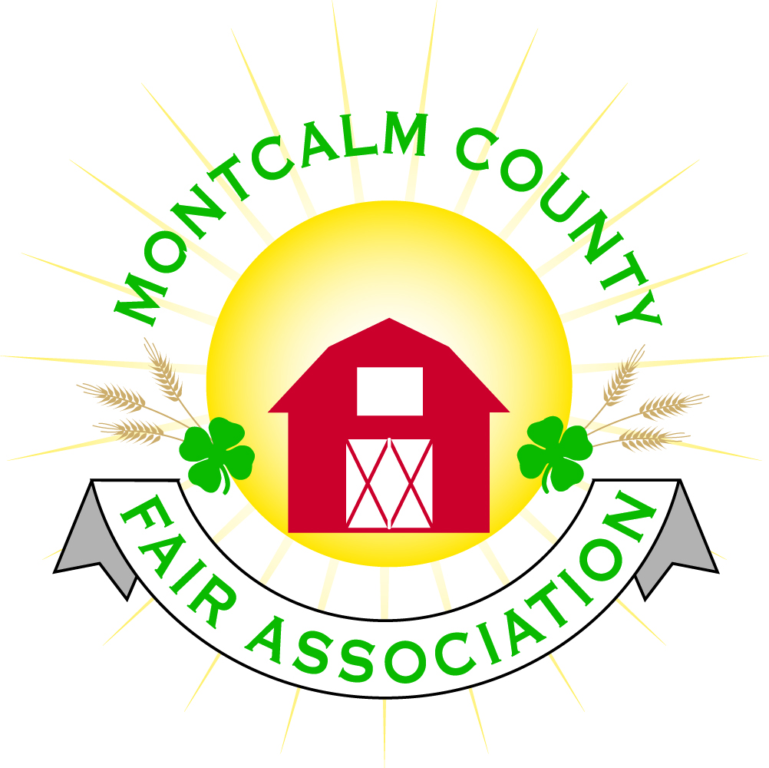
po box 513 • Greenville, MI 48838

Montcalm County Fair Association Board Meeting
April 01, 2019 Ash Building
Montcalm County Fairgrounds, Greenville, MI

The meeting was called to order by President Melissa Eldridge at 7:04 pm.

Board members present were;
Melissa Eldridge, Lisa Johnson, Holly Esterling, Brad Heft, Lee Rasmussen, Carrie Harkness, Mike Jensen, Tammi Jahnke, Todd Hetherington, Jason Nadeau, Shaun Hyde, Amy Bell, Cheryl Strautz Brian Plank
Absent: Melanie Rodenhouse
Others present were:
Tarin Minkel

Motion by Todd Hetherington, support by Lee Rasmussen to approve the Secretary’s minutes from the March meeting. Motion Carried
Motion by Todd Hetherington support by Carrie Harkness to put the financials as presented on file. Motion carried.

Extension Office:
  - Alternative spring break was a success
  - Education outreach program is progressing – local schools are participating
  - 23 Kids enrolled for exploration days
  - Superintendent meeting will be May 6th at 5:30PM

Executive Committee:
- Nothing to report

Budget & Audit Committee:
- Nothing to report

Buildings, Grounds & Construction Committee:
- Melissa is working on getting approval from health department on drawings for septic.
- Lee is looking for suggestions on wordage for signs out by entrance

Rental Committee:
- Month of March – Brought in $1,773 - 4 Events
- April & May projected to bring in $8,561.50- 9 Events
- 6 signed contracts & 2 facility tours
- 35 rentals booked for 2019, 4 rentals booked for 2020
- Horse area has 20 events booked
  - 4-H events (6)
  - 14 paid events

Judges:
- 2 more contracts to go out – Cheryl is waiting for signed contracts to come back

Livestock/Agriculture – Bio-Security:
- Shaun is working on getting a meeting together

Concessions, Commercial Exhibits & Grandstand:
- Grandstand events:
  - Sunday - Figure 8 trailer races
  - Monday – Antique Tractor pulls
  - Tuesday – Mini Modified Tractor Pulls
  - Wednesday -?
  - Thursday – Livestock Sale
  - Friday – Rodeo
  - Sunday– Demolition Derby
- Concessions are coming in
- Work on having a Flea Market/Craft show
- Kids area at fair with activities
- Carnival signed for 1-year contract

Fairbook:
- Nothing to Report

Showorks:
- Online Registration May 1st – 15th

Awards/Trophies:
- Awards are ordered and majority will be in possession by May 6th

Marketing & Fundraising Committee:
- Dicastel sponsorship may be changing with new management at the company
- Spectrum Health wants to sponsor the Kid’s Day
- Chemical Bank has committed to sponsor
- Ed Koehn would like to do a whole grandstand sponsorship

New Business:
- Discussion about mandating vaccines in the horse projects – What are we doing to help prevent disease issues – Committee to put together a plan
- Amy Bell is attending the Klackle Orchard auction – Looking for suggestions
  - PA Systems
  - Picnic tables
  - Floor cleaner
  - Playground equipment
- Clean up Days
  - May 4th 10-12
  - May 18th 10 -12
  - June 1st – 11-1
  - June 15 – TBA
  - Please let Jason know when members are attending
  - Please bring yard tools, Wheelbarrows, Weedwhackers

Melissa Eldridge adjourned meeting at 8:15 PM

Respectfully submitted by Holly Esterling, Secretary

Next Meeting Date – 05/06/2019 7:00 PM
Fair Dates – June 23 – 29, 2019

