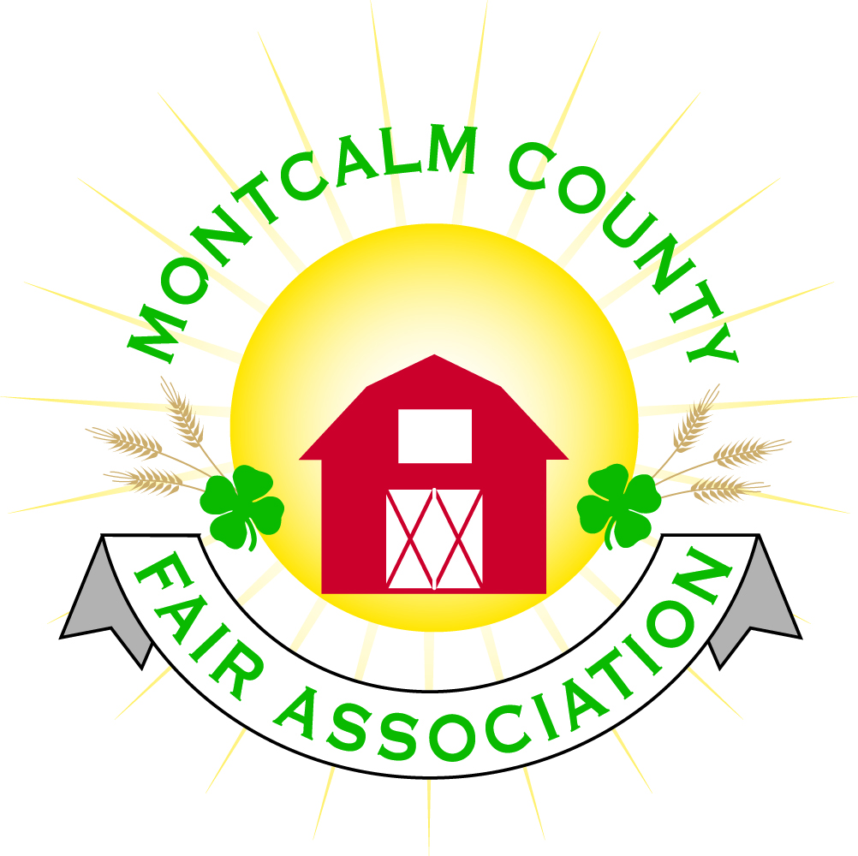
po box 513 • Greenville, MI 48838

Montcalm County Fair Association Board Meeting
May 06, 2019 Ash Building
Montcalm County Fairgrounds, Greenville, MI

The meeting was called to order by President Melissa Eldridge at 7:08 pm.

Board members present were;
Melissa Eldridge, Lisa Johnson, Holly Esterling, Brad Heft, Lee Rasmussen, Carrie Harkness, Mike Jensen, Tammi Jahnke, Todd Hetherington, Jason Nadeau, Shaun Hyde, Brian Plank, Melanie Rodenhouse
Absent: Cheryl Strautz Amy Bell

Others present were:
Tarin Minkel, Mary Gee, Michelle Nitengale, Amanda Wall, Sally Thomson, Tom Gillespie

Motion by Todd Hetherington, support by Lee Rasmussen to approve the Secretary’s minutes from the April meeting. Motion Carried
Lisa Johnson Moves that we assess a clarification of Motion regarding Horse leaders Lean to Funding from March meeting – Motion was withdrawn by Lisa Johnson after discussion
Motion by Brian Plank support by Lee Rassmusen to put the financials as presented on file. Motion carried.

Extension Office:
- Superintendents meeting prior to Fairboard meeting
  - Discussion for an additional tent for the small animal show
- Tarin will be out of office next week – only contact by e-mail
- Office hours need to be more concrete - Tarin will address

Executive Committee:
- Nothing to report

Budget & Audit Committee:
- Nothing to report

Buildings, Grounds & Construction Committee:
- Furnace has been fixed
- Roof leak has been fixed
- Signs made for the entrance
  - Motion made by Lee Rasmussen to offer a gift card for printing Jason
  - Discussion about other options to show appreciation
- Septic system update – Health Department is not satisfied with our drain field system as this time.
- Motion made by Lisa Johnson In light that the MDARD grant has been approved for $40,000 to match $20,000 for a total cost of $60,000 for the construction of the Lean to on the South side of the North Horse Barn, The fair board requires that the Montcalm County Fair Association Agricultural Horse Committee collects $50.00 per stall for a total of 135 stalls annually and deposited into the Montcalm county horse leaders ag committee fund until the balance of $20,000 is paid – Carrie Harkness support – Motion Carried

Rental Committee:
- Month of April – Brought in $3,700 - 3 Events
- May & June projected to bring in $7,001.50- 7 Events
- 3 signed contracts & 2 facility tours
- 38 rentals booked for 2019, 4 rentals booked for 2020
- Horse area has 20 events booked
  - 4-H events (6)
  - 14 paid events

Judges:
- All judges have been hired – still waiting on a few contracts

Livestock/Agriculture – Bio-Security:
- Shaun has found a policy and is working on fine tuning

Concessions, Commercial Exhibits & Grandstand:
- Grandstand events:
  - Sunday - Figure 8 trailer races
  - Monday – Antique Tractor pulls
  - Tuesday – Mini Modified Tractor Pulls
  - Wednesday -?
  - Thursday – Livestock Sale
  - Friday – Rodeo
  - Sunday– Demolition Derby

Fairbook:
- Nothing to Report

Showorks:
- Online Registration May 1st – 15th
- Exhibitor numbers - Laminating – Melanie moved to spend the expense of $300 for the printing of the cards and laminating – Support by Brian Plank – Motion Approved

Awards/Trophies:
- Awards Are coming in and will be completed by Fair

Marketing & Fundraising Committee:
- Dicastel sponsorship - Have agreed to sponsor the fair but not an amount
- Spectrum sponsorship has been received
- Banner and sign sponsors are coming in

New Business:
- Kids Day – Spectrum health is sponsoring 10 – 2 on Friday
  - Will need the area on the East side of small animal barn for large equipment and activities
  - Bounce houses
  - Stilt walking balloon artist
- Parade of clubs
  - Club has asked if we can bring before the rodeo – Board support

Melissa Eldridge adjourned meeting at 8:43 PM

Respectfully submitted by Holly Esterling, Secretary

Next Meeting Date – 05/06/2019 7:00 PM
Fair Dates – June 23 – 29, 2019
Clean up Days
May 18th 10 -12
June 1st – 11-1
June 15 – TBA

