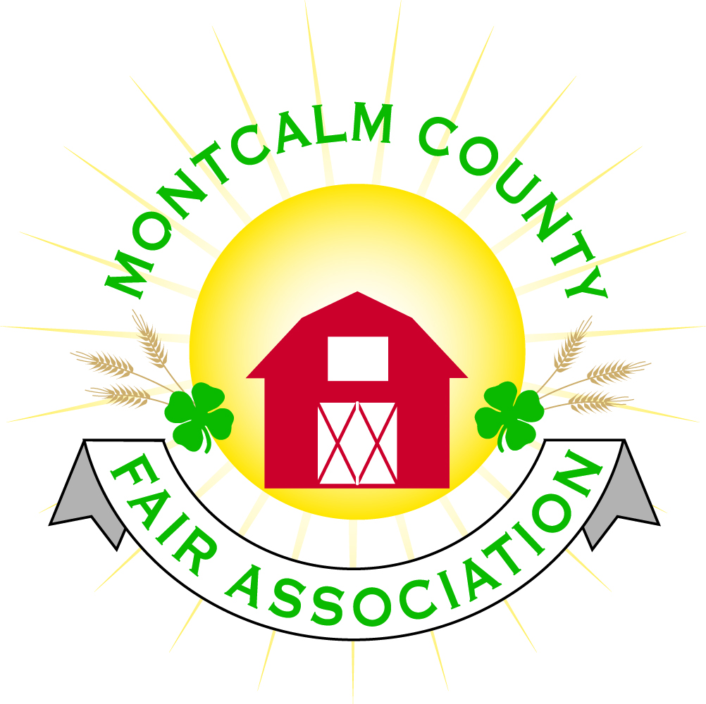
po box 513 • Greenville, MI 48838

Montcalm County Fair Association Board Meeting
October 07, 2019 Ash Building
Montcalm County Fairgrounds, Greenville, MI

The meeting was called to order by President Melissa Eldridge at 7:10 pm.

Board members present were;
Lisa Johnson, Holly Esterling, Brad Heft, Melissa Eldridge, Tammi Jahnke, Brian Plank, Jason Nadeau, Carrie Harkness, Shaun Hyde, Todd Hetherington, Mike Jensen, Melanie Rodenhouse, Amy Bell
Absent:
Lee Rasmussen, Cheryl Strautz,
Others present were:
Tarin Minkel, Mary Gee

Motion by Tammi Jahnke, support by Carrie Harkness to approve the Secretary’s minutes from the September meeting. Motion Carried
Motion by Carrie Harkness support by Todd Hetherington to put the financials as presented on file. Motion carried.

Extension Office:
- Montcalm County 4H accepted a grant from JC Penny - Greenville store through round up campaign - $5,000.00.
- Annual bake – off at Fruit Haven Farm – had 2x as many entries as previous year. Had good turnout.
- This coming Sunday is Fall Celebration Banquet.
- Starting discussion for sign-up genius to help with volunteer responsibilities.
  - Would like to split the cost up amongst the Extension office, council & fair board. – Extension would pay for half.
  - Motion made by Todd Hetherington, support by Carrie Harkness that if 4H council would match up to $150.00 to help pay for Sign-up Genius that the fair board would pay our portion. Motion Carried.

Executive Committee:
- Melissa presented a fair memorandum of agreement for committees.
  - Recommended that this be annually reviewed by current board association and the acting 4H coordinator.
  - Motion made by Lisa Johnson support by Carrie Harkness to approve the amended document as discussed – Motion carried.

Budget & Audit Committee:
- Discussion over Greenville Foundation moneys left in account to be transferred into our construction account at Isabella Bank. The account with Greenville Foundation will be closed.
  - Motion made by Lisa Johnson support by Carrie Harkness to give $500.00 out of account and donate it to the Greenville Foundations General fund. The balance of the moneys to be deposited into the construction account at Isabella Bank. – motion carried.
- It is time for annual budget to be presented. Lisa to schedule a time with Tammi to get one put together and present at the next meeting.

Buildings, Grounds & Construction Committee:
- Lisa to contact Russels to blow out the bath house and have Mike Tronsen to get the lines in the barns and campground blown out for winter.
- Lisa would like to review propane usage and suppliers.
- An energy audit is being reviewed and recommendations will be presented.

Rental Committee:
- Month of September – Brought in $.00 – Events
- Month of October/November - $.00 – events
- contracts signed; facility tours
- 2019 rentals – 44; 2020 rentals – 19
- Horse area:
  - 2019 Events – 10 events – Total Net income $19,260.00
    - Expense
      - Campground - $957.50
      - Arena - $2,353.73
    - Gross Income
      - Camping - $5,187.50
      - Arena - $16,906.27
- Amy presented the committees proposal for the proposed show manager. – Amy will e-mail to members for review.

Judges:
- Committee recommendation for 2020 judges due by November 1st, 2019

Livestock/Agriculture – Bio-Security:
- Nothing to report

Concessions, Commercial Exhibits & Grandstand:
- Todd had met with Troyer – Proposed mud runs would be a good attraction
  - $5,000 plus pits, Troyer gets 1 driver and 1pit the rest goes to Fairboard.
  - We would pay for prep with Ross Sr. Excavating
  - Motion made by Jason Nadeau support by Melanie Rodenhouse to accept and move forward with the contract as presented by Todd for the Mud Bog for Sunday evening entertainment. – Motion Carried.
Fairbook:
- All the edits have been submitted and will be edited by November 1st.

Showorks:
- Motion made by Carrie Harkness Support Holly Esterling to make the Dell laptop to be designated as the Showorks admin laptop – Motion carried.

Awards/Trophies:
- Nothing to report

Marketing & Fundraising Committee:
- Nothing to report

New Business:
- Annual meeting –
  - Sages have been contacted to supply meat, and drinks
  - Nominating committee – Carrie Harkness to confirm nominees.
  - Friends of the fair –
    - Mary Gee
    - Caleb Wieland
    - Michelle Nitengale
    - Ashley Davis
    - Amble Electric – Jake Newman
    - Taylor Harkness

Jason Nadaeu move to adjourned meeting at 9:03 PM - Support by Melanie Rodenhouse– Motion Carried

Respectfully submitted by Holly Esterling, Secretary

Next Meeting Date – 11/04/2019 7:00 PM
Annual Meeting October 24th 6:00 PM social hour
Fairbook Changes due November 1st, 2019

