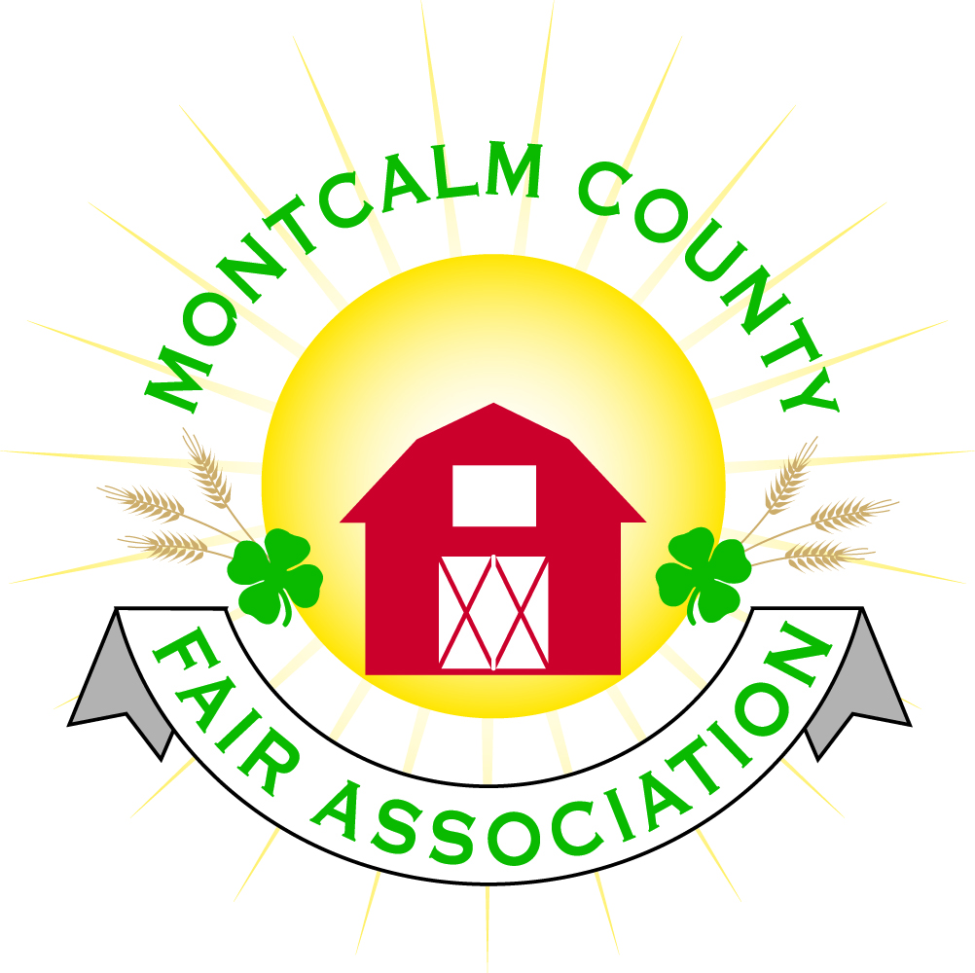
po box 513 • Greenville, MI 48838

Montcalm County Fair Association Annual Meeting Minutes
Montcalm County Fairgrounds, Greenville, MI
October 24, 2019

Registration:
Doors opened at 6:00pm- members signed in and received packet

Welcome:
Lisa Johnson welcomed members
Cory Wall presented prayer

Dinner:
Dinner commenced at 6:30pm
Main course was prepared by Sage’s meat market

Pledges:
Hailey Heft presented the pledges

Presentation:
Melissa Eldridge, President, presented a slideshow covering a year in review.
Fair dates June 21 – 27, 2020
Melissa covered areas that we have improved and expanded on.
Committees were covered and request for volunteers
Our future goals were presented.
- Fair manager
- Strategic Plan
- Water/Electric in more campsites
- Entrance design plan/implementation
- Beef barn expansion/livestock office
- Grand stand ticket booth
- Grandstand roof
- Enclosed arena
- Grounds keeper
- Accountant
- Campground expansion
- Fence by large paking area

Introductions:

- Board Members:
- President – Melissa Eldridge
- 1st Vise President – Brian Plank
- 2nd Vice President – Carrie Harkness
- Secretary – Holly Esterling
- Treasurer – Lisa Johnson
- Members:
  - Shaun Hyde
  - Brad Heft
  - Amy Bell
  - Melanie Rodenhouse
  - Lee Rasmussen
  - Todd Hetherington
  - Tammi Jahnke
  - Cheryl Strautz
  - Mike Jensen
  - Jason Nadeau

- Outstanding Volunteers:
- Amble Electric
- Mary Gee
- Michelle Nightingale
- Taylor Harkness
- Ashley Davis
- Caleb Wieland

Annual Meeting:
- Meeting called to order at 7:27pm by Melissa Eldridge, Fairboard President.
- Please note that our roll call was completed as guests registered upon arrival.
- Information was handed out including minutes from the October 18, 2018 meeting, 2018-2019 financial reports, and ballots for voting.

Secretaries Minutes:
- Motion by Todd Hetherington Support from Tammi Jahnke to approve the 2018 annual meeting minutes.
- Motion approved

Treasurer’s Report:
- Treasurer’s report was presented by Lisa Johnson
- Motion by Brian Plank, support Cory Wall to place treasurer’s report on file.
- Motion carried
No Old Business to present
New Business
- Tarin Minkel, 4H Program coordinator, discussed areas in regard to roles and responsibilities and the differences between 4H and the Fair organization.
- Role of 4H focuses on the education of our youth, the role of the fair is to provide a facility and an event for the youth to showcase their abilities.
- Melissa Eldridge discussed the memorandum of responsibilities that the board members have approved.
- Meliss

Introduction of Nominees for the Fairboard:
Nominees are:
- Melanie Rodenhouse
- Mary Newman
- Clifton Dickinson
- Todd Hetherington
- Lisa Johnson
- Brian Plank
- Jennifer Senn
- Becka Merren

Election of Fairboard Members:
5 positions open, 3-year terms
- Mary Newman
- Todd Hetherington
- Lisa Johnson
- Jennifer Senn
- Becka Merren

Meeting adjourned at 8:23pm.

Respectfully submitted by
Holly Esterling, Secretary

