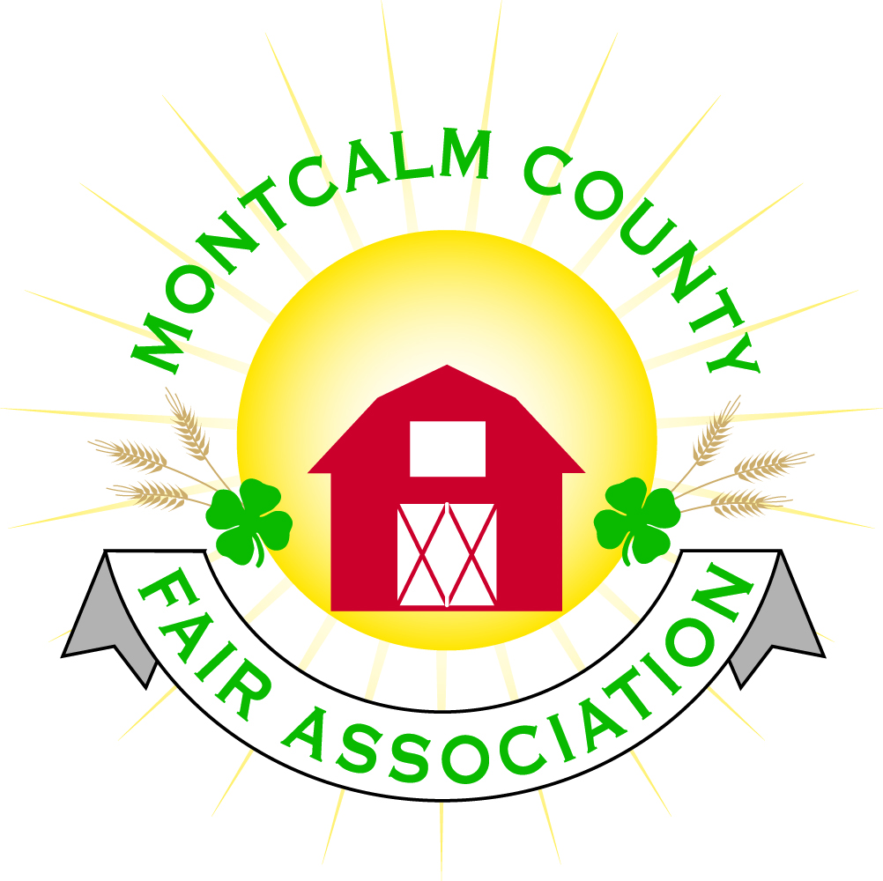
po box 513 • Greenville, MI 48838

Montcalm County Fair Association Board Meeting
November 04, 2019 Ash Building
Montcalm County Fairgrounds, Greenville, MI

The meeting was called to order by President Melissa Eldridge at 7:02 pm.

Board members present were;
Lisa Johnson, Brad Heft, Melissa Eldridge, Tammi Jahnke, Jenn Senn, Jason Nadeau, Carrie Harkness, Shaun Hyde, Todd Hetherington, Mike Jensen, Becca Merrin, Amy Bell, Lisa Johnson, Lee Rasmussen, Cheryl Rosso, Mary Newman
Absent:
Others present were:
Tarin Minkel, Mary Gee, Holly Esterling, Michelle Nitengale

Motion by Lee Rasmussen, support by Carrie Harkness to approve the Secretary’s minutes from the September meeting. Motion Carried
Motion by Jason Nadeau support by Todd Hetherington to put the financials as presented on file. Motion carried.

Extension Office:
- December 1st deadline to get re-enrolled
- Workshops are in the works over the winter
  - Spa workshop – Before Christmas Time
- Encourage clubs to start thinking about meetings
- Rebel Clovers won the food contest and win the ice cream

Executive Committee:
- New and re-elected members were sworn in.
  - Lisa Johnson
  - Todd Hetherington
  - Jenn Senn
  - Beca Merrin
  - Mary Newman
- Nominations for President
  - Carrie Harkness Nominated by Melissa Eldridge support by Cheryl Rosso – Melissa Accepted
    - Motion made by Lisa Johnson to close nominations and call the vote – Supported by Carrie Harkness – Motion Carried
- Nominations for First Vice President
  - Jason Nadeau Nominated by Todd Hetherington support by Carrie Harkness – Todd Hetherington Accepted
    - Motion made by Lisa Johnson to close nominations and call the vote – Supported by Amy Bell – Motion Carried
- Nominations for Second Vice President
  - Amy Bell Nominated by Carrie Harkness support by Cheryl Rosso – Carrie Harkness Accepted
    - Motion made by Cheryl Rosso to close nominations and call the vote – Supported by Todd Hetherington – Motion Carried
- Nominations for Secretary
  - Tammi Jahnke Nominated by Lisa Johnson support by Cheryl Rosso – Tammi Jahnke declined nomination
  - Amy Bell Nominated by Carrie Harkness support - Amy Bell declined
  - Cheryl Rosso nominated by Amy Bell Support by Jenn Senn – Cheryl accepted.
  - Motion made by Jason Nadeau to close nominations and call the vote – Supported by Melissa Eldridge – Motion Carrie
- Nominations for Treasurer
  - Lisa Johnson Nominated by Tammi Jahnke support by Amy Bell – Lisa Johnson Accepted nomination
  - Motion made by Todd Hetherington to close nominations and call the vote – Supported by Melissa Eldridge – Motion Carried

Budget & Audit Committee:
- Nothing to report
- Audit scheduled for early January

Buildings, Grounds & Construction Committee:
- Todd Hetherington reported that all the wells, horse barn, camping, cafeteria water lines have been blown out.
Russels winterized the bath house
- Need to get Ash Building water tested. – Waiting for quotes from a couple companies.
- Manure pits – need to get cleaned – Amy Bell to follow up
- The dump station is closed

Rental Committee:
- Month of September/October – Brought in $12,950.50
- Month of November/December - $8,663.00
- 2020 horse rentals – 3; 2020 rentals – 22
- Camping rally looking to come in weekend of Danish Festival

Judges:
- Cheryl Rosso has received a few lists from committees

Livestock/Agriculture – Bio-Security:
- Nothing to report

Concessions, Commercial Exhibits & Grandstand:
- Contract with Troller has been set up but not signed– Sunday, And Saturday events
- Tractor pull for Tuesday night
- Friday night event suggestions:
  - Rodeo
- Carnival is still up in the air. – Would like to explore other options.

Fairbook:
- Michelle addressed the board – changes to fairbook –
  - Incorporated exhibitor agreement is included
  - Updated the excel spreadsheet – schedule of events with no dates
  - Conflict on Sunday with Dog Show & Carcass class utilizing the livestock area
  - Horse area 8 years olds can show Cloverbud or 4H.
- Motion made by Cheryl Rosso to accept the draft of the fair book pending the changes yet to be made in the Horse are – Support by Todd Hetherington – Motion Accepted

Showorks:
- Michelle will be delegated and recruiting volunteers to help with data entry.
- Michelle Will put together proposal for equipment purchase current and future use.

Awards/Trophies:
- Nothing to report

Marketing & Fundraising Committee:
- Nothing to report

New Business:
- MAFE – January 9-11 at the Amway Grand Plaza
  - $65.00 – Name Badge (Paid for by the board)
  - $50.00 for Spouse
  - Need to get a list to Lisa, so she can get tickets ordered
  - Also need hotel reservation count
    - First preference to those who want it Thursday, Friday, Saturday night
- Fair Theme will be out for suggestions
- Melissa would like to put together a work plan

Melissa Aldridge adjourned meeting at 8:21 PM

Respectfully submitted by Holly Esterling, Secretary

Next Meeting Date – 12/02/2019 7:00 PM

