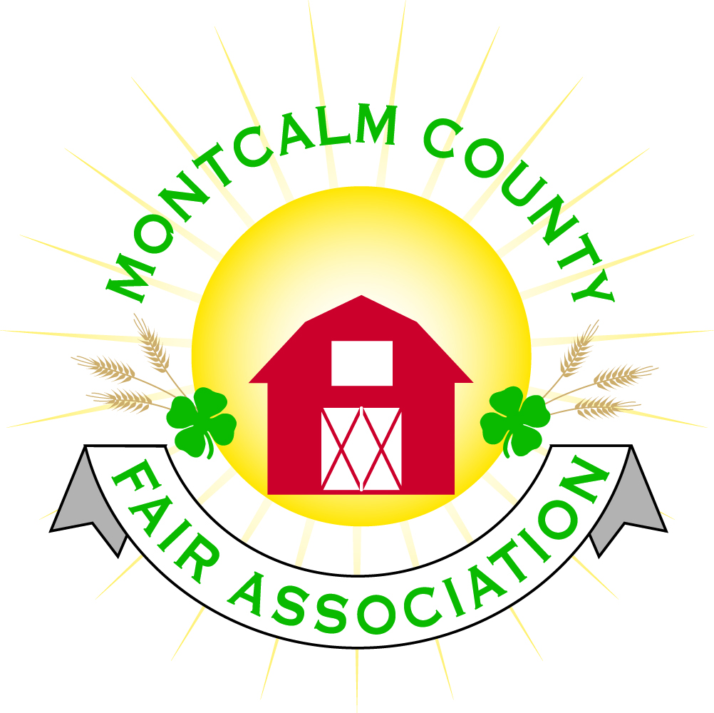
po box 513 • Greenville, MI 48838

Montcalm County Fair Association Board Meeting
April 5, 2020 via ZOOM teleconference

The meeting was called to order 7:03pm

Board members present were;
Melissa Eldridge, Lisa Johnson, Brad Heft, Tammi Jahnke, Jenn Senn, Shaun Hyde, Todd Hetherington, Becca Merrin, Amy Bell, Lisa Johnson, Lee Rasmussen, Mary Newman, Jason Nadeau, Cheryl Rosso, Heidi Brandt, Jennifer Senn
Absent: Mike Jensen
Others present were:
Tarin Minkel, Kim Thomsen. Mary Nitengale

Lengthy discussion regarding having fair during the pandemic. Discussed factors including MSUE’s decision to cancel in person events, what other fairs are doing, economics of having a fair with or potentially without spectators and grand stand events and how that will impact future fairs, economic impact on buyers and the livestock sale, potential impact on sponsorships, paring down the fair for this year, potential alternatives for the livestock sale and shows and if we can get market animals processed, and how this will impact our members and volunteers.

Motion to cut grandstand events for 2020 & move to 2021 by Jason, support Todd. Motion passes.
Todd will let them know. Lisa will talk to mini mods and tractors.

Board will reconvene in two weeks with committee chairs on Monday April 20 at 7pm via zoom. Melissa and Tarin will draft a statement to let people know that we’re working on a decision regarding fair.

Adjourn at 8:06pm

Respectfully Submitted,
Cheryl Rosso
Secretary

