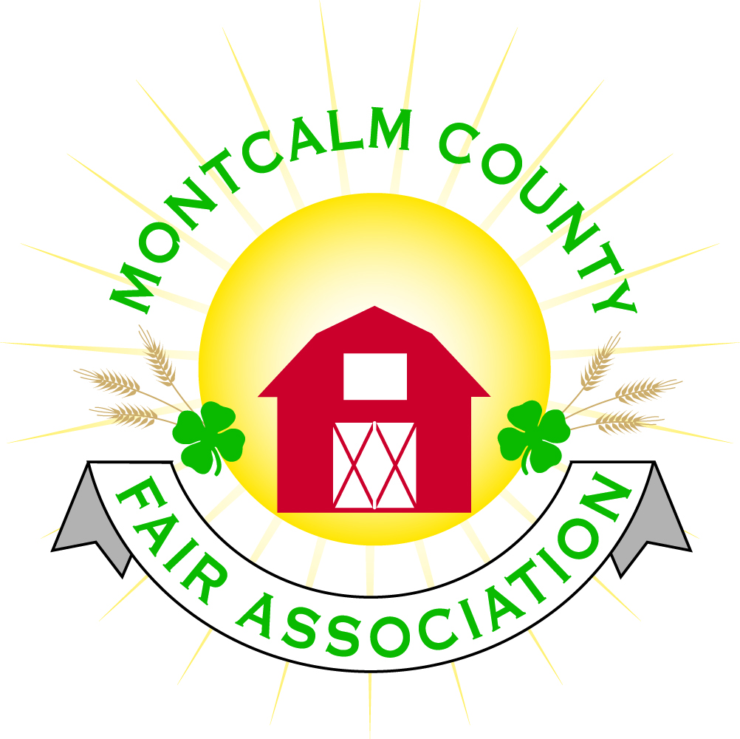
po box 513 • Greenville, MI 48838

Montcalm County Fair Association Board Meeting
May 4, 2020 via Zoom

The meeting was called to order at 7:02PM by Melissa Eldridge

Board members present were;
Melissa Eldridge, Becca Merren, Brad Heft, Lisa Johnson, Amy Bell, Mary Neuman, Jenn Senn, Tammy Jahnke, Carrie Harkness, Todd Hetherington, Jason Nadeau, Shaun Hyde, Cheryl Rosso
Guests & committee representatives: Deanna Garbow, Kim Thomsen, Melanie Rodenhouse, Garlicks, Cassie Newman, Kim Bunker, Heidi Brandt, Michelle Nitengale, Tarin Minkel

MAFE Report
  - Zoom zone meeting on April 30 (previous Thursday)
    - 4 fairs have cancelled.
    - Volunteers are not covered by insurance, as there is no 4H insurance like usual. Lisa will look into a policy to cover them.
    - Things owned by 4H at fairs cannot be used. In our case, this includes the scale and some equipment.
    - Limited availability of getting animals slaughtered/processed is an issue.

Fair Camping
- Has had inquiries (7) regarding fair camping
- One campsite has been refunded under the normal rule allowing a refund option until June 1
Motion by Todd Hetherington that if fair is cancelled, everyone is rolled over to 2021 camping, maintaining their current spot. Anyone who chooses to get a refund will be moved to the bottom of the list for 2021 camping.
2nd by Mary Neuman.
Discussion:
Reminder that refunds cost us money. We get $169 from PayPal payments, which is $6 less than the camping price of $175. Lisa writes a check for refunds. PayPal sweeps every 24 hours. Discussed changing policy to make refunds less fees.
Motion passes, no opposition.

Motion by Tammy Jahnke to amend camping policy to include a $10 convenience charge, so it reads “Refunds are less a $10 convenience fee for those using PayPal” beginning in 2021.
2nd by Cheryl Rosso.
No discussion.
Motion Passes, no opposition

Livestock Committee Report
  - Met Monday, April 27
  - Showorks
    - Emailed Showorks regarding fees. If we open registration, they will only refund our money if we don’t download the reports.
    - Looking at opening registrations at the end of May for one week.
  - Auctioneers
    - Committee has been in contact with our auctioneers. An online auction has been discussed and has had conversations with Sheridan Auction.
  - Virtual carcass class has been discussed. No final decision has been made.
  - If fair is canceled, would set up a system for kids who needed help finding buyers. Would set price for animals and connect kids to buyers.
  - Sages needs to know about carcass tonight. Space will be set aside for carcass class, but if we don’t have it, processing would be on a first come, first serve basis. Sages is booked into November for beef processing. Concern that there will not be enough spots for processing and it will need to be spaced out

Vendor Refunds
  - One vendor has asked for their deposit back.
  - Gazellas (food vendor) are willing to renegotiate contract.

4H Council-Kim Thomsen
Council meeting is May 5. Have not met since last fair board meeting.

Small Animals-Heidi Brandt
No meeting. Not many registrations yet.

Horse Committee-Melanie Rodenhouse
  - Discussed potential day haul-ins for shows
  - Horse leaders decided not to do Saturday classes (which are sponsored by the horse committee)
  - Asked if we would be still doing Sweepstakes on Saturday, and if we’d be ending on Friday instead of Saturday due to shows and sale being finished.

Other Business

- Volunteers: We need to know if key people who run the shows are coming to the fair.
- Committees need to decide how shows will run, what chore schedules will look like. Committees need to put those details together.

- Zoom meeting with fair board, superintendents, and committee reps with a realistic timeline, how to do social distancing, how to safely put on a fair. Melissa will coordinate and put together a document with guidelines ahead of the meeting.

- Livestock meeting is May 18.

- Horse leaders’ meetings are May 5 and 12.

- The food auction cannot happen, so the event needs to be canceled on Facebook. Jenn will take care of this.

- Livestock committee decided there will be no buyers’ meal this year.

- Water Testing

  - Will be getting this done later in May. The only place the water is currently on is the Ash Building.

Next Fair Board meeting is June 1, 7pm via Zoom.

Adjourned at 8:51pm.

Respectfully submitted,
Cheryl Rosso
Secretary

