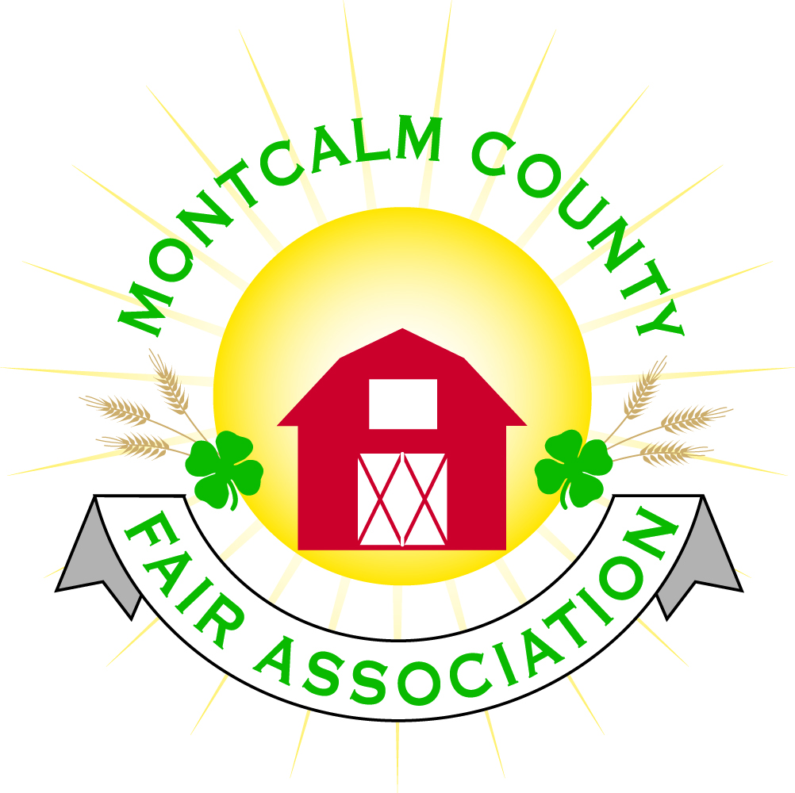
po box 513 • Greenville, MI 48838

Montcalm County Fair Association Special Meeting with committees and superintendents
May 17, 2020 via Zoom

The meeting was called to order by Melissa Eldridge

Present were: (in no particular order)
Melissa Eldridge, Becka Merren, Doug Uzelac, Cory Wall, Melanie Rodenhouse, Mary Newman, Heidi Brandt, Holly Esterling, Brad Heft, Tarin Minkel, Todd Hetherington, Michelle Nitengale, Laura Thompson, Lisa Johnson, Bo ______ (Lions Club), Jason Nadeau, Shaun Hyde, Kim Thomsen, Carrie Harkness, Rachelle Croy, Lee Thompson, Tammy Jahnke, Amy Bell, Sunni Haglund, Linda Petersen, Mike Jensen, Rory Eldridge, Jennifer Senn, Wendy Kareus, Ray Peterson, Brian Plank, Cheryl Rosso

Fair board President Melissa Eldridge said she would be calling the Health Department and Sheriff’s Department regarding holding the fair.
Livestock Committee Report:
- Plan A—Fair goes on as usual. Auctioneers are lined up for the sale.
- Plan B—No Fair, sale alternative.
  - Have talked to Sages, Ben’s Butcher Shop, and Jones’s regarding processing
  - Have to determine floor pricing and logistics. Payment will be run through the livestock committee; animals will be delivered to fair and distributed to processors over a span of weeks.
Tarin asked about setting up something on Facebook (page or group) as her office has been contacted by people interested in buying animals.

Horse Committee Report:
- No Saturday events at fair or Thursday Pro-Am
- Asked about doing day haul-ins
Small Animal Committee Report:
- Linda Petersen and Heidi Brandt (superintendents) will not be at the fair this year due to health concerns relating to COVID
- Barn is always crowded for small animal shows; not sure how to work out those logistics for social distancing. Committee will have to figure this out.
  - Additional discussion regarding potential places to move animals and/or shows
4H Council Report:
- Kim can do what is necessary in order to have showmanship sweepstakes contest, however, sweepstakes may be cancelled to do sanitary health concerns and lower exhibitor numbers
Dog Committee Report:
- Committee has decided to cancel the dog show for this year
Still Exhibits:
- Have volunteers to contact judges but are waiting
- Council has previously paid for judges’ meal, requested if fair board is willing to cover that cost
- Discussion regarding whether there was objection to condensing judging time while staying within social distancing guidelines
- Discussion regarding displaying items and limiting viewing hours
- Could potentially display exhibits virtually instead of in an enclosed space
Period of open discussion, including what other organizations are doing, spacing exhibitors, input from the Health Department, and current COVID restrictions, including festivals not being allowed to open until Phase 6 of the current plan.
- Report from discussion with Dr. Averill at MDARD
  - MDARD oversees animal health and food safety at county fairs
  - MAFE has sent a letter to the Governor’s office requesting a timeline for fairs and festivals to help in planning; an answer is expected Monday or Tuesday
Showorks Report
- May have issues with volunteers being able to attend fair
- Need a list of classes that are NOT happening so exhibitors don’t sign up for classes that aren’t happening
- Needs a commitment from the fair in order to pull class lists on June 2
  - If we never download the entries, we don’t pay for them
Performing Arts/Style Show Report:
- Discussion of logistics. Number of exhibitors will not be available until they enter via Showorks. May be able to do a virtual experience instead of in per
Awards Report
- Holly has an inventory of awards. Current ribbons say Montcalm County 4H Fair. Discussed potentially changing new ribbons to use Fair Association logo; setup fee is $35
- Action Awards is currently closed and unable to work with no firm reopening date. Normally takes 4-6 weeks to get awards, so there is a definite time concern
- No response from jacket vendor, not sure if they are open or not
- Estimate of $5,000 for awards, with opportunities to save money
Motion made by Todd Hetherington to not have awards this year. 2nd by Jennifer Senn. No discussion. Roll call vote, motion passes with no opposition
Water on Grounds
- Russell’s will need to do work on the bath house to un-winterize if/when we open it
- Sprinklers need to be turned on
Lions Club Report—Bo ______________
- Asked about protocol for allowing people (non exhibitors and their families) on the grounds
- Lions Club is concerned about sanitizing the fair grounds-common areas, touch points, etc.
- Asked if the board has talked to a lawyer regarding liability, potential lawsuit(s) is someone gets sick or injured
Motion made by Lisa Johnson to cancel the fair for 2020, but to allow the livestock committee to move forward with their Plan B for marketing livestock. 2nd by Cheryl Rosso.
No further discussion.
Roll call vote, motion passes 11-4 (*I counted Melissa in this count; this may be incorrect as per Robert’s Rules, the president’s vote only counts in the event of a tie)
Amy Bell announced her resignation from the board.
Adjourned meeting at 9:03pm

Respectfully submitted by Cheryl Strautz-Rosso, Secretary

Next Meeting Date – 6/1/20 7:00 PM via Zoom

