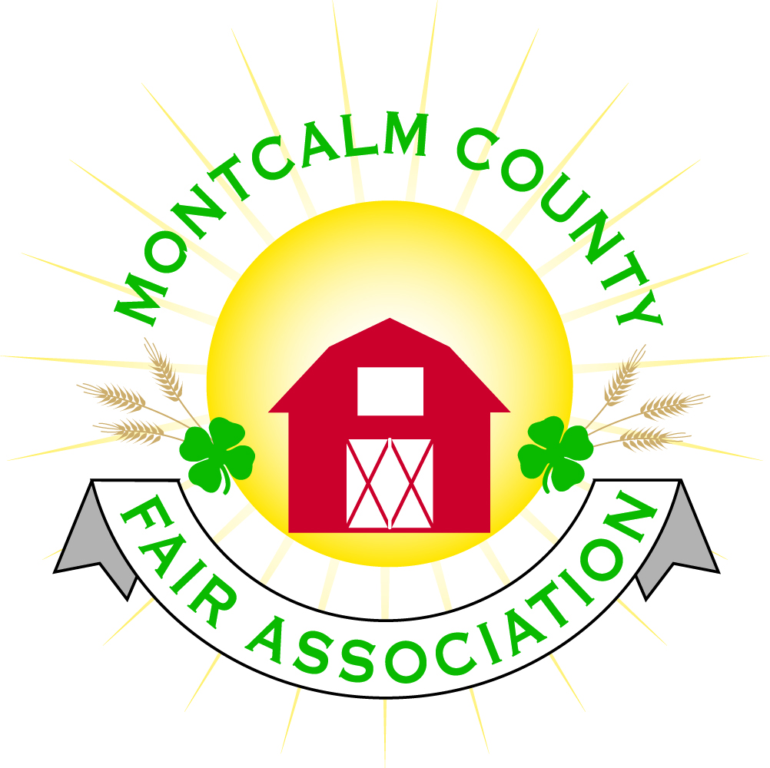
po box 513 • Greenville, MI 48838

Montcalm County Fair Association Board Meeting
June 1, 2020
via Zoom Virtual Meeting

The meeting was called to order by President Melissa Eldridge at 7:05 pm.

Board members present were;
Melissa Eldridge, Becka Merren, Shaun Hyde, Lisa Johnson, Brad Heft, Todd Hetherington, Jennifer Senn, Carrie Harkness, Tammi Jahnke, and Mary Newman

Absent:
Cheryl Rosso, Jason Nadeau, Mike Jensen & Lee Rasmussen

Others present were:
Tarin Minkel, Kim Thomsen, Michelle Nitengale, Brian Plank and Melanie Rodenhouse.

Melissa brought up during previous zoom meetings we didn’t always use roll call votes and it was confusing. She recommended that all votes tonight be done by asking each person’s vote so we can know for sure that the motions pass or fail.

Motion by Todd Hetherington, support by Mary Newman to approve the Secretary’s minutes from last four meetings (Regular Meeting April 5, 2020, Special Meeting April 20, 2020, Regular Meeting May 4, 2020 and Special Meeting May 17, 2020). Discussion followed regarding revisions of minutes. Motion failed to pass. Carrie Harkness offered to reach out to Cheryl Rosso to assist with revisions of minutes.
Motion by Carrie Harkness support by Todd Hetherington to put the financials as presented on file. Motion carried.

Extension Office:
Week of Fair:
- Livestock & Still Exhibit Judging videos – only Judges will see – still working on how to showcase.
- 4-Her of Year application deadline was today (June 1, 2020).
- 4-H Scholarships have been judged and decision will be made June 2, 2020, results on June 3, 2020.
- Michelle Nitengale reported on sale of livestock. The judging will be a carcass class using ultrasound and live weights. This is to be done on June 14, 23, 30 and July 1.
- Brian added that resale of Sheep and goats has been made available for the buyers who don’t want to have them processed.

Executive Committee:
- Nothing to report

Budget & Audit Committee:
- Nothing to report

Buildings, Grounds & Construction Committee:
- Request to have water turned on at fairgrounds, Lisa to contact Thompson’s and/or Russell’s.
- Fair Camping Report from Jennifer Senn:
- 13 refunds of electric sites
- 10 refunds of rustic sites
- 19 rustic site reservations that have not heard from
- 10 electric site reservations that have not heard from

Rental Committee:
- Discussion about opening up rental facilities and the addition of an Addendum to all rental contracts in reference to Covid-19 requirements and the Governor ‘s Executive Orders
- Motion made by Carrie Harkness to approve Addendum as drafted and open up fairground rental facilities effective immediately with Addendum added to all existing rental contracts and all new rental contracts. Support by Becka Merren. Motion passed.

Judges:
- Judges for Virtual Show being sought

Livestock/Agriculture – Bio-Security:
- Michelle Nitengale reported that one-third of livestock listed on virtual auction are sold. Would like Buyers completed by June 10, 2020.
- Buyers letters went out May 31, 2020
- Carcass class to be done by ultrasound
- Offering resale lambs/goats
- Lisa confirmed that we are insured for contagious disease

Concessions, Commercial Exhibits & Grandstand:
- Status of Vendor Contracts will have to be reviewed with Melanie Rodenhouse

Fairbook:
- Nothing to report

Showorks:
- Nothing to report

Awards/Trophies:
- Action Awards still closed

Marketing & Fundraising Committee:
- Nothing to report

New Business:
- None at this time

Meeting at 7:57pm

Respectfully submitted by Lisa Johnson & Tammi Jahnke, acting in absence of Cheryl Russo

Next Meeting Date – July 6, 7:00 PM

