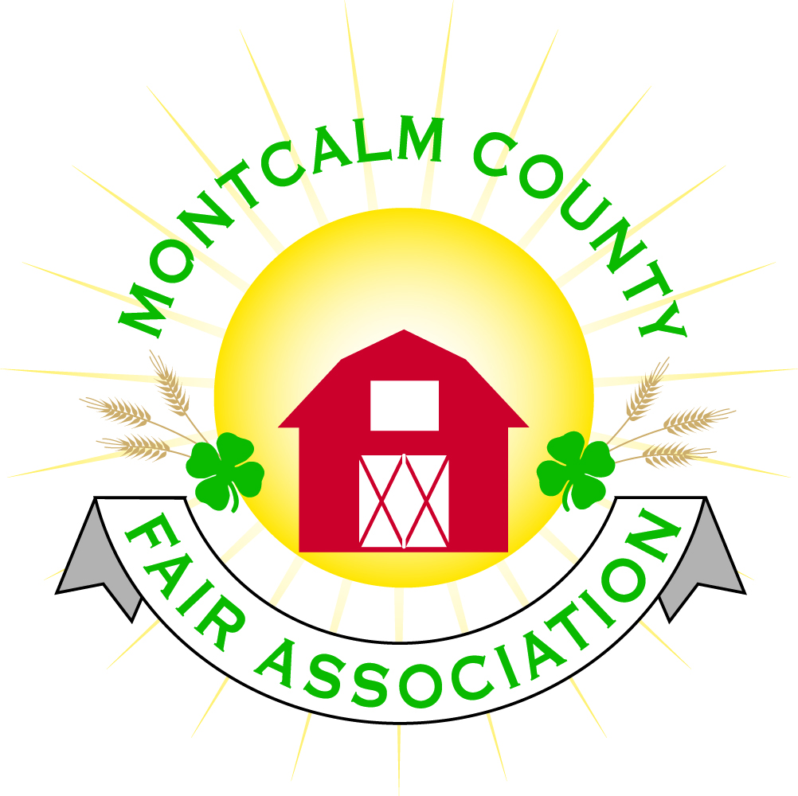
po box 513 • Greenville, MI 48838

Montcalm County Fair Association Board Meeting
September 8, 2020 Ash Building
Montcalm County Fairgrounds, Greenville, MI

The meeting was called to order at 7:07pm

Board members present were;
Melissa Eldridge, Lisa Johnson, Brad Heft, Tammi Jahnke, Jenn Senn, Shaun Hyde, Todd Hetherington, Becca Merrin, Amy Bell, Lisa Johnson, Mary Newman, Jason Nadeau
Absent: Lee Rasmussen, Mike Jensen
Others present were:
Brian Plank, Tarin Minkel (by phone for extension report)

Secretary’s Report: Distributed at meeting
Motion by 2nd to approve minutes, motion carried
Financial Report: July & August compilation. September is end of fiscal year. Note that premium account is actually the Square account. Lisa has talked to TCF Bank regarding mortgage rates.
Motion by Todd to place financials on file, 2nd by Shaun . Motion carried.

Guest Comments
- none

Extension Office:
- September 1 begins new program year.
- No face to face programming yet. No date yet when that will resume.
- Fall leader updates are coming. Tarin can give more information.
- 4H benefit auction is moving online in October.
- Re-enrollment time
  - Participation fee is waived for 2020
  - 4H Online is being updated and will be open in mid September.
- 4H newsletter being emailed tomorrow.

Executive Committee:
- 2 meetings since last board meeting
- Rentals & Rental Position to fill
  - Board has taken over Horse area rentals
  - Carrie Harkness will oversee rentals until the new position is filled.
  - Looking at other rental opportunities including livestock shows.
  - Re-evaluating job description, responsibilities, and possible funding sources for the position
  - There is potential for one full time employee plus an intern or part timer
- October 17—Winter Storage
  - $300 per unit, enough space for 25-26 units

Budget & Audit Committee:
- Some preliminary work is done toward budget, should be completed for October meeting

Buildings, Grounds & Construction Committee:
- Winterization is tentatively scheduled for October 24
- Front Sign
  - $1300 for new skin from Busy Bees. Lisa will get more quotes
- Discussed area around the pond and drainage issues

Rental Committee:
- Horse Area
  - Approximately $14,000 from 7 in rentals since June (with no advertising)
  - Lots of opportunity for more income
- Working on updating contracts for 2021
- Currently have a couple bookings for 2021 for both the horse area and Ash Building.

Judges:
- Email going out to committees

Livestock/Agriculture – Bio-Security:
- No livestock committee meeting last month, will be having one soon to elect officers

Concessions, Commercial Exhibits & Grandstand:
- None

Fairbook:
- Changes due October 1

Showorks:
- None

Awards/Trophies:
- None

Marketing & Fundraising Committee:
- None

Old Business:
- Annual Meeting
  - October 15 at 7pm
    - 5 positions to vote on, 3 are open positions
      - Motion by Cheryl to have an in person meeting at 7pm with no social hour at the fairgrounds to elect board members for 2020-2021. 2nd by Carrie, Motion Passes
    - Must be a member for at least 30 days prior to the annual meeting (membership received by September 15) in order to vote or run for open positions.

New Business:
- MAFE
  - Lisa received a call polling fairs to see if they’re willing to come to an in person MAFE meeting if they have it.
  - District Zone meeting via Zoom is October 14.

Adjourned meeting at 9:03 pm

Respectfully submitted by Cheryl Strautz-Rosso, Secretary

Next Meeting Date – 11/02/20 7:00 PM

