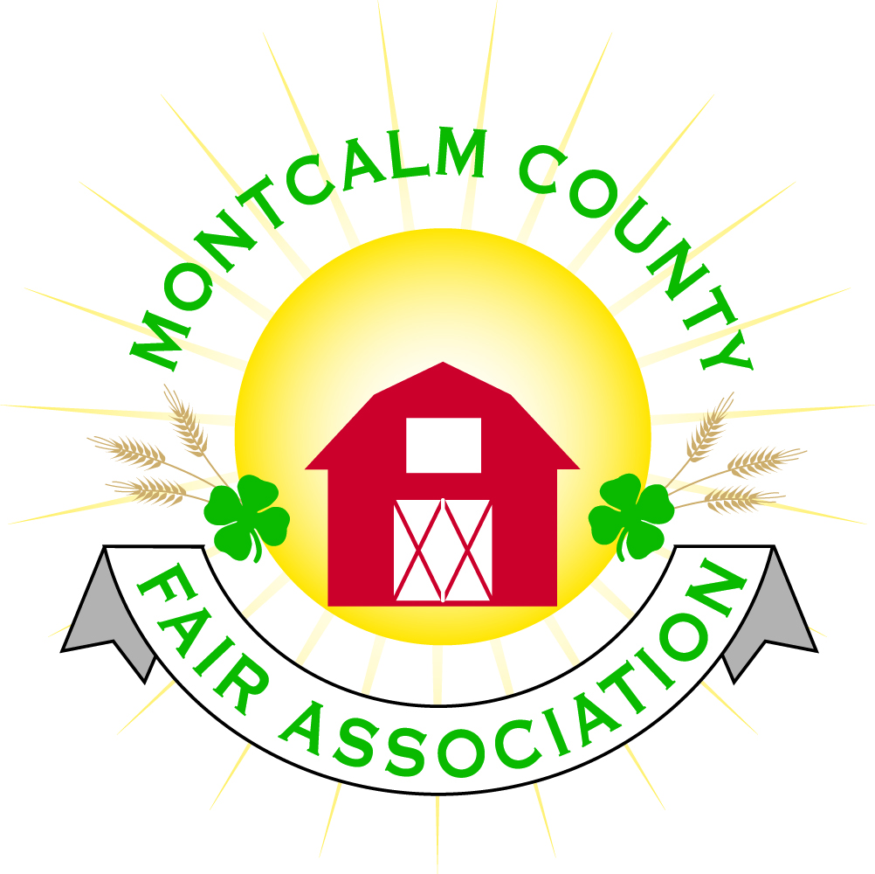
po box 513 • Greenville, MI 48838

Montcalm County Fair Association Board Meeting
October 5, 2020
Ash Building at Fairgrounds

The meeting was called to order by President Melissa Eldridge at 7:03 pm.

Board members present were;
Melissa Eldridge, Becka Merren, Shaun Hyde, Mike Jensen, Lisa Johnson, Brad Heft, Carrie Harkness, Todd Hetherington, Lee Rasmussen, Jason Nadeau, Tammi Jahnke, and Mary Newman

Absent:
Cheryl Rosso and Jennifer Senn.

Motion by Todd Hetherington, support by Shaun Hyde to approve the Secretary’s minutes of September 8, 2020. Motion passed.
Motion by Todd Hetherington support by Carrie Harkness to put the financials as presented on file. Discussion – Tammi Jahnke presented graphs to provide a comparison of the of the past two years and the pandemic effect on the association. Motion passed.

Extension Office:
- Fall Leader Update completed.
- The volunteer and member recognition broadcast is available on Facebook page.
- Annual pins and certificates are being mailed.
- Received fall flower bulbs and will be distributing them as well as putting together a virtual bulb workshop.
- Leader background check notices are going out to those needing to be updated.
- Although it is National 4-H Week there is not a lot that can be done to promote it during this time due to clubs being unable to have face-to-fact contact.
- Approximately 2/3rds of clubs have submitted their required annual paperwork to close out the 2019-2020 fiscal year.
- There is no participation fee required for the 2020-2021 4-H year.
- New/updated website for re-enrollments is available. Login remains the same. Contact office with any issues.
- Hoping to get a benefit auction done in October online.

Executive Committee:
- Nothing to report

Budget & Audit Committee:
- Lisa Johnson and Tammi Jahnke met on September 28, 2020 to finalize the 2019-2020 financials and begun working on the 2020-2021 budget. They will be meeting again in October in hopes of finalizing the budget.

Buildings, Grounds & Construction Committee:
- Carrie Harkness advised that the horse shows are completed for this year, the area is ready to be winterized and that she has 4-H kids available to clean the announcer’s booth.
- Fill is still being brought in to fill pond.
- Lisa has been putting tenants in line for RV storage as soon as she receives their payments. Will have to start a waiting list soon. Hoping to put RVs into storage on the 17th of October 2020 from 9am to 3pm.
- Goal set is to have storage emptied by the 10th of April 2021, by unanimous agreement of board members present.
- Todd Hetherington advised he will see that the winterization of the grounds and tractor get accomplished.
- Lee Rasmussen reminded us that the tractor needs a log book.
Rental Committee:
- 4-H Concession Stand is in need of specific rental contract.
- Booking rental dates for 2021 now, but Carrie is re-doing contracts and will have completed by December. Carrie is also working on a way to implement tracking procedures, “to do” lists for prepping arena and list of willing volunteers. (Note: 7-10 shows do not require arena prep).
- Identification will be required to operate tractor.
- Discussion as to when to allow horse arena/area rentals to begin in 2021. Unanimously agreed by board to offer dates available after April 30, 2021 due to uncertainties at this time of how weather may affect the ability to empty the RV storage in 2021.
- Lisa Johnson has been handling Ash Building rentals, postponements & refunds.

Judges:
- Carrie Harkness will reach out to the Horse Leaders regarding judges.
- Nothing further to report.

Livestock/Agriculture – Bio-Security:
- Becka Merren reported that slaughter dates at Sages have been set aside for our 2021 Livestock Sale in anticipation of Fair.
- In need of a Rabbits/Cavies Superintendent.

Concessions, Commercial Exhibits & Grandstand:
- Nothing new to report, contracts from 2020 have been held over to 2021.

Fairbook:
- Needs to be reviewed regarding changing dates, Covid-19 procedures, and any other changes with Michelle Nitengale.

Showorks:
- Need to follow up with Michelle Nitengale to see if she will continue doing.

Awards/Trophies:
- Nothing to report

Marketing & Fundraising Committee:
- Ideas shared by Lisa Johnson to sell permanent sponsorships to pig/sheep pens and beef stalls.
- Committee considering selling sponsorships for banners on show arenas (10 @ $300 to $400), also over rodeo gates.
- Committee exploring selling sponsored feather flags at the Entrance to Fairgrounds.

New Business:
- Discussion regarding upcoming Annual Association Meeting (October 15th) and ballots regarding election of 5 open positions on the Fair Board. So far there are 6 new candidates and 2 incumbents vying for a position.

Meeting at 9:06 pm

Respectfully submitted by Tammi Jahnke, acting in absence of Cheryl Russo

Next Meeting Date – November 2, 2020, 7:00 PM

