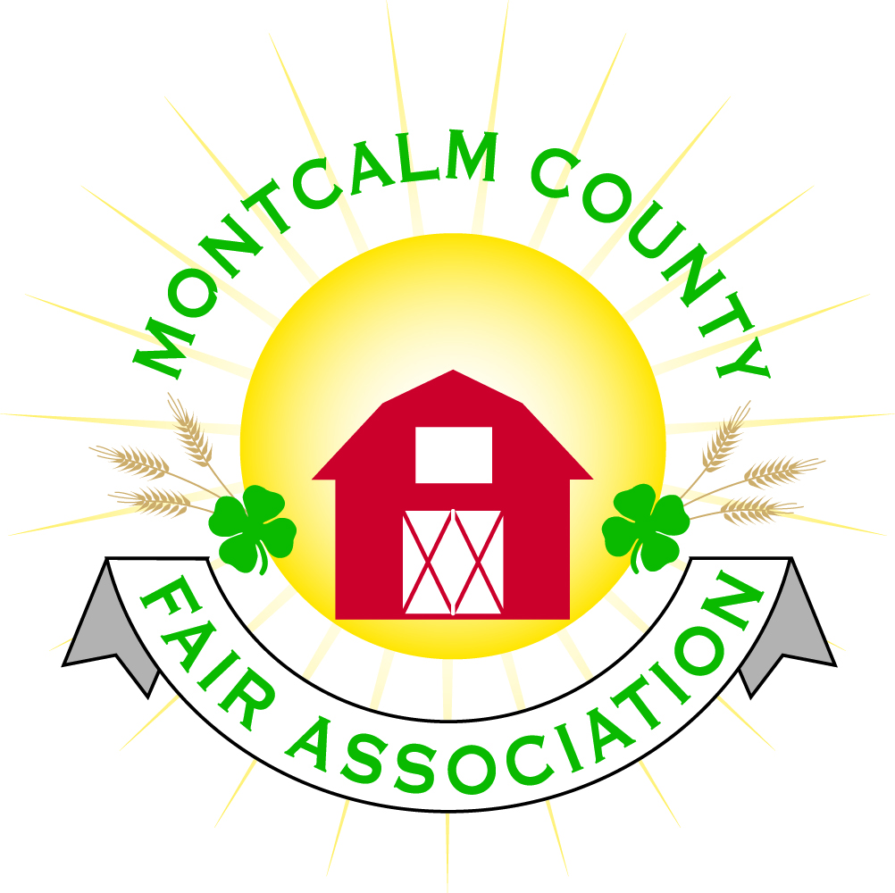
po box 513 • Greenville, MI 48838

Montcalm County Fair Association Board Meeting
4 January 2021
Montcalm County Fairgrounds, Greenville, MI

The meeting was called to order at 7:07pm by Todd Hetherington

Board members present:
Officers: President Todd Hetherington, 2nd Vice President Becka Merren, Treasurer Lisa Johnson, and Secretary Tammi Jahnke

Directors: Melissa Eldridge, Mary Newman, Brad Heft, Shaun Hyde and Amanda Wall.

Absent Officers: 1st Vice President Jason Nadeau
Absent Directors: Cliff Dickinson, Mike Jensen, Cheryl Rosso, , Amber Ryan, and Jenn Senn
Others present were:
Tarin Minkel on behalf of MSUE via phone

Secretary’s Report: Minutes distributed.
Motion by Lisa, support by Shaun to approve minutes. Motion carried
Financial Report:

Motion by Mary, support by Tammi to place financials on file. Motion carried.

Guest Comments
- None

Extension Office:
- Tarin Minkel provided board with MSUE Update
- Tarin is still working from home, putting together upcoming virtual workshops and project kits for youth to do at home.
- Workshop coming up on the 14th of January 2021 with Clinton County about Youth and Mental Health.
- Tarin will be instruction a Cooking Under Pressure Workshop in March 2021.
- There of lots of virtual events listed on the State Calendar for 2021.
- MSUE has formed a 4-H going back to Face-to-Fact Taskforce – awaiting an update.
- Reminder per the December 2020 MAFE newsletter, MDART no longer providing swine tags effective immediately, individuals must secure tags on their own through their farms/premises. Lisa will look into whether or not the fair has a premises ID to obtain tags.

Executive Committee:
- Met with the 4-H Horse Leaders and presented an audit of the Horse Rental Financial Account with two proposals for the 4-H Horse Leaders to discuss at their January 2021 meeting in hopes of reaching an agreement regarding the allocation of funds.

Budget & Audit Committee:
- Lisa still researching loan refinance for better rate(s) on our loan(s).

Buildings, Grounds & Construction Committee:
- Lisa advised temperature in Ash Building being set to 55 degrees & 50 degrees on East/West wings appears to be saving electric and usage/costs during non-use times. Schedule being put in place with Tammi, Becka & one other volunteer (to be determined) to check on building & verify furnace stays running, etc. during the week.
- Most Fair Camping rolled over to 2021, however, some that requested refunds have not cashed their refund checks. Lisa to follow-up and obtain a list of the ones who have opted to roll-over to 2021.
- Lisa reminded board of quarterly water testing procedures.

Rental Committee:
- No Rentals currently scheduled until February 4, 2021 and the amount of individuals interested in renting facilities as slowed down (due to Covid restrictions).
- Katie Johnson is still interested in helping with Rentals, but unable to meet in December 2020 due to Covid-19. A meeting with the Executive Board will be rescheduled.
- Todd will follow-up with Carrie Harkness regarding status of Horse Rentals as of her resignation in December 2020.
- Received a Thank-you from the Lion’s Club for use of the Ash Building for their Toys for Tots distribution in December 2020.
- Lisa and Tammi will not be available during Tax Season (January-April) to show the building to potential renters, so Rental Committee will need to put a back-up plan in place.
- Discontinued floor mat service until February & also dumpster service to save money.

Judges:
- Mary will follow-up with Cheryl to verify the proposal last month to use a lot of the same Judges that were scheduled for 2020 and obtain any additional judges needed.

Livestock/Agriculture – Bio-Security:
- Swine tags still an issue (See report from Extension Office above)
- No other new information to report
- Still in need of a Rabbit Superintendent.

Concessions, Commercial Exhibits & Grandstand:
- Still need to check to see if there are any carnivals available.
- Virtual MAFE and Hospitality discussions & opportunities are scheduled January 15th & 16th, 2021. There will be 5-6 representatives from our county in attendance.
- Mud Run might not be possible – dependent on Covid restrictions.
- Mini Mods would like to put on a show, have contacted Lisa.

Fairbook & Showorks
- Fairbook is online and there or no additional changes at this time. (Will look at addressing any Covid issues as Fair gets closer.)
- Showorks Michelle Nitengale continuing to head it up as of this time.

Awards/Trophies:
- Holly Esterling and Amber Ryan are working on this area. Upon discussion, it was decided a Fair Budget is needed first, due to the uncertainties we face this year.

Marketing & Fundraising Committee:
- Continued issue with constant Covid restrictions, committee members have not been able to approach anyone “in person” for sponsorship requests. Upon discussion it was decided that a Fair Budget is needed first.

Old Business:
- Continued discussion from December 2020 meeting regarding a back-up plan in case of government cancellation of Fair.
- Discussed using the Livestock’s 2020 plan to expand upon for all areas and incorporate ideas that some of the other fairs did around us such as showing off the trailer and one-day shows.
- Lisa to draft a Budget of the costs involved in hosting a 3-day and/or minimal Fair plan, with the youth showing out of trailers if necessary.
- Suggested that we initiate conversation with the Sheriff and Heath Departments (Montcalm/Mid-Michigan) regarding what might be required of us at Fair.
- Suggested that area neighbors be provided with complimentary parking and grandstand passes to the Fair 2021.

New Business:
- Brought to attention of the Board that Cliff Dickerson has missed 3 consecutive meetings (and did not attend November 2020 Meeting to be sworn in), per Bylaws missing 3 consecutive meetings is an automatic resignation. Todd to address the issue.
- Tammi requested permission to provide Secretary Minutes via email to the Committees with the request that the Fair Board Minutes (both approved and those pending approval) be shared at all Committee Meetings in an effort to strengthen the lines of communication between the Fair Board and its Committees. Motion by Melissa to go forward with Tammi’s request, Second by Mary. Motion passed.

Motion made by Mary to adjourn. Meeting adjourned at 8:56pm.

Respectfully submitted by Tammi Jahnke, Secretary

Next Meeting Date – 1 February 2021 at 7:00 PM
At Ash Building, Montcalm County Fairgrounds,
Greenville, Michigan
(Unless Covid restrictions require meeting via Zoom)

ALL Fair Committee Members and interested 4-H Volunteers/Members
are invited to attend.

