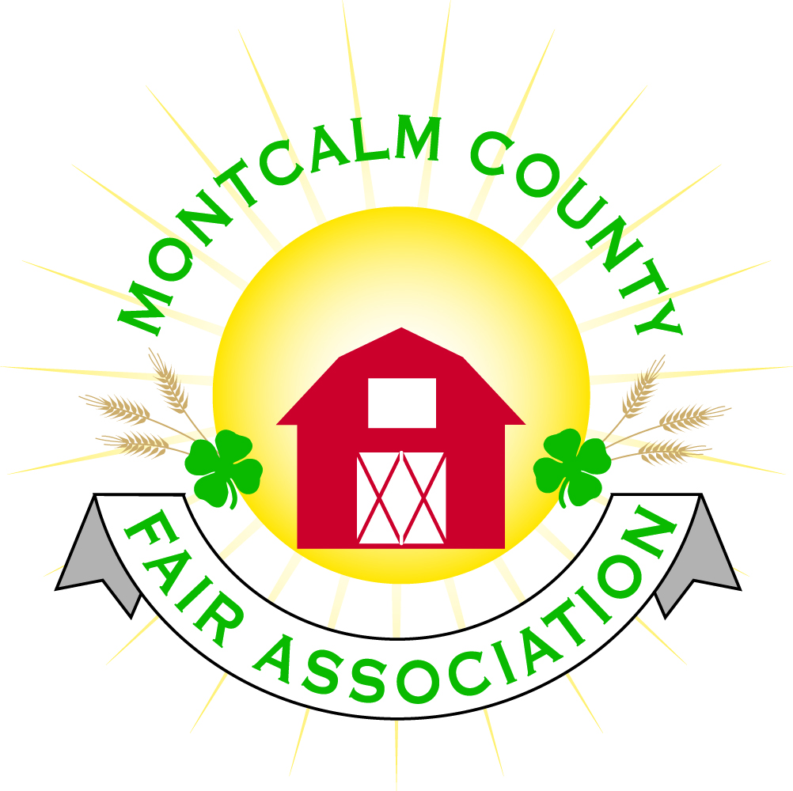
po box 513 • Greenville, MI 48838

Montcalm County Fair Association Board Meeting
1 March 2021
Montcalm County Fairgrounds, Greenville, MI

The meeting was called to order at 7:07 pm by Todd Hetherington

Board members present:
Officers: President Todd Hetherington, 1st Vice President Jason Nadeau (via Zoom), 2nd Vice President Becka Merren, Treasurer Lisa Johnson, and Secretary Tammi Jahnke
Directors: Melissa Eldridge (via Zoom), Mary Newman, Brad Heft, Amber Ryan, Doug Jackson (Via Zoom), Mike Jensen, Jennifer Senn, Shaun Hyde and Amanda Wall.
Absent Directors: Cheryl Russo
Others present:
Tarin Minkel on behalf of MSUE via Zoom
Guests: Nicki Chaffin and Michelle Nitengale (via Zoom)

Secretary’s Report: Minutes distributed.
Motion by Mary, support by Shaun to approve minutes. Motion carried. Minutes approved to be filed.
Financial Report: Distributed.

Motion by Shaun, support by Mike to place financials on file. Motion carried, financials approved to be placed on file.

Guest Comments
- None.

Extension Office:
- Tarin Minkel provided board with MSUE Update
- Tarin is still working from home, continuing to work on upcoming virtual workshops and project kits for youth to do at home, including virtual spring break activities.
- Still awaiting an update form the 4-H going back to Face-to-Fact Taskforce formed by MSUE.
- 9-10 kids participated in the first of the 3-part Animal Nutrition educational program.
- Melissa asked Tarin the status of 4-H member enrollment for this year. Tarin advised it is down in comparison to previous years by approximately 50 youth.

Executive Committee:
- Has not met.

Budget & Audit Committee:
- Has not met.

Buildings, Grounds & Construction Committee:
- Jenn proposed getting a quote to add electric and water to some of the rustic camp sites in an effort to apply for a grant that is available. Grant application is due the 15th of March 2021. Lisa to get 120 report to Melissa, so Melissa can attempt to apply for grant.

Rental Committee:
- Amanda Wall advised that per notes from Rachel from the 4-H Horse Committee, members of 4-H Horse Committee switched to form the MCFA Horse Agriculture Committee via vote. Said MCFA Horse Agriculture Committee to meet in March 2021 to complete fair plans, per Tarin.
- Amanda Wall also advised that the inventory has been completed of the horse area equipment and the 4-H Horse Committee has agreed to turn almost all of the equipment over to the MCFA. Equipment kept as property of the 4-H Horse Committee would be stored in the movable ribbon building.
- Brad provided the board with a report from Katie on the number of rentals currently scheduled for the rest of 2021.

Judges:
- Committee met before the February meeting, but still need to meet again per Mary.
- At the request of the 4-H Horse Committee, Melissa made a motion that the Judges Committee release a preliminary Judges List to the Chairperson of each committee as soon as available, support by Lisa. Motion passed.

Livestock/Agriculture – Bio-Security:
- Per Tarin a plan will need to be in place for the Health Department and possibility MAFE, for both humans (covid) and animals.
- Per Mary, a meeting is scheduled with Health Department members at the Ash Building on the 4th of March 2021 to create up to 3 plans for bio-security management. Becca will also attend. Goal is to develop plans and get out to parents and kids as soon as possible.
- Fair Board members that are working on the COVID-19 Back-up plan are- Becka Merren, Doug Jackson and Amanda Wall, and Mary Newman.

Concessions, Commercial Exhibits & Grandstand:
- Lisa needs to check on the vintage tractors.
- Sunday night event (deposit) carried forward to 2022.
- Mini-mods ready to go.
- Saturday even still on board.
- Rodeo is ready to go.
- Gazellas is also on board.
- Lisa has told concessions to send contract without deposit until we know more about status of fair.
- Lisa also had other new concessions contact her.

Fairbook & Showorks
- Michelle advised she has received 30-32 beef registrations. Tags being handed out at Livestock Ag Committee Meeting or can be obtained by coming to her house.
- Michelle also advised that Showorks is getting set up. Registration between May 15th and June 1st could shift. Needs some volunteers to assist her.

Awards/Trophies:
- Amber is working with Holly Esterling. Will be meeting in March 2021 in hopes of having order placed in April. Amber requested a budget amount for ribbons. Lisa advised it has been set at $5,000 for this year. Suggestion made to avoid putting a year 2021on awards as a precaution in the event Fair is canceled due to covid restriction, so awards could still be utilized in the future.

Marketing & Fundraising Committee:
- Lisa advised having a difficult time marketing without knowing what kind of fair we will be able to have.
- Canceled billboards last year, so we currently have 3 billboards reserved with a suspended payment (already paid for).
- Jason made a motion to not do any of the “Save the Date” billboards, but rather to just promote the fair with the June billboards that are already paid for. Support from Amber. Motion carried.

Old Business:
- Winter storage scheduled to come out of grounds on the 10th of April 2021. Lisa to send out notice now and again 2 weeks prior to the 10th of April.

New Business:
- No new business currently.

Motion made by Jason to adjourn. Support by Doug. Meeting adjourned at 8:15 pm.

Respectfully submitted by Tammi Jahnke, Secretary

Next Meeting Date – 5 April 2021 at 7:00 PM
At Ash Building, Montcalm County Fairgrounds,
Greenville, Michigan
(In Person and via Zoom if Covid Restrictions still in place)
ALL Fair Committee Members and interested 4-H Volunteers/Members
are invited to attend.

