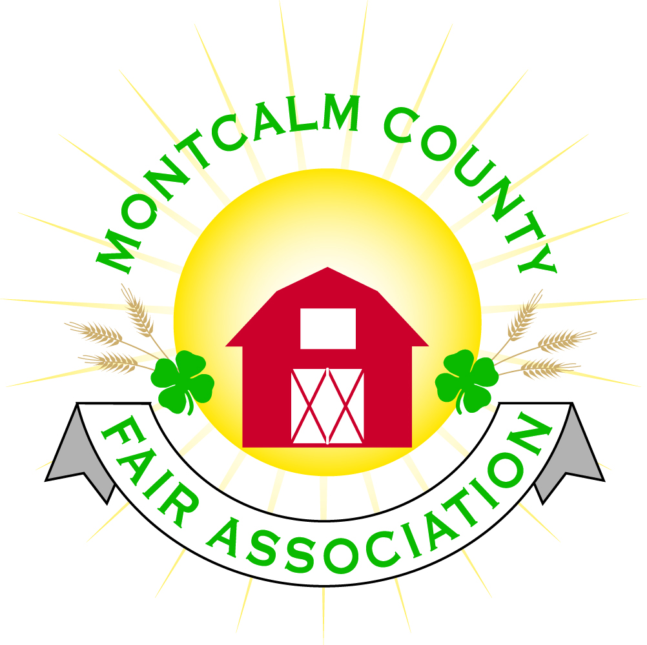
po box 513 • Greenville, MI 48838

Montcalm County Fair Association Board Meeting
5 April 2021
Montcalm County Fairgrounds, Greenville, MI

The meeting was called to order at 7:00 pm by Todd Hetherington

Board members present:
Officers: President Todd Hetherington, 1st Vice President Jason Nadeau, 2nd Vice President Becka Merren, Treasurer Lisa Johnson, and Secretary Tammi Jahnke
Directors: Melissa Eldridge (via Zoom), Mary Newman, Brad Heft, Amber Ryan, Doug Jackson (via Zoom), Mike Jensen, Cheryl Russo(via Zoom), Jennifer Senn, Shaun Hyde and Amanda Wall.

Others present were:
Tarin Minkel on behalf of MSUE via Zoom
Guests: Brian Plank (via Zoom), Rachel Croy(via Zoom), Joanne Dudenhofer, Dave Harper, Jackie Nadeau, Steve VanHolstyn, Joan Taylor, and Katie Johnson

Secretary’s Report:
Motion by Lisa Johnson to approve the 1 March 2021 Secretary’s Report with corrections as noted, support by Shawn Hyde to approve minutes. Motion carried.
Financial Report:

Lisa Johnson provided financial report and advised that money may need to be transferred from our “deposit” account to cover upcoming expenses. Currently have expenses of approximately $3,000 per month right now. Motion by Mike Jensen support by Jason Nadeau to place financial report on file. Motion carried, financials place on file.

Guest Comments
- Joanne Dudenhofer presented a potential Fair conflict regarding an upcoming Junior Equestrian Team Horse Show on the 26th of June 2021, which may affect at least 3 or more youth showing horses at our fair (5th grade through 8th graders potentially from Central Montcalm, Lakeview and Greenville per Tarin Minkel). Joanne requested the MCFA consider allowing the youth with horses involved be allowed to leave fair early (Friday night June 25, 2021). Rachel Croy suggested this be tabled until plans for fair week are more concrete. Todd Heatherington tabled discussion to a later date.
- Dave Harper on behalf of Poorman Pullers scheduled for Tuesday the 22nd of June 2021 and presented a contract for 2021. Motion to accept contract made by Amber Ryan, support by Becka Merren. Motion carried.

Extension Office:
- Tarin Minkel provided board with MSUE Update
- Tarin is still working from home
- Last week did alternative Spring Break – 3 events. Dropped off incubators to Central Montcalm to 3rd grade students. Offering a virtual fishing workshop in May 2021. Farm Safety Event through Farm Bureau with support of 4-H on April 22, 2021. Several upcoming virtual events and workshops are being offered.

Executive Committee:
- Did not meet.

Budget & Audit Committee:
- Did not meet.

Buildings, Grounds & Construction Committee:
- Lisa Johnson reported that remaining campers stored on grounds will be leaving here by Saturday, April 10, 2021. Several have already left.

Rental Committee:
- Brad Heft presented the Rental Committee Report. During March 2021 received a signed contract for January 2022. Katie Johnson met with many potential renters. Received a wedding cancellation for November 2021. Katie spent total of 5 hours cleaning the Ash Building. Rental Committee discussed changing the rental contract in regards to cancellations.

Judges:
- Cheryl Russo reported she has secured all of the horse judges. Scheduled a committee meeting next week, in person, on Thursday, April 8, 2021 at 5pm at Ash Building to work towards finalizing the remainder of Judges. Cheryl will provide list of horse judges to Rachelle Croy.
- Still Exhibit Judges – Kim Thomsen has a spreadsheet. Lisa Johnson will work with Kim to get the judges secured.

Livestock/Agriculture – Bio-Security:
- Mary Newman informed us that Kent County has 10 fish cleaning stations available which they have offered for our use during fair as hand washing stations, if we would like to utilize them.
- Bio-Security Committee reached out to various community leaders, including individuals associated with the health department, and developed a Covid-19 Safety Plan proposal, with 3 scenarios, to present to the board. County Sheriff, Mike Lamb, thought it was a wonderful idea we had the foresight to implement a plan and is willing to assist us.
- Current proposal is a guideline (Copy Attached to Minutes).
- Mary requests that each board member review it and share suggestions by Friday, April 9, 2021.
- The more events we can have outside this year at fair, the better.
- Steven D. VanHolstyn addressed the proposed Covid-19 Plan and advised we have challenges ahead of us, but he believes we are on track with our initial proposal. Steve offered that the Montcalm County Fire Association is willing to assist with sanitization at the Fair as needed.

Concessions, Commercial Exhibits & Grandstand:
- Lisa Johnson advised that representatives on behalf of the concessions, commercial exhibits and grandstand events have been in touch with her and are in the process of finalizing contracts.

Fairbook & Showorks
- 30 market beef, 14 market feeders, given out sheep, goats & swine tags. Registration will open up May 15th. (Per email from Michelle Nitengale and update from Lisa Johnson).

Awards/Trophies:
- Amber Ryan has not met with Holly Esterline, but will be meeting later this month.

Marketing & Fundraising Committee:
- Mary Newman has a potential donor that has contacted her offering to make a donation to assist us with fair. Mary suggested we use his donation for Covid signage.
- Lisa Johnson advised will be going forward on the 20th of April 2021 to secure sponsors.

Old Business:
- None.

New Business:
- Todd suggested that we should consider our Annual Food/Craft Auction be a Craft Only Auction this year. Melissa Eldridge made a motion to change the Annual Still Exhibits Auction to a “Still Exhibit Project Only/Non-Food Items Auction” with Departments 61, 66-Division 2, and 68 of the Fair Book being excluded from Auction, supported by Amber Ryan. Yeas – 11, Nays – 3, Abstain – 1. Motion passed.
- In place of Kids Day, Lisa Johnson has some suggestions for a couple of free shows, a magician, all social distanced for Kids throughout the week.

Motion made by Jason Nadeau to adjourn. Support Becka Merren. Meeting adjourned at 8:54 pm.

Respectfully submitted by Tammi Jahnke, Secretary

Next Meeting Date – 3 May 2021 at 7:00 PM
At Ash Building, Montcalm County Fairgrounds,
Greenville, Michigan
(In Person and via Zoom if Covid Restrictions still in place)
ALL Fair Committee Members and interested 4-H Volunteers/Members
are invited to attend.

