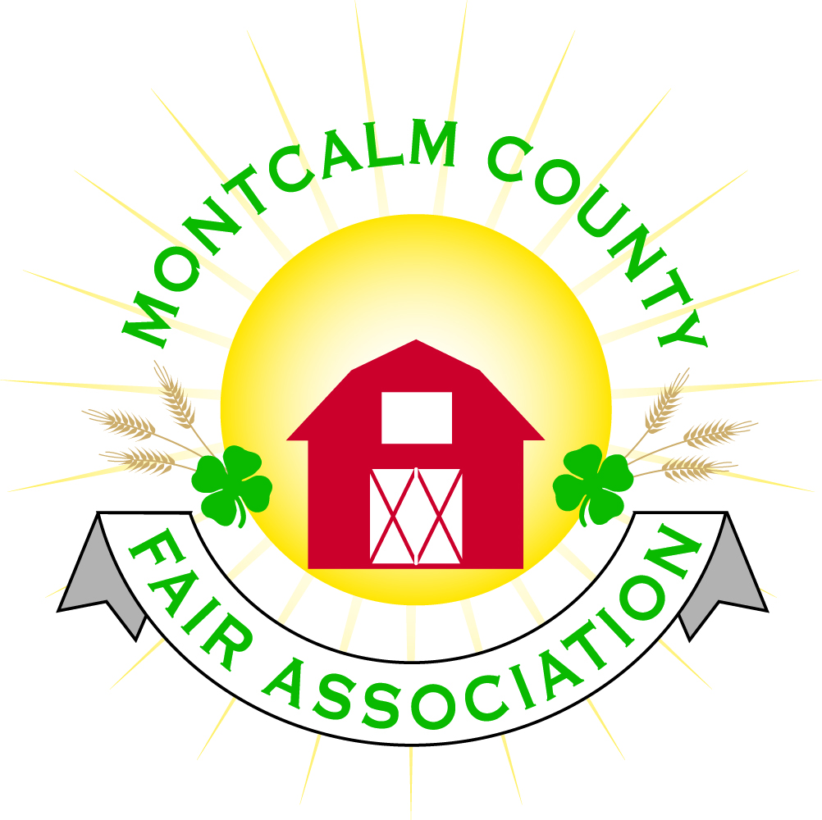
po box 513 • Greenville, MI 48838

Montcalm County Fair Association Board Meeting
25 May 2021
Montcalm County Fairgrounds, Greenville, MI

The meeting was called to order at 7:02 pm by Todd Hetherington

Board members present:
Officers: President Todd Hetherington, 1st Vice President Jason Nadeau, 2nd Vice President Becka Merren, Treasurer Lisa Johnson, and Secretary Tammi Jahnke

Directors: Mary Newman, Brad Heft, Doug Jackson, Jennifer Senn, Amanda Wall, Shaun Hyde, and Melissa Eldridge.

Directors Absent: Cheryl Rosso, Mike Jensen, and Amber Ryan

Others present were:
Katie Johnson – Rental Coordinator

Guests: Jackie Nadeau, Mary Gee, Ben Tacoma-Youth Pastor of Trinity Church, Tony Gerheiser of Red Cross, Philip Carstensen of Sheriff Dept., and Bob Halfix of Family Fun Tyme.

Guest Comments
- Philip Carstensen of the Montcalm Sheriff Dept advised that they would have their mobile unit set-up on the Fairgrounds during the week of fair and be available to assist as needed.
- Ben Tacoma, Youth Pastor of Trinity Church of Stanton, Michigan was introduced as a member of the non-profit organization willing to assist the fair with parking this year.
- Tony Gerheiser of the Red Cross brought a request to the fair board to host a Red Cross Blood Drive during the Summer 2021 and presented members with information. Jason Nadeau made a motion to partner with the Red Cross by allowing them use the Ash Building to host a blood drive Thursday, July 22, 2021 and Thursday, July 29, 2021. Seconded by Tammi Jahnke. Motion passed.
- Bob Halfix presented the fair board with the opportunity to contract with him to provide Family Fun Tyme carnival rides (wrist bands $20 per person) and 3 food booths for June 23rd from 3pm to 9pm, June 24th from 3pm to 9pm, June 25th from 12pm to 9pm (Kid’s Day special - wrist bands $15) and June 26th from 12pm to 9pm. Carnival would come into grounds on Monday and be ready to run by Wednesday. Lisa Johnson made a motion to sign a contract with Bob Halfix, Second by Melissa Eldridge. Motion passed.

Extension Office:
- Tarin Minkel’s employment ended May 21st. No replace has been hired yet, therefore no report.

Executive Committee:
- Did not meet.

Budget & Audit Committee:
- Did not meet.

Buildings, Grounds, Camping & Construction Committee:
- Melissa advised that the grant applied for this year was not approved by MDART.
- Jenn Senn updated everyone on the current camping reservations for fair.

Rental Committee:
- Katie Johnson reported on the rental activities to date for the month of May and those scheduled in the near future.

Judges:
- Mary Newman received a text from Cheryl Rosso that all the Judges have been secured except for a Dog Judge.

Livestock/Agriculture – Bio-Security:
- Covid Plan - Mary Newman advised that we still need to get our “point of contact” person chosen and in place.

Concessions, Commercial Exhibits & Grandstand:
- Still waiting to hear status of the Lion’s Club running the food booth and whether or not the Dairy Barn will be up and running at the fair.
- Carnival now in the works.
- Kid’s Day “free” activities are still being put together.

Fairbook & Showorks
- Showorks is now open for registrations until May 31st. Still Exhibits will only use Showorks to register for the Food/Craft Auction. The still exhibits will register the rest of their projects at the time of showing on Saturday, June 19th.
- It was discussed and decided that ALL Still Exhibits will be on display in the Ash Building during the week of Fair as normally done. Displayed by “project area” similar to open shows at various fairs. There will be no club booths. Superintendent Brad Heft and Tammi Jahnke will set up the display area on Friday June 18th at 6pm. Mary Newman offered some table cloths she has available. Volunteers to help Brad and Tammi would be welcomed.

Awards/Trophies:
- Lisa Johnson advised that we are still in need of additional sponsors and made copies of the Sponsor sheets available to everyone. She will also send out the sponsor sheet by email.
- Ribbons have been ordered with the fair logo in place of the 4-H clover, however, leftover ribbons will also be used.

Marketing & Fundraising Committee:
- Lisa Johnson advised we have received some sponsors, but are still looking for more and will be placing banners with sponsors information throughout the fairgrounds.
- Update (after meeting) Billboard person contacted Lisa and advised that although there are no billboards available (their mistake) we will receive a credit to carry forward and they will advertise our Fair on the electronic Billboard on US-131 near Comstock Park.

Old Business:
- Discussion was brought up regarding ending the Zoom Meetings due to lifting of Michigan Covid restrictions, as was defined in the Executive Board Meeting minutes implementing Zoom Meetings. Concern was expressed regarding MSUE’s former restrictions and the Program Coordinator being allowed to attend in-person meetings. That has now been altered by MSUE also. Motion made by Jason Nadeau to return to meetings in person and discontinue Zoom meetings. Second by Amanda Wall. Motion passed 9 yeas, 1 nay and 1 abstain.
- Fairgrounds clean-up days are scheduled for:
Sat. June 5th 10am to 1pm
Wed. June 9th 4pm to 7pm
Sun. June 13th 3pm to 6pm
As usual, Youth Exhibitors ages 8 and up are expected to perform a minimum of 2 hours assisting with clean-up. Jennifer Senn will post on our web page.

Motion made by Jason Nadeau to adjourn. Support Doug Jackson. Meeting adjourned at 9:15 pm.

Respectfully submitted by Tammi Jahnke, Secretary

Next Meeting Dates:
Regular Meeting - 7 June 2021 at 7:00 PM
At Ash Building, Montcalm County Fairgrounds,
Greenville, Michigan
ALL Fair Committee Members and interested 4-H Volunteers/Members
are invited to attend.

