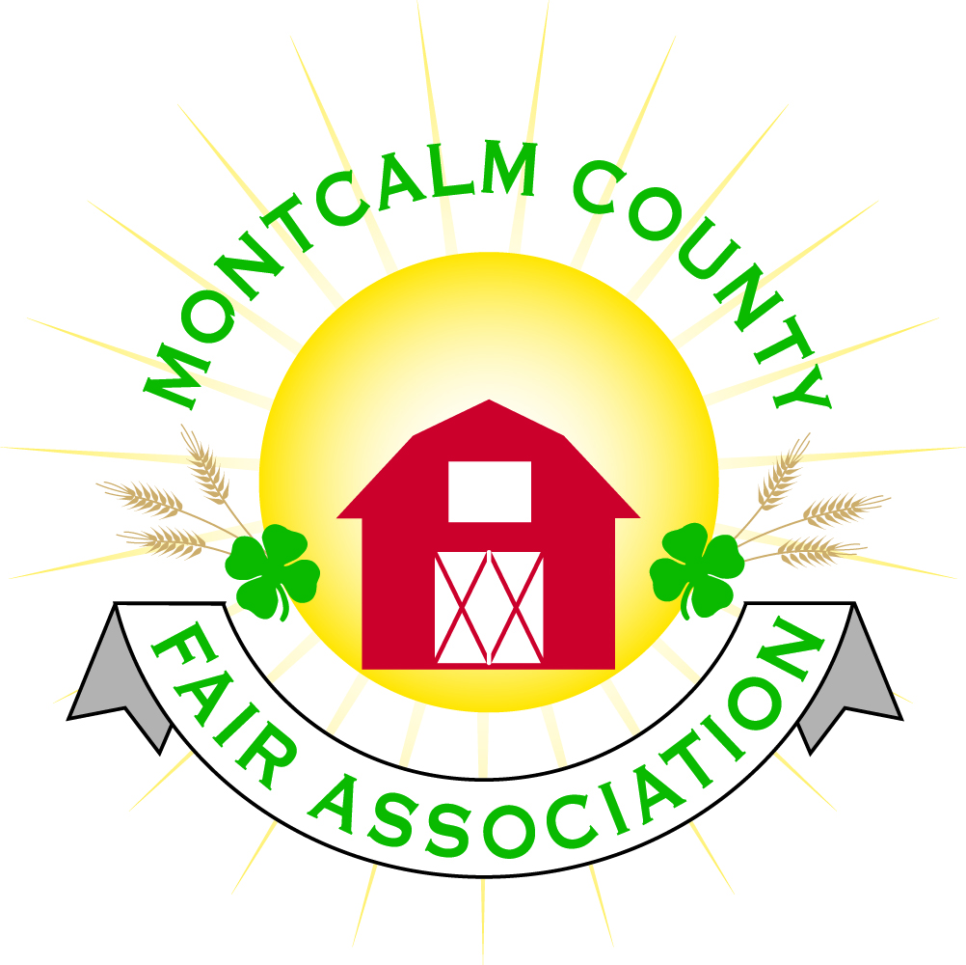
po box 513 • Greenville, MI 48838

Montcalm County Fair Association “Emergency” Board Meeting
25 June 2021 & 26 June 2021
Montcalm County Fairgrounds, Greenville, MI

Friday – 25 June 2021 Emergency Meeting Minutes

A “Emergency” Meeting was called to order on the 25th of June 2021 at 10:05 am by Todd Hetherington

Board members present:
Officers: President Todd Hetherington, 1st Vice President Jason Nadeau, Treasurer Lisa Johnson, and Secretary Tammi Jahnke

Directors: Melissa Eldridge, Shaun Hyde, Brad Heft, Amanda Wall, and Mike Jensen.

Emergency Fair Items Addressed:
- Due to weather the Demolition Derby scheduled for Saturday the 26th of June 2021 is canceling. However, they are will to do a show on Saturday the 9th of October 2021 to make up for it. Motion made by Amanda Wall to move the Demolition Derby to Saturday the 9th of October 2021, Second by Tammi Jahnke. Motion passed.
- Rodeo has contacted Lisa Johnson and advise they will continue to run per contract tonight (Friday the 25th of June 2021) rain or shine. Will only stop for a 15-minute delay in the case of lightening. Lisa Johnson advised that we have $6,500 in sponsorships to cover the cost of the Rodeo, so we have a potential loss of $5,500 unless we have spectators in attendance. Discussion regarding lowering the spectator fee to draw them in and help lessen the loss took place. Tammi Jahnke made a motion we lower the spectator fee to $10 adults, $5 ages 10 & under. Seconded by Mike Jensen. Motion passed. Also, decided that the East Road for Rodeo Participants’ parking would be shut down between 4 & 5pm.
- Lisa Johnson will check to see if we can get a discount on the Wheels of Agriculture cost if they leave the fair early.
- Notice will be made that Campers may leave their campers for up to a week if they wish to allow for the muddy sites and driveways to dry up some before attempting to pull them out.
- Jason Nadeau made a Motion to adjourn at 10:40am. Seconded by Shaun Hyde. Meeting adjourned.

A “Emergency” Meeting was called to order on the 25th of June 2021 at 4:45pm by Todd Hetherington

Board members present:
Officers: President Todd Hetherington, 1st Vice President Jason Nadeau, Treasurer Lisa Johnson, and Secretary Tammi Jahnke

Directors: Melissa Eldridge, Shaun Hyde, Brad Heft, Amanda Wall, Jennifer Senn and Mike Jensen.

Emergency Fair Items Addressed:
- Board was advised horse area is requesting to remove animals prior to the 6am release of animals on Sunday the 27th of June 2021. Motion by Jennifer Senn to reevaluate flooding of stalls/pens at 9am on Saturday the 26th of June 2021 regarding the early release of animals. For tonight the horse superintendent will be advised to allow the owners to move their animals to dry stalls as we have several empty dry stalls available that are not being used at fair this year. Second by Melissa Eldridge. Motion passed.
- Jason Nadeau moved to adjourn meeting at 5:15pm. Mike Jensen second. Meeting adjourned.

Saturday – 26 June 2021 Emergency Meeting Minutes

A “Emergency” Meeting was called to order on the 26th of June 2021 at 9:05 am by Todd Hetherington

Board members present:
Officers: President Todd Hetherington, 1st Vice President Jason Nadeau, 2nd Vice President Becka Merren, Treasurer Lisa Johnson, and Secretary Tammi Jahnke

Directors: Melissa Eldridge, Shaun Hyde, Mike Jensen, Brad Heft, Mary Newman, Amber Ryan, and Jennifer Senn.

Emergency Fair Items Addressed:
- Due to weather, the horse project area has requested that animals be released early. Tammi Jahnke advised that she and 3 others went through the horse barns to view the stalls of those complaining about wet stalls. 11 stalls were flooded on the North side of the North Barn and considered by them as unusable. All 11 except for 2 had moved their horses/tack to dryer stalls as was suggested yesterday. No motion was made to allow early release by any of the board members. Release remains at 6am on Sunday the 27th of June 2021.
- Demo Derby has already added October 9th to their schedule on their website and titled it “The Halloween Crash Bash” with tricker treating for kids.
- 4-H Community Connection Committee has requested that they be allowed to hold their Annual Fall Bake-Off that same date at the Fairgrounds.
- 4-H Dog Committee has requested that they be allowed to hold their annual fundraising event on the same date (already scheduled at fairgrounds) with the rental fee being waived.
- Lisa Johnson will talk to vendors and carnival about their availability also for the 9th of October and at our next regular board meeting we will discuss having a Fall Festival at the Fairgrounds on the 9th of October 2021.
- Discussion regarding issues at Rodeo with handicap access due to extreme mud took place. Melissa Eldridge made a motion that signs be posted throughout fairgrounds, handicap parking and campgrounds during fair week to say “If you need assistance to and from various events on the fairgrounds, please call (and list number)”. Mike Jensen seconded. Motion passed.
- Motion by Jason Nadeau to adjourn at 9:36am, Second by Becka Merren. Meeting adjourned.

Respectfully submitted by Tammi Jahnke, Secretary

Next Meeting Dates:
Regular Meeting – 12 July 2021 at 7:00 PM
At Ash Building, Montcalm County Fairgrounds,
Greenville, Michigan
ALL Fair Committee Members and interested 4-H Volunteers/Members
are invited to attend.

