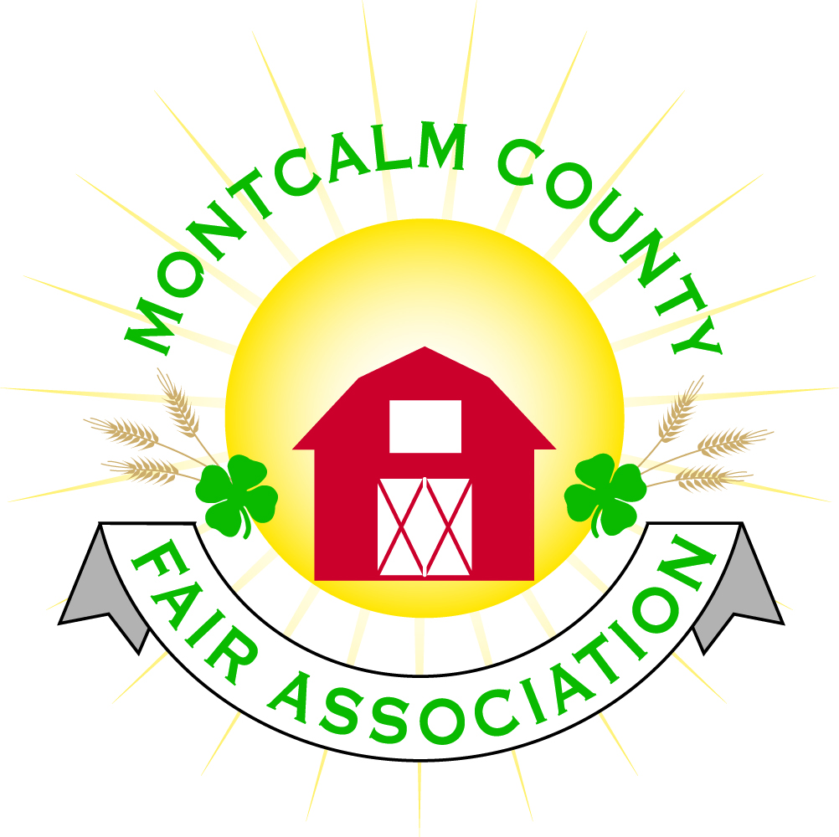
po box 513 • Greenville, MI 48838

Montcalm County Fair Association Board Meeting
12 July 2021
Montcalm County Fairgrounds, Greenville, MI

The meeting was called to order at 7:05pm by Todd Hetherington

Board members present:
Officers: President Todd Hetherington, 1st Vice President Jason Nadeau, 2nd Vice President Becka Merren, Treasurer Lisa Johnson, and Secretary Tammi Jahnke

Directors: Melissa Eldridge, Mary Newman, Brad Heft, Amanda Wall, and Amber Ryan.

Directors Absent: Mike Jensen, Doug Jackson, Jennifer Senn, and Shaun Hyde,

Guests: Mary Gee, Michelle Nitengale, Brian Plank and Jackie Nadeau

Secretary Minutes from 7 June 2021 presented by Tammi Jahnke. Motion to approve by Melissa Eldridge. Second by Mary Newman. Motion passed to place on file.

Secretary “Emergency Fair Meeting” Minutes from 25 June and 26 June 2021 presented by Tammi Jahnke. Motion to approve by Melissa Eldridge. Second by Amber Ryan. Motion passed to place on file.

Financials presented through the end of June 2021 by Treasurer Lisa Johnson with understanding that June 2021 is not completed. Motion to approve financials through the end of May 2021 by Tammi Jahnke. Second by Melissa Eldridge. Motion passed to place on file.

Guest Comments
- Brian Plank brought to the board an episode regarding a call he received to pick up 9 head of cattle. Discovered after the fact that the $25,000 cattle temporarily housed on his property had zero insurance on them and that $280K cattle in the livestock sale had zero insurance on them. Lisa contacted our insurance provider 10 days prior to fair to set up policy through Hartford and didn’t hear back from them. By the time she heard back it was too late to set up the policy because it was fully canceled in 2020 (due to no fair), so per the agent it could not be a renewal of policy, but had to be a brand-new policy and there was not enough time to obtain it. Going forward this issue has to be addressed well in advance of the 2022 Fair.

Extension Office:
- Do not have a Program Coordinator yet.
- Michelle Nitengale advised that 1st set of interviews have been done, second interviews scheduled for next week (20 July) with a September 2021 start date. Tracking how long we are without a PC so that millage money is extended to equal that time period.

Executive Committee:
- Did not meet.

Budget & Audit Committee:
- Did not meet.
- Need to review the P&L by Class re: Livestock totals to date at request of Michelle Nitengale.
- Still Exhibit Auction money still needs to be classified.

Buildings, Grounds, Camping & Construction Committee:
- Melissa Eldridge spoke with Kim Thomson about a committee to address our handicap accessibility issue. Kim volunteered to sit on that committee. Committee to be added to Buildings & Grounds as a subcommittee and Melissa will take charge of putting it together. Michelle Nitengale and Mary Newman also volunteered to assist.
- Entrance to the hill by grandstand has severe ruts from the mud/soft ground due to rain at rodeo that needs to be addressed per Lisa Johnson.
- Arena roof needs attention per Brian Plank as leaking caused an issue with the internet cables during Fair.

Rental Committee:
- Mary Gee brought up that we should advertise Ash Building Rental dates available.
- Katie’s report via Brad Heft: During the month of June, we started off with an Open House in the Lobby area, MHSRA Horse Show and a Wedding. We also started the Month of July with the NBHA Show. Katie cleaned for the month of June as there was quite a bit that went into getting the bath house ready for both the Horse Shows and Fair, cleaning the Announcer’s Booth and Ash Building. Katie ordered “No Smoking” stickers for the doors. She has 1 signed contract for a 2021 Wedding. Has had quite a few potential renters interested in touring the grounds and was added by Jennifer Senn to the Facebook page to be able to put information out on it.

Judges:
- No new reports

Livestock/Agriculture – Bio-Security:
- See Guest Comments above.

Concessions, Commercial Exhibits & Grandstand:
- Per Lisa Magician moved to 2022 (did not perform due to weather in 2021)
- Carnival and Food Vendors are considering coming back on the 9th of October 2021 per Lisa.

Fairbook & Showorks
- Melissa proposed that we find some type of an Event App to get information out to attendees at fair and use our contact information from Showorks to make those contacts.
- Deadline to make changes for changes is October 1st.
- Michelle Nitengale auction sale of $306,112 – 250 animals went through the auction sale ring. 120 buyers, 43 add-ons, approx. $35K in payments outstanding. Goal is to have checks ready by next livestock meeting.

Awards/Trophies:
- Committee has not met.

Marketing, Website & Fundraising Committee:
- Lisa brought up building a new website.

Old Business:

New Business:
- Motion Jason to hold a Fall Crash Bash Weekend October 8th & 9th. Further plans to be developed by Fair Board. Second by Becca. Motion carried.
- Amber Ryan made a motion to allow the 4-H CCC to do their Annual Fall Bake-Off and put together an Adult Cooking Contest; and Dog Committee to hold their Doggie Dash Fundraiser during the Fall Crash Bash at no rental charge. Mary Newman 2nd. Motion carried.

Motion made by Jason. Support by Mary. Meeting adjourned at 8.46 pm.

Respectfully submitted by Tammi Jahnke, Secretary

Next Meeting Dates:
Regular Meeting – 2 August 2021 at 7:00 PM
At Ash Building, Montcalm County Fairgrounds,
Greenville, Michigan
ALL Fair Committee Members and interested 4-H Volunteers/Members
are invited to attend.

