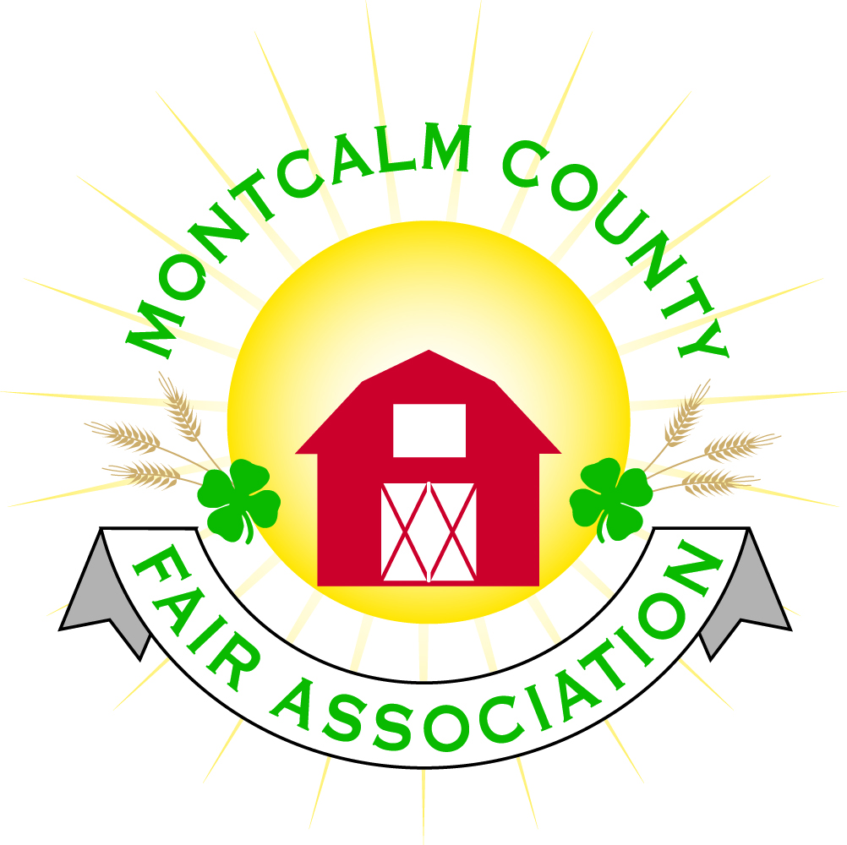
po box 513 • Greenville, MI 48838

Montcalm County Fair Association Board Meeting
2 August 2021
Montcalm County Fairgrounds, Greenville, MI

The meeting was called to order at 7:03 pm by Todd Hetherington

Board members present:
Officers: President Todd Hetherington, 1st Vice President Jason Nadeau, 2nd Vice President Becka Merren, Treasurer Lisa Johnson, and Secretary Tammi Jahnke

Directors: Melissa Eldridge, Mary Newman, Brad Heft, Doug Jackson, Jennifer Senn, Amanda Wall, and Shaun Hyde

Directors Absent: Cheryl Rosso, Mike Jensen, and Amber Ryan.

Others present were:
Katie Johnson – Rental Coordinator

Guests: Jackie Nadeau, Mary Gee and Kim Pennock.

Secretary Minutes from July 2021 presented by Tammi Jahnke. Motion to approve made by Melissa Eldridge. Second by Mary Newman. Motion passed to place minutes on file.

Financials presented through the end of June 2021 by Treasurer Lisa Johnson. Motion to approve financials through the end of June 2021 by Jason Nadeau. Second by Shaun Hyde. Motion passed to place financials on file.

Guest Comments
- Kim Pennock from 4-H CCC to update on Bake-Off and Cook-Off planned for October 9, 2021 during Fall Crash Bash.

Extension Office:
- No report. No Program Coordinator at current time.

Executive Committee:
- Met 2 August 2021 at 6pm. prior to regular meeting of the Board of Directors, to set nominating committee. Need to set annual meeting date and have approved by Board of Directors.
- Lisa brought up the livestock account issue that was discovered in the checking account.

Budget & Audit Committee:
- Met on July 30, 2021. Reviewed the Food/Craft Auction results and provided a spreadsheet to Directors.

Buildings, Grounds, Camping & Construction Committee:
- Melissa Eldridge advised that the new Accessibility Committee met (Mary Newman, Kim Thomsen & Melissa). Kim Thomsen approached Brian Gardner for information about the Gratiot County Fair’s accessibility plan, which was funded with a grant, donations and fair funds. Their plan appeared to be less than $20,000 to complete. Melissa and Mary reviewed accessibility of the fairgrounds with Kim to see where her wheelchair could and could not travel, then began a draft of a plan to improve accessibility. Next step is that they will take plan to other committees for input.

Rental Committee:
- Katie Johnson reported on the rental activities to date for the month of July 2021: 3 weddings, 2 horse shows, Apex meeting, Red Cross Blood Drive, and performed 7 hours of cleaning. Met with 2 potential renters. No new contracts signed. Suggestion made to have a booth set up at the Crash Bash Event to promote rentals of the Ash Building.
- Horse Event this past weekend, issue with locked out of announcer’s booth, key missing. Have one spare key. Katie to make a few copies of it and give to the fair office. Danish Festival email receive asking if we would like any advertising.
- Brad Heft held a Rental Rommittee meeting on July 21st. Discussed painting in the Ash Building. Looking for volunteers to assist. Still need to check on the estimated cost.
- Melissa Eldridge made a motion to allow Katie Johnson a $250 budget for promotion of our rental facilities and events (such as upcoming Fall Crash Bash). Seconded by Tammi Jahnke. Motion passed.

Judges:
- No report. Judge suggestions for 2022 Fair need to be submitted by the 1st of November 2021.

Livestock/Agriculture – Bio-Security:
- Shaun Hyde advised African Swine Flu found in Dominion Republic.
- No other report.

Concessions, Commercial Exhibits & Grandstand:
- Lisa Johnson advised that we need volunteers for parking and ticket sales on the 9th of October 2021.
- Lisa Johnson also advised that we are still awaiting confirmation from Carnival for Fall Crash Bash and (maybe) Fair 2022 as of this date.
- Two of our regular food vendors are interested in participating in the Fall Crash Bash Weekend.
- Mary Newman made a Motion to put Katie Johnson in charge of the Fall Crash Bash organization on a commission basis of 15% commission from the events she is able to coordinate. Also, to secure some additional sponsorships for advertising (vinyl signs??). Second by Jason Nadeau. Motion carried.

Fairbook & Showorks
- Fairbook changes are Due by the 1st of October 2021.

Awards/Trophies:
- No report

Marketing & Fundraising Committee:
- Lisa Johnson is working on quotes to design a new website.
- Committee will rehang Fair Sponsor signs for the Fall Crash Bash (that sponsored the Fair) and Katie Johnson will search for more sponsors.

Old Business:
- Fall Crash Bash plans already discussed above.

New Business:
- Fall Crash Bash Meetings will be called by Katie as needed.
- Motion by Tammi Jahnke to set the Annual Meeting date for the 21st of October 2021 at 6pm dinner, 7pm meeting. Second by Shaun Hyde. Motion passed.
- Motion made by Mary Newman to move our September 2021 meeting to the 30th of August 2021 at 7pm. Second by Amanda Wall. Motion passed.
- Motion made by Amanda Wall to set the 2022 Fair dates for June 19 through June 25. Second by Jennifer Senn. Motion carried. Melissa Eldridge volunteered to advise the MSUE office and get a request out to the 4-H clubs for suggestions of Fair Themes to be submitted by October 25, 2021.
- Nominating Committee appointments made by Todd Heatherington are: Jackie Nadeau, Mary Newman, and Doug Jackson. September 21st is the deadline for nominations. Nominations must also be a “paid” MCFA Member by the 21st of September 2021. Motion passed.

Motion made by Jason Nadeau to adjourn. Support by Becka Merren. Meeting adjourned at 9:27 pm.

Respectfully submitted by Tammi Jahnke, Secretary

Next Meeting Dates:
Regular Meeting – 30 August 2021 at 7:00 PM
At Ash Building, Montcalm County Fairgrounds,
Greenville, Michigan
ALL Fair Committee Members and interested 4-H Volunteers/Members
are invited to attend.

