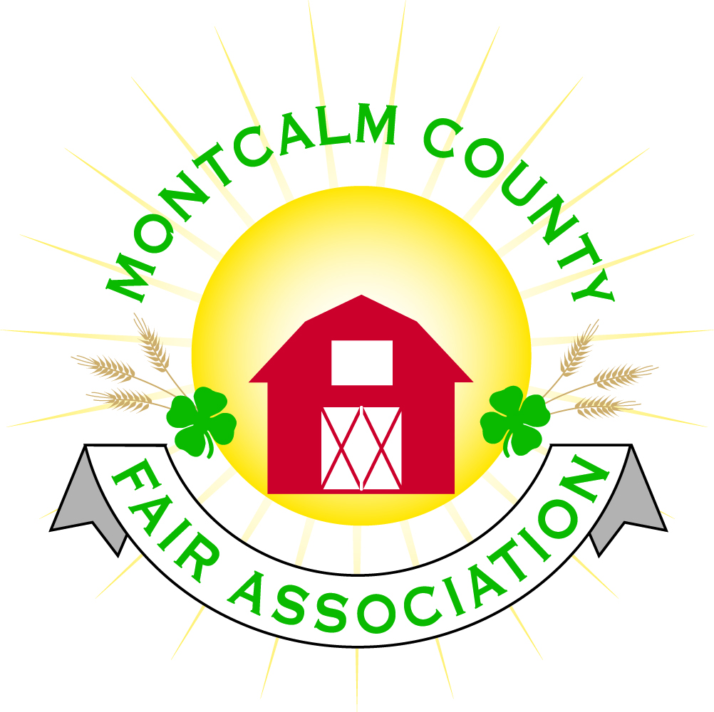
po box 513 • Greenville, MI 48838

Montcalm County Fair Association Board Meeting
30 August 2021
Montcalm County Fairgrounds, Greenville, MI

The meeting was called to order at 7:02 pm by Todd Hetherington

Board members present:
Officers: President Todd Hetherington, 1st Vice President Jason Nadeau, 2nd Vice President Becka Merren, Treasurer Lisa Johnson, and Secretary Tammi Jahnke

Directors: Melissa Eldridge, Mary Newman, Brad Heft, Doug Jackson, Jennifer Senn, and Mike Jensen.

Directors Absent:
Shaun Hyde, Cheryl Rosso, Amber Ryan, and Amanda Wall

Others present were:
Katie Johnson – Rental Coordinator

Guests:
Mary Gee, Jackie Nadeau, and Kimberly Pennock.

Secretary Executive Board Minutes from 2 August 2021 presented by Tammi Jahnke. Motion to approve made by Jason Nadeau. Second by Lisa Johnson. Motion passed to place minutes on file.
Secretary Minutes from August 2021 presented by Tammi Jahnke. Motion to approve made by Melissa Eldridge. Second by Lisa Johnson.

Financials presented through the end of July 2021 by Treasurer Lisa Johnson. Motion to approve financials through the end of July 2021 by Mike Jensen. Second by Jason Nadeau. Motion passed to place financials on file.

Guest Comments
- None

Extension Office:
- No Program Coordinator available until October 2021

Executive Committee:
- Has not met since 2 August 2021.

Budget & Audit Committee:
- Lisa Johnson and Tammi Jahnke met the 25th August 2021. Worked on preparing for October Audit (need another member to join committee for audit). Prepared for the Annual Meeting. Provided Mary with spread sheets for securing nominations.
- Discussion on separating Livestock Accounts in QuickBooks from MCFA for Balance Sheet & Profit/Loss documentation purposes effective the 2021-22 financial year. Motion by Doug Jackson to allow separation of QuickBooks accounts. Second by Becka Merren. Motion passed.

Buildings, Grounds, Camping & Construction Committee:
- Todd Hetherington advised that we need a campground clean-up following recent storm. First row (west side) – pick up debris. Ross has advised he will cut up anything that requires use of a chainsaw to clear but will still require help to remove. Large debris mostly on the east side. A campground clean-up is scheduled for 12 September 2021 from 11am to 1pm per Jason Nadeau. Doug Jackson volunteered to bring in dump trailer and coordinate with Jason prior to the next horse show (September 10-11).

Rental Committee:
- Katie Johnson reported on the rental activities to date for the month of August 2021: 3 weddings, 2 horse shows – all went well. Two campers at Danish Festival were here camping.
- Katie Johnson received a suggestion that metal horse barrels be replaced. Carrie Harkness checking into some replacements. (IBRA is required to use metal.)
- Hot water in bath house showers was not working properly – Lisa Johnson to follow up on.
- There was a theft of cards at a recent wedding, so question as to whether we need to look at turning on security cameras (unhooked currently due to an internet issue).
- Complaint about the flower beds looking like weeds. Melissa Eldridge to obtain and place Master Gardner’s signs, so it’s better understood to those viewing the flower bed that this is a habitat designed for the benefit of insects and wildlife.

Judges:
- Deadline to turn in information for 2022 Judges is 1 November 2021.

Livestock/Agriculture – Bio-Security:
- Shaun Hyde absent – No report.
Concessions, Commercial Exhibits & Grandstand:
- See Fall Crash Bash information below.

Fairbook & Showorks
- Deadline for changes to Fairbook is 1 October 2021.

Awards/Trophies:
- No report.

Marketing, Website, & Fundraising Committee:
- Lisa Johnson and Tammi Jahnke shared information received from Gordon Taylor at Just Smart Guys (associate of Red Beard Computer Repair – Tyler Colman) for website. Tammi forwarded email and quote to all directors for review and comparison.
- Jennifer Senn is working on an additional quote for website.

Old Business:
- Fair Themes are due 25 October 2021.

Fall Crash Bash:
- Katie Johnson requested approval of Weaver Farms Petting Zoo for Fall Crash Bash at $50 per hour – booking for 3 hours, 11am to 2pm on 9 October 2021. Motion to approve by Melissa Eldridge. Second by Mary Newman. Motion passed.
- Katie Johnson also requested approval to spend $25 on a liquor permit for 9 October 2021, Wine, Cider & Beer Tasting. Motion to pay by Jason Nadeau, Second by Tammi Jahnke. Motion passed.
- Agreed that Parking is $5 for the day (same as Fair), passes will be available per Lisa Johnson.
- 4 Food trucks – Katie Johnson has secured Big Reds BBQ and Brick Oven Pizza, Lisa Johnson advised that Dryes and Gazzellas (who got rained out at fair) will also be attending Fall Crash Bash.
- Demo Derby is planning on being completed by dark per Lisa Johnson.
- Lisa Johnson did receive a response from the carnival from our 2021 Fair – they are planning to be here Friday & Saturday. Lisa to check on times rides will be functioning.
- Camping Friday & Saturday will be available. Non-fair camping rate at $30 per night for hook-up, $15 per night for rustic.
- Katie Johnson is still trying to coordinate a corn hole tournament.
- Jennifer Senn asked if the Demo Derby is doing flyers for our event. Todd Hetherington to check on it.
- Melissa Eldridge suggested getting a 4x8 foot Banner for Fall Crash Bash to put up on M-91. Motion made by Jason Nadeau to spend up to $300.00 for an Event Banners for Fall Crash Bash. Second by Mary Newman. Motion passed.
- There are approximately 14 Craft & various Vendors scheduled as of today per Katie Johnson. 10x10 spaces provided with 1 table at $25 rental rate.
- Still looking for a club to sell beverages in Ash Building during judging for a fundraiser. Tammi Jahnke to contact Vicki at MSUE for help.

- Annual Meeting: Lisa Johnson and Tammi Jahnke are working on the post cards to go out the 1st of October 2021. 21st of October is the Annual Meeting. Jason advised that we have requests for drive thru voting like last year, Mary Newman advised she is willing to assist with it. Jennifer Senn has posted meeting on our website: 6pm potluck dinner, 7pm meeting.

Motion made by Jason Nadeau to adjourn. Support by Doug Jackson. Meeting adjourned at 8:48 pm.

Respectfully submitted by Tammi Jahnke, Secretary

Next Meeting Dates:
Regular Meeting – 4 October 2021 at 7:00 PM
Annual MCFA Meeting – 21 October 2021, Dinner 6pm, Meeting 7pm
At Ash Building, Montcalm County Fairgrounds,
Greenville, Michigan
ALL Fair Committee Members and interested 4-H Volunteers/Members
are invited to attend.

