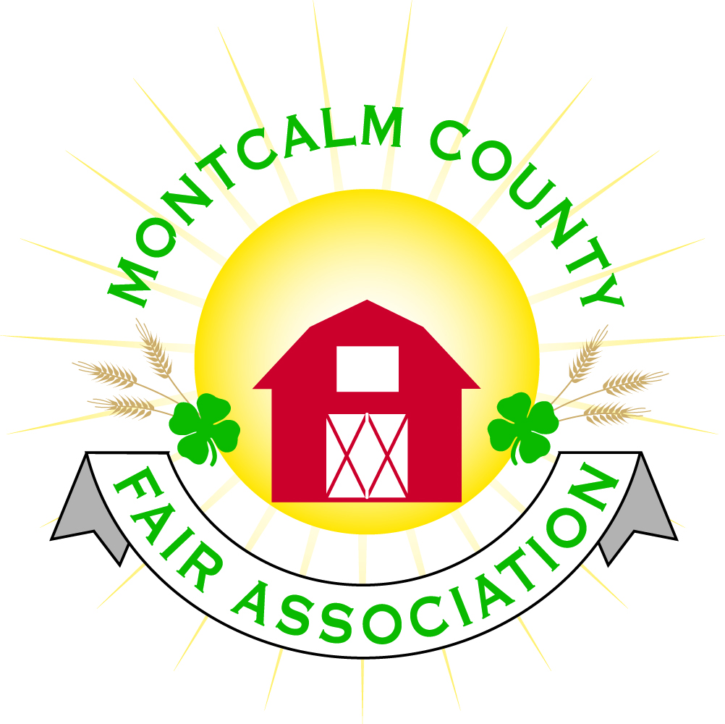
po box 513 • Greenville, MI 48838

Montcalm County Fair Association Board Meeting
4 October 2021
Montcalm County Fairgrounds, Greenville, MI

The meeting was called to order at 7:04 pm by Todd Hetherington

Board members present:
Officers: President Todd Hetherington, 1st Vice President Jason Nadeau, Treasurer Lisa Johnson, and Secretary Tammi Jahnke

Directors: Melissa Eldridge, Mary Newman, Brad Heft, Shaun Hyde, Mike Jensen, Doug Jackson, Amanda Wall and Amber Ryan.

Directors Absent: Becka Merren, Cheryl Rosso, and Jennifer Senn.

Others present were:
Katie Johnson – Rental Coordinator

Guests: Kim Pennock, Jackie Nadeau, Michelle Nitengale and Mary Gee.

Secretary Minutes from 30 August 2021 presented by Tammi Jahnke. Motion to approve made Doug Jackson. Second by Lisa Johnson. Motion passed to place minutes on file.

Financials presented through the end of August 2021 by Treasurer Lisa Johnson. Motion to approve financials through the end of August 2021 by Doug Jackson. Second by Shaun Hyde. Motion passed to place financials on file.

Guest Comments
- Michelle Nitengale – presented Ag Committee changes to Fairbook, voted in July 2021 to not make fair a terminal event for swine (removing “all swine go to slaughter”), (See email & add here). Verified that everyone is agreeable to continuing to use Showorks. Charged $76 for online entries for 2021. Amanda motion to continue with Showorks, Melissa second. Motion passed.
- Kim Pennock – updated the board on the 4-H CCC Youth Bake-Off and Cook-Off plans for the Fall Crash Bash.

Extension Office:
- No Program Coordinator at meeting. Rachel Sheff began today at MSUE. She should be able to attend our next Annual and November 2021 meeting.

Executive Committee:
- Did not meet.

Budget & Audit Committee:
- Met on 4 October 2021 at 5:30pm. No Report – working on Budget for 2021. Need a third person for audit integrity.

Buildings, Grounds, Camping & Construction Committee:
- Melissa advised woodchuck problem again – east end of Ash Building.
- In preparation of Crash Bash – need to mow, need trash clean-up, need cans moved into primary areas from livestock barn, need portable lighting,

Rental Committee:
- Katie Johnson reported on the rental activities to date for the month of September 2021. Two weddings, horse show, and Pheasants Forever banquet. No new rentals scheduled, but has had showings. Mary Gee advised that contact numbers need to be more visible on web page. Will have a rental display set-up during Crash Bash to promote Rentals.

Judges:
- Mary Newman received a list from the livestock committee of judges they would like. Needs a committee formed to get started on it. Amanda Wall offered to join Mary on the judges committee.

Livestock/Agriculture – Bio-Security:
- No report.

Concessions, Commercial Exhibits & Grandstand:
- No report.

Fairbook & Showorks
- Michelle went through above under Guests.

Awards/Trophies:
- Tabled to Spring 2022.

Marketing & Fundraising Committee:
- Lisa advised have not gotten any further regarding website design. Tammi asked if another quote was obtained yet as Jenn had stated she would like to have at the last meeting (so far no).

Accessibility Committee:
- Melissa presented a map of grounds. Melissa, Mary Newman and Kim Thomsen have met a couple times to discuss accessibility. Red lines on diagram provided are places where we need some form of asphalt or cement pathways. Main road system appears good. Need another bridge across ditch to north of the Ash Building. Melissa made a visit to Gratiot Fair where roads/pathways were paved between buildings. Melissa is searching for a grant, Kim also found a few more to cover costs. Kim did get a copy of Gratiot’s grant request for a sample to base one for us on. Doug volunteered to assist on this committee.
- Mary presented verbiage for signage providing information to those in need of assistance with accessibility to our buildings, grandstands and grounds.

Old Business:
- Katie updated on Fall Crash Bash. Friday – Carnival, Big Reds & Cornhole (6pm to midnight). Parking will be charged. 50 teams pre-registered for cornhole. Have some interest in campsites for the weekend. Jason will make sure campers have paid and are in their right site. Cornhole people will help clean up on Friday night after event and set-up for Saturday.
- Saturday – Doggie Dash (27 registered @ $25 each – set-up 8am), Bake-Off & Cook-Off, Craft Show, Food venders start at 11am (Pizza only going until 3pm depending on outdoor temperature), Beer Wine Cider tastings until 3pm, Petting Zoo noon to 3pm in small animal barn. Need parking volunteers – Lisa calling in a trade-off with Lions’ Club on Saturday, for use of grounds.
- Daily News ad 1/8 page run 6th & 8th. Add on top of website every week. $276 cost. Katie has contacted the local radio station and has not heard back.
- Annual Meeting and Nominating Committee Status – Mary provided list, Lisa provided postcards which are going in the mail tomorrow.

New Business:
- Fair Themes due 25 October 2021. Will be reviewed in November 2021.

Motion made by Jason Nadeau to adjourn. Support by Shaun. Meeting adjourned at 8:32 pm.

Respectfully submitted by Tammi Jahnke, Secretary

Next Meeting Dates:
Annual Association Meeting – 21 October 2021, Dinner 6pm, Meeting 7pm
Regular Meeting – 1 November 2021 at 7:00 PM
At Ash Building, Montcalm County Fairgrounds,
Greenville, Michigan
ALL Fair Committee Members and interested 4-H Volunteers/Members
are invited to attend.

