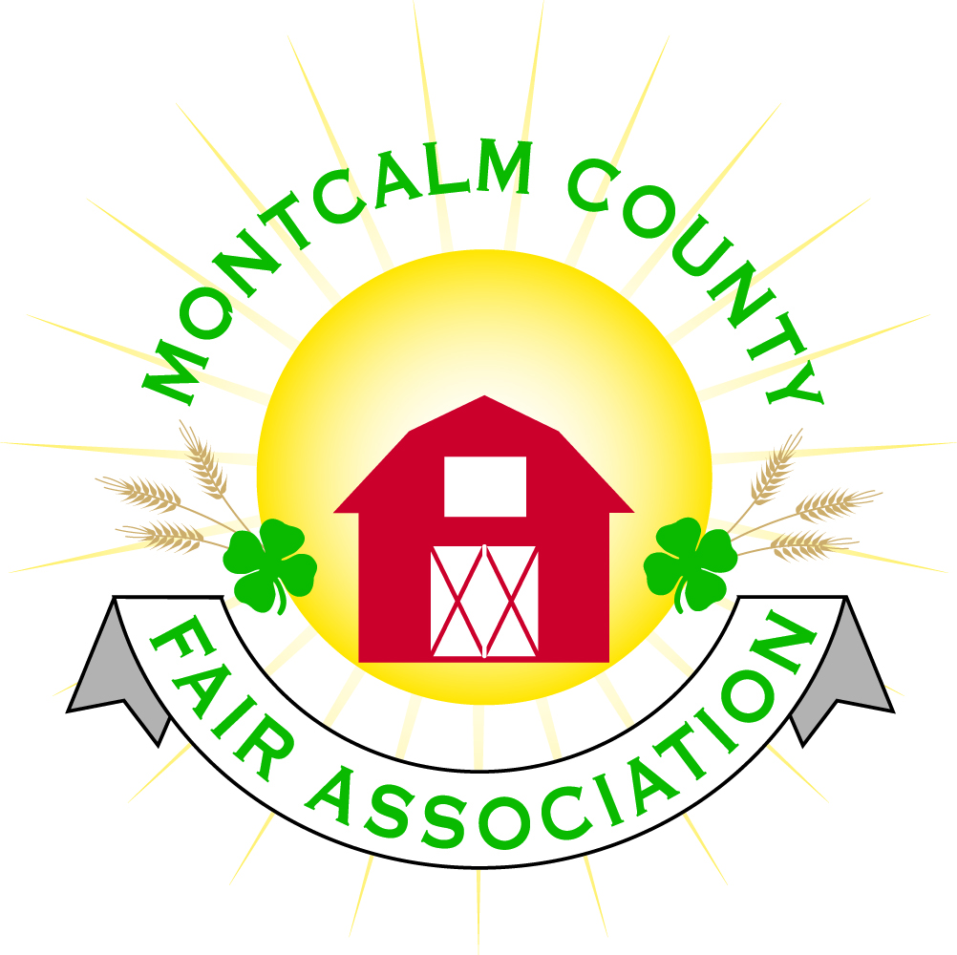
po box 513 • Greenville, MI 48838

Montcalm County Fair Association Board Meeting
1 November 2021
Montcalm County Fairgrounds, Greenville, MI

The meeting was called to order at 7:02 pm by President Todd Hetherington

Board members present:
Officers: President Todd Hetherington, 1st Vice President Jason Nadeau, 2nd Vice President Becka Merren, Treasurer Lisa Johnson, and Secretary Tammi Jahnke

Directors: Mary Newman, Brad Heft, Jennifer Senn, Shaun Hyde, Doug Jackson, Shirley Dean, Joe Minkel, Tom Aldridge.

Directors Absent: Amber Ryan and Amanda Wall

Others present were:
Katie Johnson – Rental Coordinator
Rachel Sheff – MSUE PC

Guests: Mary Gee, Michelle Nitengale, and Jackie Nadaeu.

Installation of New and Returning Fair Board Members: Shaun Hyde, Tammi Jahnke, Joe Minkel, Tom Aldridge and Shirley Dean.

The election of officers was then addressed for the 2021-2021 year:

President Nominations:
Todd Hetherington (by Shirley Dean/Tammi Jahnke)
Declined: Lisa Johnson (by Jennifer Senn/Doug Jackson)
Move to close and cast unanimous ballot by Jason, 2nd Shaun Hyde. Motion passes.
NEW PRESIDENT: Todd Hetherington

1st VP Nominations:
Jason Nadeau (by Shaun Hyde/Becka Merren)
Declined: Mary Newman (by Jennifer Senn/Shirley Dean)
Move to close and cast unanimous ballot by Tammi Jahnke, 2nd Shaun
Hyde. Motion passes.
NEW 1st VP: Jason Nadeau

2nd VP Nominations: Becka Merren (by Jason Nadeau/Mary Newman)
Move to close and cast unanimous ballot by Jason Nadeau, 2nd Doug Jackson. Motion passes.
NEW 2nd VP: Becka Merren

Secretary Nominations: Tammi Jahnke (by Jason Nadeau/Becka Merren)
Move to close and cast unanimous ballot by Jason Nadeau, 2nd Doug Jackson. Motion passes.
NEW SECRETARY: Tammi Jahnke

Treasurer Nominations: Lisa Johnson (by Jason Nadeau/Doug Jackson)
Declined: Tammi Jahnke (by Jennifer Senn), Mary Newman (by Jennifer Senn)
Move to close and cast unanimous ballot by Jason Nadeau, 2nd Shaun Hyde. Motion passes.
NEW TREASURER: Lisa Johnson

Motion to approve Election results by Lisa Johnson, 2nd by Tammi Jahnke. Motion passes (12 Yeas to 1 Nay vote by Jennifer Senn).

Sign – up sheet for 2021-2022 Committees passed around. Tammi Jahnke to update and provide copies to directors.

Secretary Minutes from 4 October 2021 presented by Tammi Jahnke. Motion to approve made by Jason Nadeau. Second by Becka Merren. Motion passed to place minutes on file.

Financials presented through the end of September 2021 by Treasurer Lisa Johnson. Motion to approve financials through the end of September 2021 by Tammi Jahnke. Second by Jason Nadeau. Motion passed to place financials on file.

Guest Comments
- None

Extension Office:
- Rachel Sheff requested clarification of 4-H’s role in the fair. Lisa addressed that you don’t have to be a 4-H member to participate in Fair. Michelle Nitengale added that FFA members are welcome to participate in Fair also. Rachel would like to address the connection between 4-H and Fair with Advisory Council also and needs an equipment inventory list of 4-H equipment. Todd Hetherington to help with the list.

Executive Committee:
- Did not meet.

Budget & Audit Committee:
- Did not meet. Will be meeting in November 2021.

Buildings, Grounds, Camping & Construction Committee:
- Did not meet. Scheduled to meet November 6, 2021 to winterize fairgrounds. Todd Hetherington to call Jennifer Senn when done & ready for Russell’s to come in.

Rental Committee:
- Katie Johnson reported on the rental activities to date for the month of October 2021. There were 3 weddings, the Fall Crash Bash, and she signed 3 contracts for Christmas Eve & for 2022. Katie has been receiving many phone calls regarding rentals.
- Next Rental Committee meeting is set for Wednesday the 17th November 2021 at 7pm, at the Ash Building.

Judges:
- Mary Newman advised this committee will start meeting in the near future. Deadline to submit has passed. If there are any more suggestions, please contact Mary.

Livestock/Agriculture – Bio-Security:
- No report per Shaun Hyde.

Concessions, Commercial Exhibits & Grandstand:
- General consensus that we need to start working on before MAFE meeting in January 2022.

Fairbook & Showorks
- General rules and livestock sections of the fair book recommended to be changed are as follows:

Page 5 - added Weigh-in & Tag- In dates
Page 9 - Market Livestock and Sale Rules - added Rule 12 setting a time limit for dropping an animal from the sale
Page 12 - Rule 9 - added that an exhibitor can miss with prior approval from the superintendent
Page 12 - Added Class 419 - Market Beef-Dairy Class
Page 13 - Rule 12 - added that an exhibitor can miss with prior approval from the superintendent
Page 15 - added overall Goat Exhibitor class
Page 16 - Rule 11 - added that an exhibitor can miss with prior approval from the superintendent
Page 17 - some rules for eggs changed

In addition: Swine are not required to go to slaughter. And Swine weight range of 220 to 299 will be maintained for 2022.

Lisa Johnson moved to approve changes above that were presented by Michelle Nitengale, which does not include still exhibit changes still being worked on. Support Doug Jackson. Motion carried.
- Lisa Johnson made a motion that all livestock registrations in use are to be the ones available on our website or received and completed when they arrive at weigh-in/tag-in. No others will be accepted. Doug Jackson second. Motion carried.
- Nothing to report on Showorks.

Awards/Trophies:
- No report. Amber Ryan absent.

Marketing & Fundraising Committee:
- Lisa Johnson expressed that she would like to get marketing going very soon.
- Need to look at getting billboards asap – suggestion from Jackie Nadeau and agreed upon by general consensus.
- Todd Heatherington has information from Hearst Communications regarding website communications for just under $1,000 to set-up, support throughout the year, $79 a month expense thereafter. Example: Mecosta County Fair website. Todd met him at 2019 MAFE.

Accessibility Committee:
- Mary Newman advised they are continuing to meet and that she will contact Melissa Eldridge regarding whether she is willing to continue with grant and assistance.
- Jason Nadeau knows someone who might be able to do some donating of some equipment to facilitate an accessibility plan.
- Michelle Nitengale advised she will be obtaining the survey needed.

Old Business:
- Fall Crash Bash report given by Katie Johnson, along with Brad Heft concerning the Doggy Dash and Tammi Jahnke regarding the Bake-Off/Cook-Off. Overall consensus was a success.

New Business:
- 2022 Fair Theme: Motion by Shirley Dean to support a patriotic theme for the fair. Jenn support. Narrowed down to two of the many themes submitted: American Flair at the County Fair (vote 8) and Something Old, Something New, Forever Red, White & Blue (vote 5). Theme for 2022 is “American Flair at the County Fair.”
- MAFE January 13th through 15th 2022. November 22, 2021 deadline to let Lisa Johnson know if you need a hotel room for MAFE.

Motion made by Jason Nadeau to adjourn. Support by Doug Jackson. Meeting adjourned at 8:49 pm.

Respectfully submitted by Tammi Jahnke, Secretary

Next Meeting Dates:
Regular Meeting – 6 December 2021 at 7:00 PM
At Ash Building, Montcalm County Fairgrounds,
Greenville, Michigan
ALL Fair Committee Members and interested 4-H Volunteers/Members
are invited to attend.

