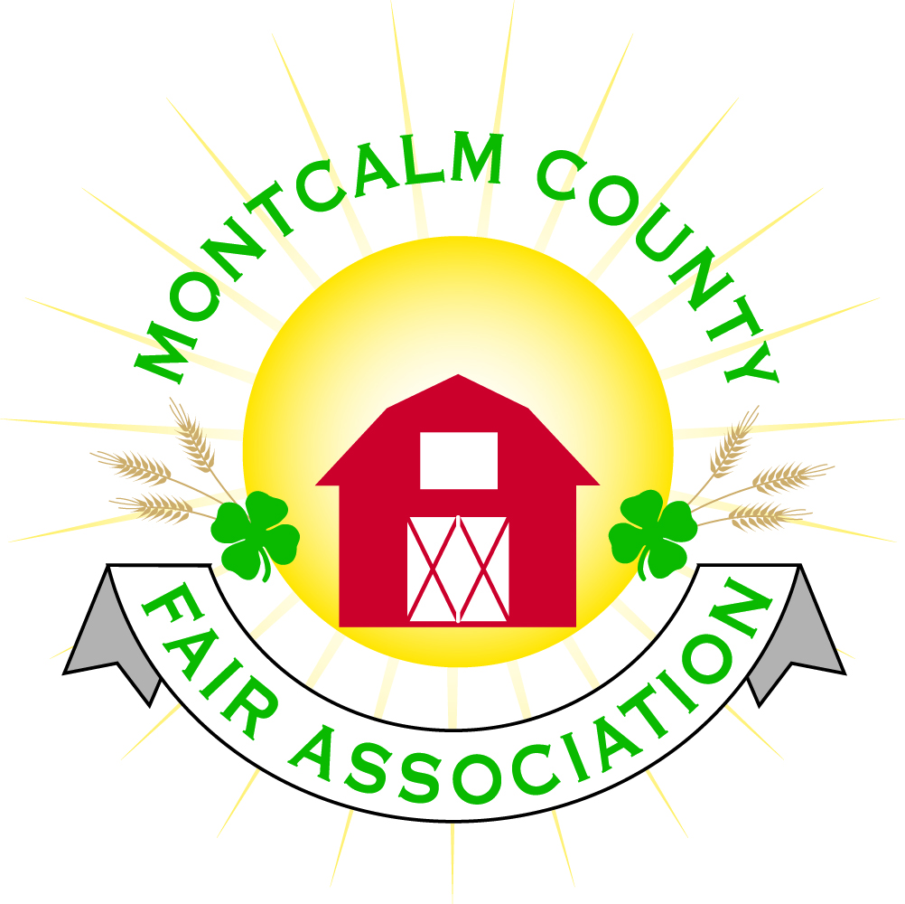
po box 513 • Greenville, MI 48838

Montcalm County Fair Association Board Meeting
6 December 2021
Montcalm County Fairgrounds, Greenville, MI

The meeting was called to order at 7:01 pm by Todd Hetherington.

Pledges were completed.

Board members present:
Officers: President Todd Hetherington, 1st Vice President Jason Nadeau, 2nd Treasurer Lisa Johnson, and Secretary Tammi Jahnke
Absent: Vice President Becka Merren,

Directors: Brad Heft, Jennifer Senn, Doug Jackson, Amanda Wall, Joe Minkel, and Tom Aldridge.
Directors Absent: Mary Newman, Shaun Hyde, Amber Ryan, and Shirley Dean.

Others present were:
Rachel Sheff – MSUE PC via phone call for Extension Office update

Guests: Kim Pennock and Jackie Nadaeu.

Secretary Minutes from 1 November 2021 presented by Tammi Jahnke. Motion to approve made by Lisa Johnson. Second by Jason Nadaeu. Motion passed to place minutes on file.

Financials presented through the end of October 2021 by Treasurer Lisa Johnson. Motion to approve financials through the end of October 2021 on file by Jason Nadaeu. Second by Tammi Jahnke. Motion passed to place financials on file.

Guest Comments
- Kim Pennock, President of 4-H CCC informed the Board regarding the Blood Drive scheduled for the 22nd of March 2022 11am to 4:45pm. Looking for Fair Association and Board members to participate and assist with getting the word out to secure donors. Kim agreed to get the information to Jennifer Senn as soon as the Red Cross provides it to her so that Jenn can promote it through the MCFA website and Facebook page.
- Tammi Jahnke Treasurer of 4-H CCC presented a request from 4-H CCC to host a line dance event to include a club competition at Fair 2022. Amanda Wall made a motion that 4-H CCC host the line dance event with club competition on Saturday of the Fair. Support by Jenn Senn. Discussion regarding line dance lessons offered prior to fair and several suggestions followed. Motion passed. (Tammi abstained from voting.)

Extension Office:
- Rachel Sheff via phone advised the only topic she had at this time to share was to check on the equipment inventory with Todd Hetherington per agreement on file. (Agreement to be reviewed annual each December.) Todd and Rachel set December 11, 2021 a little after 11am to meet at the fairgrounds.

Executive Committee:
- Did not meet.

Budget & Audit Committee:
- Lisa Johnson, Tammi Jahnke and Doug Jackson met on Friday, the 3rd of December 2021 and performed a sample audit of the 2021 records for the months of March and April 2021 – all was in order. The only issue that still needs to be addressed is obtaining a print out of the October and November 2020 bank statements from the bank as in the transfer from Chemical to TFC then to Huntington, the digital statements were removed from the online account prior to having been printed for our file. Lisa will get with the bank to accomplish this.

Buildings, Grounds, Camping & Construction Committee:
- Todd Hetherington asked the status of Russell’s performing the winterization on the grounds. Jennifer Senn advised they were scheduled for November 24, 2021 at 8:30am. Todd and Lisa will double check the bathhouse after the meeting to make sure it was completed.
- Amanda Wall brought to the board’s attention the horse arenas and a few stalls are in dire need of maintenance before next Spring 2022.

Rental Committee:
- Brad Heft reported, on behalf of Katie Johnson, on the rental activities to date for the month of November 2021: signed 3 contracts, receiving many phone calls, no events took place in November, although the 2022 calendar is filling up. Rental Committee minutes from the November 17, 2021 meeting we handed out to all directors present.
- Brad also advised that the painting of the West Wing is scheduled for January 8th & 9th of 2022. Need volunteers to help.
- The Rental Committee at their last meeting voted to add a 5% convenience fee online rental debit/credit payments. Jennifer Senn to add to our website.
- Todd Hetherington advised that the Rental Committee received an estimate of $1,200 to replace current thermostats with “smart” thermostats and because of the cost it requires MCFA Board of Directors approval. Lisa made a motion to spend up to $1,200 to replace thermostats with “smart” ones. Support by Jason. Motion passed.

Judges:
- Amanda Wall and Mary Newman met the 1st of December 2021 and are in the process of setting up the Judges from the lists that they have received. Emails are being sent out.

Livestock/Agriculture – Bio-Security:
- Shaun Hyde was absent – no report.
- Todd advised December 11, 2021 scheduled for livestock weigh-in.

Concessions, Commercial Exhibits & Grandstand:
- No report. MAFE Convention scheduled for January 13, 14 & 15, 2022 and MCFA will be represented at the convention.

Fairbook & Showorks
- No report

Awards/Trophies:
- Amber Ryan was absent - no report.

Marketing/Fundraising,/Website/Communications Committee:
- Shirley Dean and Lisa Johnson spoke today and are planning to meet on the 21st of December 2021. Looking for new ideas to promote to sponsors.

Accessibility Committee:
- Jackie Nadeau advised last update she was aware of was that Michelle Nitengale was working on a survey of the grounds in November 2021 to continue to lay out an accessibility plan.

Old Business:
- Thermostat replacement – see above under Rental Committee

New Business:
- Isabella Bank and Huntington Bank accounts need to be updated. MCFA currently is responsible for the following accounts:
  - Isabella Bank Account (formerly the construction account)
  - Huntington Bank Accounts:
    - Operating Account
    - Deposit Account (For Our Debit Card)
    - Deposit Account (Square)
    - Rental Account (formerly Horse Rental)
    - Livestock Account
- Motion made by Jennifer Senn to place Lisa Johnson, Todd Hetherington and Becka Merren as the approved signers on the Isabella Bank and Huntington Bank MCFA financial accounts listed in Quickbooks as follows: 001, 002, 004, 005, and 010, and that all other existing names listed as signers be removed. Support by Doug. Motion passed.
- Motion made by Amanda Wall to place Cory Wall, Nikole Chaffin and Todd Hetherington as approved signers on the Livestock Account listed in Quickbooks as 003 at Huntington Bank and that all other existing names listed as signers be removed. Support by Jason. Motion passed.
- Key List – for those who have access keys to buildings on the fairgrounds, please get the # stamped on your keys and what they access to Tammi Jahnke to update our list for security purposes.
- The 4-H Club, Country Kids, purchased a memorial tree in remembrance of Brian Plank and placed it in the livestock area.
- The Livestock Committee made a donation to the Cattlemen’s Association in Brian Plank’s name.
- MCFA is looking for ideas for a Brian Plank Memorial. Tabled for further discussion at the January 2022 meeting.

Motion made by Doug Jackson to adjourn. Support by Jason Nadeau. Meeting adjourned at 8:32 pm.

Respectfully submitted by Tammi Jahnke, Secretary

Next Meeting Dates:
Regular Meeting – 3 January 2021 at 7:00 PM
At Ash Building, Montcalm County Fairgrounds,
Greenville, Michigan
ALL Fair Committee Members and interested 4-H Volunteers/Members
are invited to attend.

