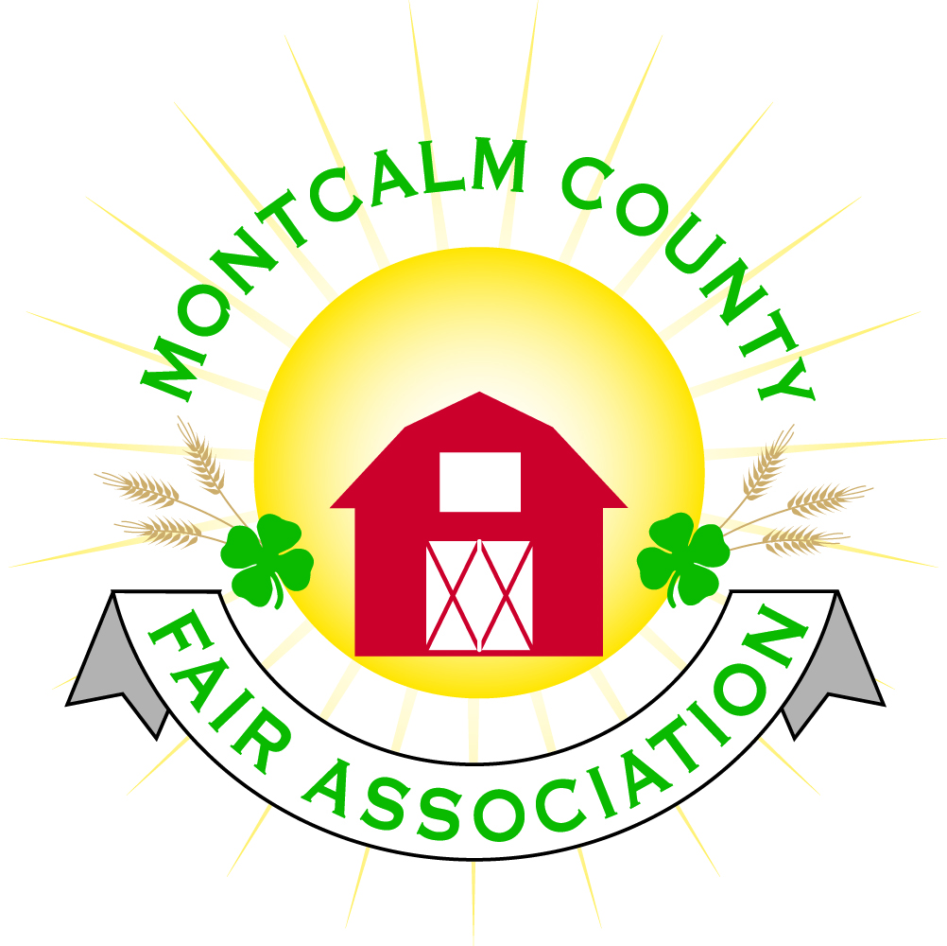
po box 513 • Greenville, MI 48838

Montcalm County Fair Association Board Meeting
3 January 2022
Montcalm County Fairgrounds, Greenville, MI

The meeting was called to order at 7:04 pm by Todd Hetherington

Board members present:
Officers: President Todd Hetherington, 2nd Vice President Becka Merren, Treasurer Lisa Johnson, and Secretary Tammi Jahnke

Directors: Mary Newman, Brad Heft, Jennifer Senn, Shaun Hyde, Amber Ryan, Doug Jackson, Shirley Dean, Joe Minkel, and Tom Aldridge.

Others present were:
Katie Johnson – Rental Coordinator
Guests: Bruce & Sue Doll, and Jessica Marks.

Absent: 1st Vice President Jason Nadeau, Amanda Wall, and Rachel Sheff-MSUE Program Coordinator.

Secretary Minutes from 6 December 2021 presented by Tammi Jahnke. Motion to approve made by Lisa Johnson. Second by Mary Newman. Motion passed to place minutes on file.

Financials presented through the end of November 2021 by Treasurer Lisa Johnson. Motion to approve financials by Tammi Jahnke. Second by Doug Jackson. Motion passed to place financials on file.

Guest Comments
- Introductions of Guests – no additional comments.

Extension Office:
- In the absence of Rachel Sheff, Tammi Jahnke of 4-H CCC reported that the January 2022 Challenge will be asking clubs to collect items for a county-wide 4-H donation to Devos Children’s Hospital, a Blood Drive is scheduled in March 2022, and that the guests in attendance at this meeting have offered to assist 4-H CCC with the upcoming Line Dance events.

Executive Committee:
- Did not meet.

Budget & Audit Committee:
- Did not meet.

Buildings, Grounds, Camping & Construction Committee:
- Painting of Ash Building happening now and on January 8th and 9th, 2022 (8am until done). Volunteers welcomed.
- Jennifer Senn advised that the 1st of March 2022 is when camping opens for reservations & those with sponsored sites must have their payments made by the 21st of February 2022.

Rental Committee:
- Katie Johnson reported on the rental activities to date for the month of December 2021. One 2022 wedding contract signed, 3 employee holiday parties, one family Christmas party. Phone calls and emails are increasing and has one appointment scheduled to view the building. She spent 9 hours cleaning of the Ash Building in December 2021. Lyons Club – toys for tots – event went well.

Judges:
- Mary Newman announced that Mary Gee has agreed to take Brian Plank’s place on the Judges committee. They are asking for input from the superintendents and starting to assemble judges.

Livestock/Agriculture – Bio-Security:
- No bio-security report at this time per Shaun Hyde.
- Beef weigh-in complete – approximately 35 (including floaters) attended. Feeders to be weighed in Spring 2022 per Todd Hetherington.

Concessions, Commercial Exhibits & Grandstand:
- Lisa Johnson advised that she had been contacted by two prior concessionaires that are planning on attending our fair.
- Todd Hetherington informed the board that we are locked in for one more year with the Demo Derby through Trolard.
- Also, Trolard contacted Todd Hetherington, regarding the possibility of a Sunday night event for the fair. (Note: It is Father’s Day.)

Fairbook & Showorks
- Fairbook is all set for 2022 with the exception that the Food/Craft Auction needs to be updated. Discussed followed. Food Auction information to be updated with an explanation of what can and cannot be sold according to the Cottage Food Laws in order to stay in compliance with the Health Department rules. 4-H Advisory Council to discuss at their next meeting.

Awards/Trophies:
- Amber Ryan reported the committee has begun working on this area.

Marketing/Fundraising/Website Communications Committee:
- Lisa Johnson and Shirley Dean met and are putting together a game plan and new ideas for securing sponsors.
- Amber Ryan asked if there were any carry-over funds for the billboards expense. Lisa Johnson advised that we still have a $400-$500 credit and is planning on contacting the vendor in the next week to secure billboard advertising.
- Amber Ryan suggested a goal be put out to the clubs to assist with obtaining sponsorships for awards and trophies.
- Shirley Dean also would like to see Buyer’s letters required for the Livestock Auction, but knows that this could be an issue with some clubs/members.
- Shirley Dean also suggested that the daily fair schedule be made more easily accessible on the website and a petting zoo be considered for fair.

Accessibility Committee:
- Has not met.

Old Business:
- Key List Updated
- Brian Plank Memorial – Katie Johnson advised that Carson City Lumber contacted her regarding donating to a memorial once a decision is made on the type of memorial. Discussion to continue at February 2022 meeting.

New Business:
- MAFE Convention – Todd will pick up everyone’s items (badges etc.) on Thursday. Members attending - be sure to connect with him to receive them.
- Horse Club from Kent County (not 4-H) has contacted Tammi Jahnke requesting information as to the requirements for a youth club and/or individuals to attend our fair. Discussion followed as our fair book does not currently contain such information. Amber Ryan will address this at the next Horse Leaders’ meeting and come back with a suggested requirement that includes attendance at a specific number of horse leaders’ meetings. Guests from Kent County shared information from their fair and suggestions. The fair board will revisit this issue in February 2022.

Motion made by Doug Jackson to adjourn. Support by Amber Ryan. Meeting adjourned at 8:35pm.

Respectfully submitted by Tammi Jahnke, Secretary

Next Meeting Dates:
Regular Meeting – 7 February 2022 at 7:00 PM
At Ash Building, Montcalm County Fairgrounds,
Greenville, Michigan
ALL Fair Committee Members and interested 4-H Volunteers/Members
are invited to attend.

