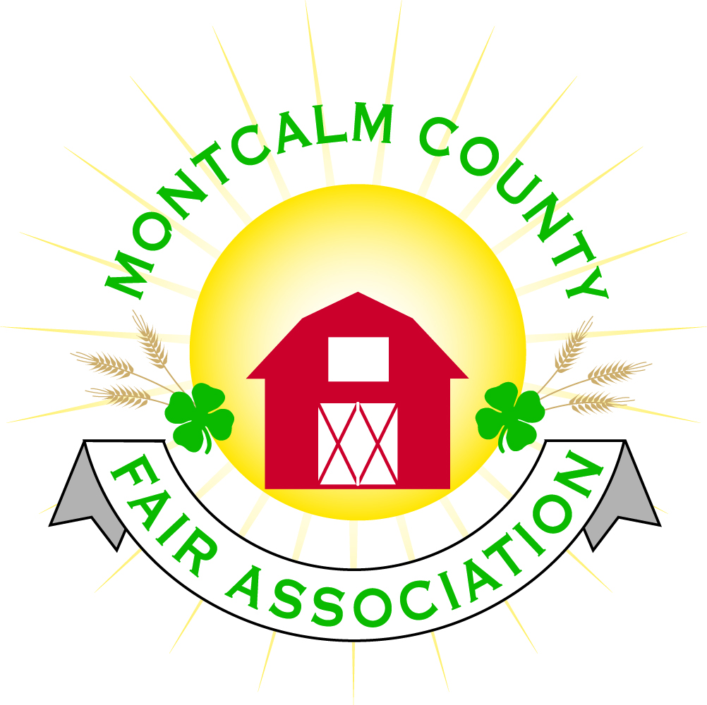
po box 513 • Greenville, MI 48838

Montcalm County Fair Association Board Meeting
7 February 2022
Montcalm County Fairgrounds, Greenville, MI

The meeting was called to order at 7:04 pm by Todd Hetherington

Board members present:
Officers: President Todd Hetherington, 1st Vice President Jason Nadeau, 2nd Vice President Becka Merren, Treasurer Lisa Johnson, and Secretary Tammi Jahnke

Directors: Mary Newman, Brad Heft, Shaun Hyde, Joe Minkel, Amber Ryan, Amanda Wall and Tom Aldridge.

Directors Absent: Jennifer Senn, Doug Jackson, and Shirley Dean.

Others present were:
Katie Johnson – Rental Coordinator
Rachel Sheff – MSUE PC

Guests: Nancy Spanski, Petra Mark, Dave Harper (Poorman Pullers), Samantha Aldridge and Jackie Nadeau.

Secretary Minutes from 3 January 2022 presented by Tammi Jahnke. Motion to approve made by Lisa Johnson. Second by Mary Newman. Motion passed to place minutes on file.

Financials presented through the end of December 2021 by Treasurer Lisa Johnson. Motion to approve financials through the end of December 2021 by Jason Nadeau. Second by Shaun Hyde. Motion passed to place financials on file.

Guest Comments
- Dave Harper with the Mini-Mods of Poorman Pullers. Proposing the 23rd of June 2022 for the event. Motion made by Tammi Jahnke to have the Mini-Mods as an Event on the 23rd of June 2022 of Fair. Support by Jason Nadeau. Motion passed.
- Petra Mark presented a request to the fair board to be able to leave Fair 2022 one day early to travel to DC as part of the delegation from Michigan participating in the Citizenship Washington Focus. She will make arrangements for animals while she is absent on the last day of fair. Amber Ryan made a motion to support Petra’s request to leave one day early to attend the 4-H Citizenship Washington Focus, make arrangements for both care and transportation of her animals following fair. Support by Mary Newman who also asked Petra to bring back some information to share. Rachel Sheff explained the program and that 40 youth have been allotted for to attend. Motion passed.

Extension Office:
- Rachel Sheff advised that she and Todd Hetherington met the end of December 2021 and reviewed the list of 4-H Inventory stored on the fairgrounds. Rachel will update list to remove the drag which belongs to the MCFA and Todd will sign. Copy to be sent to Tammi Jahnke (once signed) to added to these minutes. Rachel also added that the 4-H open office hours are from 1pm to 3pm. (See newsletter).
- Kim Pennock is working with the Red Cross for the March 22, 2022 Blood Drive.
- Lia of Lia’s Line Dance (https://www.liaslinedance.com/) and 4-H CCC have scheduled Line Dance Lessons for Thursday, April 28, 2022 6:30pm to 8pm and Monday, May 9th from 6:30pm to 8pm at the Ash Building that will be open to all 4-H and FFA members, as well as the local community. Also, Lia will be at the Fair on June 25, 2022 to assist the 4-H CCC with the Fair Line Dance Event. Jason made a motion to have dance from 4pm to 6pm on June 25th. Second by Becka. Motion passed.
- DeVos Children’s Hospital collection. Three county 4-H clubs participated. 4-H CCC to discuss at their next meeting how to recognize these clubs (Barn Stars, Rebel Clovers and 4-H Future Leaders) for their participation.

Executive Committee:
- Did not meet.

Budget & Audit Committee:
- Did not meet.

Buildings, Grounds, Camping & Construction Committee:
- Did not meet.

Rental Committee:
- Katie Johnson reported on the rental activities to date for the month of January 2022, 4 new events, 3 pending contract/payment, 1 wedding, phone calls have picked up as well as tours of the Ash Building. Signed a contract for March 26, 2022 cornhole event during Rental Committee meeting of even date. Most of west wing has been painted but there is still some trim, windows and door areas that need paint.

Judges:
- Mary Newman advised that this is going well and they only have a few areas that they are still seeking judges for.

Livestock/Agriculture – Bio-Security:
- Did not meet.

Concessions, Commercial Exhibits & Grandstand:
- Jason Nadeau reported that they met at MAFEE and have contracted with an event organizer to have Micro-Wrestling on Tuesday the 21st of June 2022. Event organizer gets all of the ticket price. We get the parking fee and have to supply him with 4 hotel rooms, 12 Red Bulls, water and a meal. Discussion followed and it was suggested that our website have a link to his site. Tickets $12 in advance and $15 day of show.
- Todd Hetherington advised of Fair schedule: Monday – Antique Tractor Pull, Tuesday Micro-Wrestling, Wed – open, Thursday – Mini-Mods, Friday Rodeo (need signed contract yet), Saturday – Demo Derby.
- Jason Nadeau proposed a truck pull for Wednesday night by West MI Pullers (of Blanchard) - our cost $5,500, we charge $15 a ticket (need to sell 366 tickets to break even), Jason needs to ask if we get the pit money for the non-card-carrying members, and who is needed to work the back gate. Would consist of tractors, semis and pickups.
- No carnival contracted at this time – still working on.
- Rodeo – Broken Horn out of Ripley, Ohio offered a contract ($11,000) for full show, supply their own feed for animals, will provide a packet on marketing in advance for all of our events, not just the Rodeo. Motion made by Jason Nadeau to use Broken Horn Rodeo for $11,000. Becka Merren support. Motion passed.
- Jackie Nadeau suggested that we do a “special needs day”. Katie Johnson explained that it consists of making the fair sensory friendly. Katie & Jackie to research and bring back information at March 2022 meeting.

Fairbook & Showorks
- Amber Ryan asked about Records Books. Need to review in fair book.
- Board reviewed the proposed Ash Foundation Building Still Exhibits – General Rules as revised and presented by Michelle Nitengale. Motion made by Amber Ryan to approve. Mary Newman support. Motion passed.
- Lisa Johnson advised that Michelle Nitengale has not been able to access Showworks from home. Lisa made a suggestion to get Michelle a key. Motion by Tammi Jahnke to provide Michelle Nitengale with an MCFA office key. Amber Ryan support. Motion passed.

Awards/Trophies:
- Did not meet.

Marketing & Fundraising Committee:
- Did not meet. But Jackie Nadeau, Jason Nadeau, Samantha Aldridge, Katie Johnson and Tom Aldridge gave notice they would like to be added to the committee.

Accessibility Committee:
- Mary Newman advised that they did not meet.
- Jason Nadeau spoke with a guy at MAFEE who would be willing to look at our bleachers regarding adding a handicap program. Lisa Johnson advised they are offering a grant program again this year, but deadline is coming up soon, possibly March. Todd Hetherington suggested we start with this project.

Old Business:
- Brian Plank Memorial – Todd Hetherington advised that the Livestock Committee is working on this.
- Youth Fair Entries (non-4H/FFA) requirements – per Rachel Sheff and Amber Ryan advised this has been discussed in the 4-H horse committee. Need more information.
New Business

Motion made by Jason Nadeau to adjourn. Support by Shaun Hyde. Meeting adjourned at 8:44 pm.

Respectfully submitted by Tammi Jahnke, Secretary

Next Meeting Dates:
Regular Meeting – 7 March 2022 at 7:00 PM
At Ash Building, Montcalm County Fairgrounds,
Greenville, Michigan
ALL Fair Committee Members and interested 4-H Volunteers/Members
are invited to attend.

