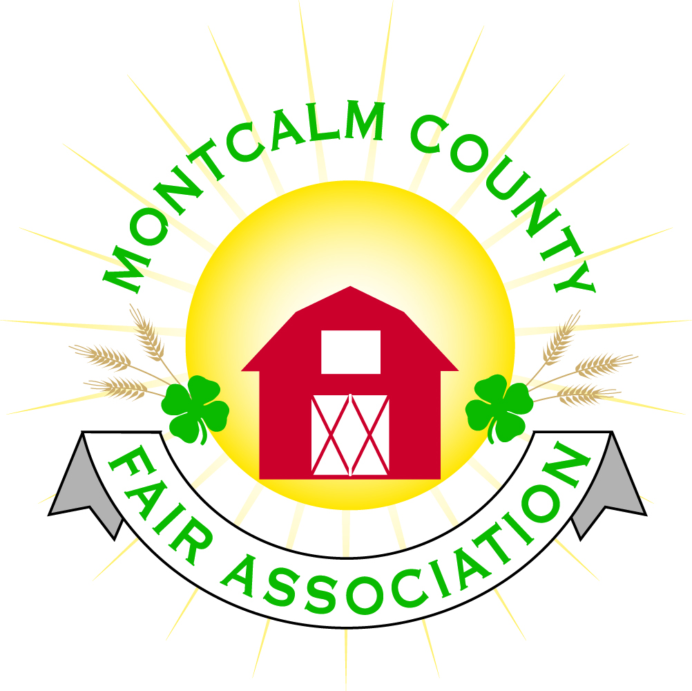
po box 513 • Greenville, MI 48838

Montcalm County Fair Association Board Meeting
6 June 2022
Montcalm County Fairgrounds, Greenville, MI

The meeting was called to order at 7:06 pm by Todd Hetherington and the American Pledge and 4-H Pledge were recited.

Board members present:
Officers: President Todd Hetherington, 1st Vice President Jason Nadeau, 2nd Vice President Becka Merren, Treasurer Lisa Johnson, and Secretary Tammi Jahnke

Directors: Mary Newman, Brad Heft, Jennifer Senn, Shaun Hyde, Doug Jackson, Amber Ryan, Amanda Wall, Shirley Dean, Joe Minkel, and Tom Aldridge.

Directors Absent:

Others present were:
Katie Johnson – Rental Coordinator
Rachel Sheff – MSUE PC

Guests: Jackie Nadaeu.

Secretary Minutes from 2 May 2022 and 25 May 2022 were presented by Tammi Jahnke. Motion to approve made by Lisa Johnson. Second by Mary Newman. Motion passed to place minutes on file.

Financials presented through the end of April 2022 by Treasurer Lisa Johnson. Motion to approve financials through the end of April 2022 by Jason Nadeau. Second by Doug Jackson. Motion passed to place financials on file.

Guest Comments
- No guest comments

Extension Office:
- Rachel Sheff PC of MSUE advised of a Horse Leaders hosting a horse practice this week on 8 June 2022. Dog Practices at fairgrounds 12 June 2022. Day Camps being offered for Cloverbuds on the 19th and 20th of July ($35 for both days - food, fun & fitness theme.) Rachel made a request to the fair board to host a Smores by the Campfire Event on Friday the 24th of June in the evening during fair at the community campfire. Motion by Tammi Jahnke to approve Rachel’s request. Support by Shaun Hyde. Motion passed.
- Tammi Jahnke of 4-H CCC provided an update on the pizza party planned at fair for the 3 clubs that participated in the DeVos Children’s Hospital Collection Challenge (January 2022), Line Dance Even scheduled for the 25th of June at fair and the Shoebox Floats Competition being hosted by 4-H CCC.

Executive Committee:
- Did not meet.

Budget & Audit Committee:
- Did not meet.

Buildings, Grounds, Camping & Construction Committee:
- Jennifer Senn advised that most of electrical boxes have now been marked in the campground. Sites 33, 84, and 4 need their # posts put back into the ground.
- It was agreed that at the upcoming grounds clean-up dates, more Weed whackers are needed, leave piles left from the recent clean-up need to be moved, downed trees in campground still need removal.
- Also, bleachers by horse arena need repair. Amber Ryan volunteered her 4-H group to work on repairs. Lisa Johnson volunteered to show her where to find supplies we already have to do these repairs.

Rental Committee:
- Katie Johnson reported on the rental activities to date for the month of May, beginning of June 2022. One wedding, Ducks Unlimited Event and a graduation open house in June. She is meeting this week to sign a May 2023 wedding.
- Soldano Rally June 18, 2022– No representative appeared at meeting as requested to discuss concerns and work together on details so as not to interfere with fair and 4-H opening activities.
- Amanda Wall advised arena needs to be dragged for show Saturday the 11th of June 2022.

Judges:
- Mary Newman – Poultry judges offered to judge carcass for grand and reserve. Mary also provided Tammi Jahnke with a list of Judges confirmed to share with the superintendents.

Livestock/Agriculture – Bio-Security:
- Ready for fair. Nothing new to report per Shaun Hyde.

Concessions, Commercial Exhibits & Grandstand:
- Lisa Johnson advised there are some Demo Derby posters that have been dropped off. Jim of Unique Motor Sports asked about borrowing our portable grandstands for another event of his. He is willing to pay a rental fee. Motion by Lisa Johnson to allow Jim of Unique Motor Sports to rent six of our portable aluminum bleachers, Second by Amanda Wall. Motion passed.
- Shirley Dean advised that the Wood splitter will be here. He also might be interested in being at the Fall Crash Bash.

Fairbook & Showorks
- No reports

Awards/Trophies:
- Lisa Johnson advised that Holly Esterling has ordered all. Lisa also advised that she has received bill therefore believes they should be ready in time.

Marketing & Fundraising Committee:
- Lisa Johnson made a list of sponsors and had the directors review it for any additions or corrections. Lisa advised that we are doing a spadix (goes on spine of newspaper of Daily News) with our events and sponsors listed. Need to add Rachel’s events on Kid’s Day and Line Dancing on Saturday to the list of events.

Accessibility Committee:
- Have not met.

Old Business:
- Kids Day plans – Shirley Dean shared the plans include Reading for Rides, Airforce to be here with an exhibit, a petting zoo. Lisa Johnson shared that she thinks Cliff Dickerson was trying to get smoke house and MCC is planning kids’ games. Katie Johnson has Farm Bureau coming to put on activities. It was mentioned that Mecosta Co. 4-H has the wooden cow to milk we might be able to borrow.
- Crash Bash – still in planning stages, no new information.

New Business:
- Yard signs will be available at the fair office on 6/7/22. Lisa has a semi-trailer with sign to be set-up. Lisa also has tents rented. Fire extinguishers have been serviced. Posse has been contacted. Advanced life support is under contract to be at the fair on Wednesday, Friday and Saturday. Water tests have been completed.
- Need more printed tickets per Lisa Johnson for Micro Wrestling.
- Fence is mostly done by rabbit barn per Todd Hetherington, 2 gates are up. 2 more gates yet to hang.
- Suggested by Jennifer Senn to have a Fair board meeting sometime on Sunday the 19th of June 2022 at the fairgrounds.
- Rachel Sheff asked if she is able to inform 4-H families of rally on Saturday. All agreed that she should go ahead and inform them.
- Doug Jackson motion to move the July 2022 meeting to the 11th, second by Jason Nadeau. Motion passed.

Motion made by Jason Nadeau to adjourn. Support by Doug. Meeting adjourned at 8:20 pm.

Respectfully submitted by Tammi Jahnke, Secretary

Next Meeting Dates:
Regular Meeting – 11 July 2022 at 7:00 PM
At Ash Building, Montcalm County Fairgrounds,
Greenville, Michigan
ALL Fair Committee Members and interested 4-H Volunteers/Members
are invited to attend.

