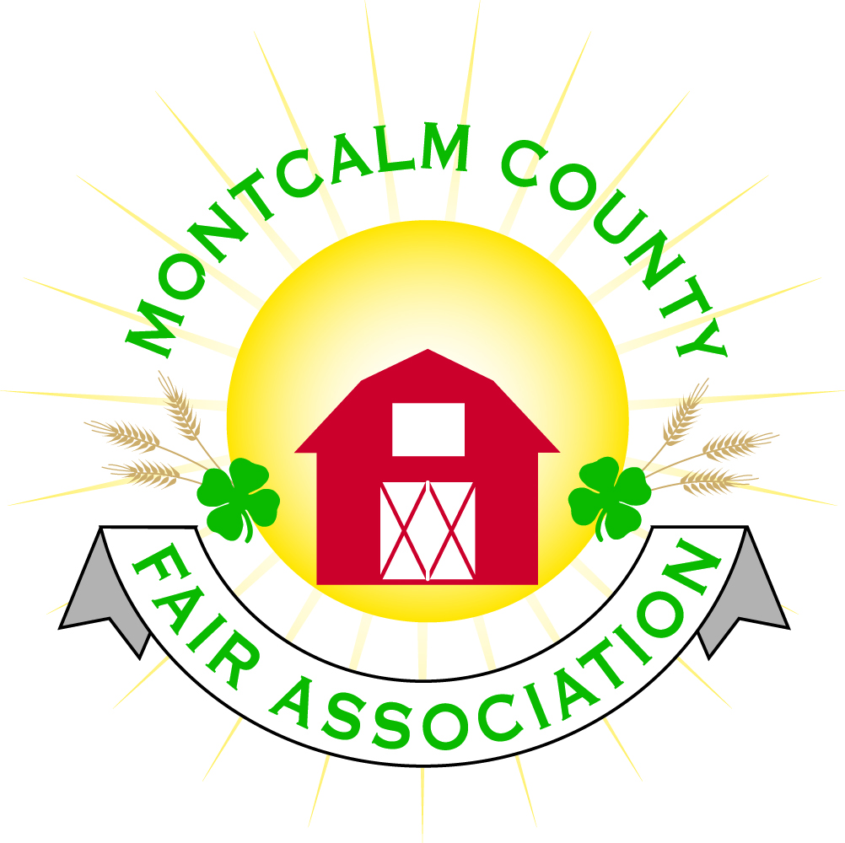
po box 513 • Greenville, MI 48838

Montcalm County Fair Association “Special” Board Meeting
21 June 2022
Montcalm County Fairgrounds, Greenville, MI

A “special” meeting of the board was requested by Lisa Johnson to address a rodeo issue and called to order at 3:53 pm by Todd Hetherington.

Board members present:
Officers: President Todd Hetherington, 1st Vice President Jason Nadeau, Treasurer Lisa Johnson, and Secretary Tammi Jahnke

Directors: Jennifer Senn, Amber Ryan, Amanda Wall, Joe Minkel, and Tom Aldridge.

Directors Absent: 2nd Vice President Becka Merren, Mary Newman, Brad Heft, Shaun Hyde, Doug Jackson, and Shirley Dean

Topic at Issue: Rodeo scheduled for Friday, 24 June 2022. Lisa advised of potential issue with a shortage of bull/bronc riders. As of this date only 6-7 bull riders and approximately 7 bronc riders have registered. Several barrel riders registered. Lisa advised we are in need of additional sponsorships to cover costs and she is requesting to raise the sponsorship fee. Discussion followed. Confirmed rodeo contract is for $10,500 and that registration is still open but due to high fuel prices, expectation of more entrants is low. Lisa made a motion to raise bull sponsorship to $300. Second by Jason Nadeau. Motion passed.

Motion made by Jason Nadeau to adjourn. Support by Joe Minkel. Meeting adjourned at 4:06 pm.

Respectfully submitted by Tammi Jahnke, Secretary

