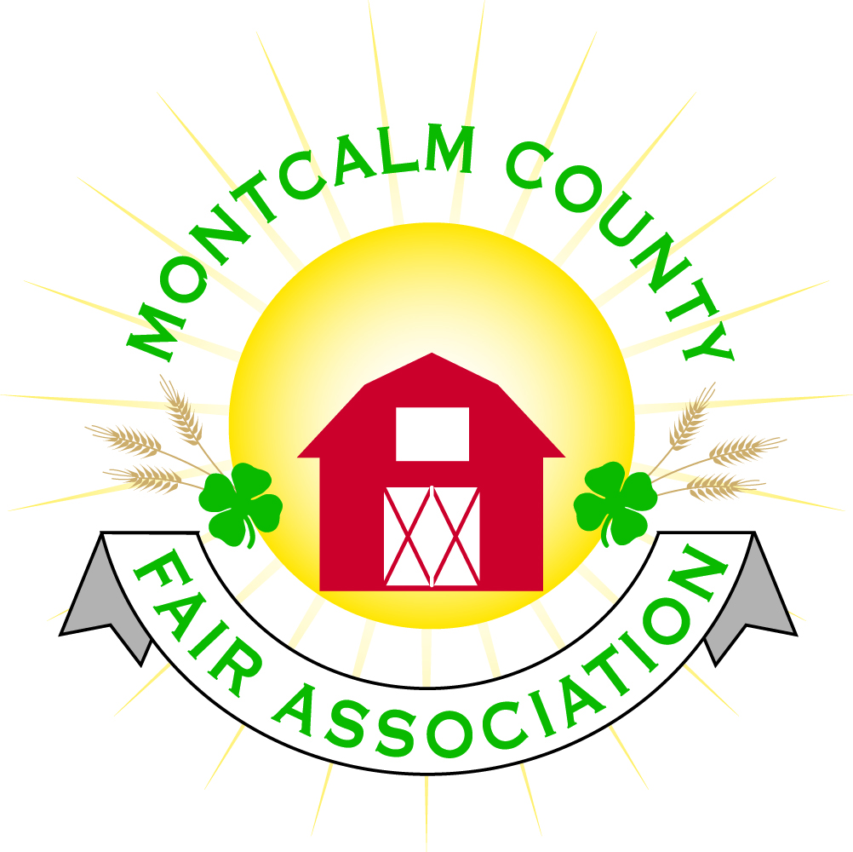
po box 513 • Greenville, MI 48838

Montcalm County Fair Association Board Meeting
11 July 2022
Montcalm County Fairgrounds, Greenville, MI

The meeting was called to order at 7:08 pm by Todd Hetherington and the Pledge of Allegiance and 4-H Pledge were recited.

Board members present:
Officers: President Todd Hetherington, 1st Vice President Jason Nadeau, 2nd Vice President Becka Merren, Treasurer Lisa Johnson, and Secretary Tammi Jahnke

Directors: Mary Newman, Brad Heft, Shaun Hyde, Doug Jackson, Shirley Dean, Amanda Wall, Joe Minkel, and Tom Aldridge.

Directors Absent: Jennifer Senn, and Amber Ryan.

Guests: Michelle Nitengale, and Jackie Nadeau.

Secretary Minutes from 6 June 2022 presented by Tammi Jahnke. Motion to approve made by Lisa. Second by Doug. Special Minutes from 21 June 2022 presented by Tammi Jahnke. Motion approved made by Lisa. Second by Doug. Both motions passed to place minutes on file.

Financials presented through the end of May 2022 by Treasurer Lisa Johnson. Motion to approve financials through the end of May 2022 by Doug. Second by Becka. Motion passed to place financials on file.

Guest Comment
- None

Extension Office:
- Rachel absent.
- Tammi gave 4-H CCC report on outcome of events held at Fair and advised planning is in the process for the Fall Bake-Off at Crash Bash in October 2022.

Executive Committee:
- Met tonight prior to MCFA meeting. Discussed more of a preplan in the future for selling tickets at events. Jason advised had one 4-H member that did not get their 2 hours of clean-up in. Had several excuses, but attended all of the grandstand events and 4-H events.
- Motion made by Jason that every exhibitor, except cloverbuds (ages 5-7), shall be required to perform 2 or more clean-up hours at the fairgrounds prior to fair annually in order to exhibit. Second by Doug. Motion passed.
- Motion made by Doug that youth fair participants/exhibitors who perform 2 or more clean-up hours during fair week be given credit for all of said hours towards the next years’ fair providing they have completed their required hours for the current fair. Mary second. Motion passed.
- Motion by Jason to have the horse superintendents address the issue of an exhibitor at the 2022 fair who did not complete their required cleanup tasks prior to or during the 2022 fair as repeatedly requested and require them to complete these tasks. Second by Becka. Motion passed.

Budget & Audit Committee:
- Did not meet.

Buildings, Grounds, Camping & Construction Committee:
- Todd asked for input on what areas need improvement. Jackie advised that a timeline from committees would be helpful as to what needs to be done daily for each of their events. Discussion ensued about investing in an application that we can subscribe to that everyone can access. Motion made Tammi that the Committees each be required to provide the fairboard with an outline/timeline/operating procedure for each of their fair event preparations and the actual event tasks that they may need assistance with so that tasks can be delegated in advance. Becka support. Motion passed.
- Lisa advised that we have site numbers/plaques that need to be put on prior to next year’s fair.

Rental Committee:
- Katie Johnson provided a report on the rental activities to date for the month of June 2022. Slow. One open house and EWHA horse show went well. Rally did pay for the portapotties and food truck spaces. There is a bogus post circulating for August 7th, Jackie had it removed.

Judges:
- Mary reported that judging went well. Received no complaints.

Livestock/Agriculture – Bio-Security:
- Shaun advised not much to report. Birds got to show.
- Becka advised that they had an emergency swine slaughter. Buyer wasn’t happy in general with the purchase despite that she filled out the paperwork regarding the cuts. Hog was fine and walked at the slaughter house despite refusing to walk at fair on the cement, feet were broken down per Amanda, right decision for the hog.

Concessions, Commercial Exhibits & Grandstand:
- Lisa advised that we made money on all of the events except the mini-modifieds.

Fairbook & Showorks
- Michelle is handing the fairbook off to anyone who wants to take it, however, fairbook changes should be in by October 1, 2022 so that the changes can be made by November 1, 2022.
- Showorks 2,635 for online entries this year. Bill for $900+ has been turned in to Lisa for payment. Believes that cloverbuds should still enter for animal project areas. Still exhibit entries were only the food auction and performing arts. Still receiving add-a-bids and seeing that the kids receive them.

Awards/Trophies:
- Everything is all taken care of except for payment for showmanship jackets. Lisa is taking care of them.
- Holly would prefer to have someone to take it over from her. Amanda advised that she is considering taking it over.

Marketing/Fundraising Committee/Website/Communications:
- Shirley advised that some things listed on the facebook page during fair are not listed on the website.
- Need to look into an app to increase communications between committees and fairboard.
- Lisa suggested that we need to find more groups that want to come in host events during fair.
- Shirley advised their committee needs more ideas.
- Jackie had someone suggest that we market the fair days differently. Lisa advised that the carnival would like to run Monday through Sunday.
- Amanda suggested that we have an ATM machine at the fair. Lisa agreed that we should check into getting a portable one through one of the local banks.

Accessibility Committee:
- Did not meet.

Old Business:
- Shirley advised that the woodsplitter thought we need to find a way to have more people in attendance, she spoke to others throughout the fair and received the same input. Believes we need a larger carnival.
- Crash Bash committee meeting July 20th. Mary will email Tammi a list of what they have so far.
- Michelle Nitengale advised that the computer person who assists us is requesting a campsite for Crash Bash.

New Business:
- Annual Meeting – October 20, 2022. Up for reelection Mary, Becka, Todd and Lisa. Drive-in voting will end. Need to start putting together plans.

Motion made by Jason to adjourn. Support by Doug. Meeting adjourned at 8:46 pm.

Respectfully submitted by Tammi Jahnke, Secretary

Next Meeting Dates:
Regular Meeting – 1 August 2022 at 7:00 PM
At Ash Building, Montcalm County Fairgrounds,
Greenville, Michigan
ALL Fair Committee Members and interested 4-H Volunteers/Members
are invited to attend.

