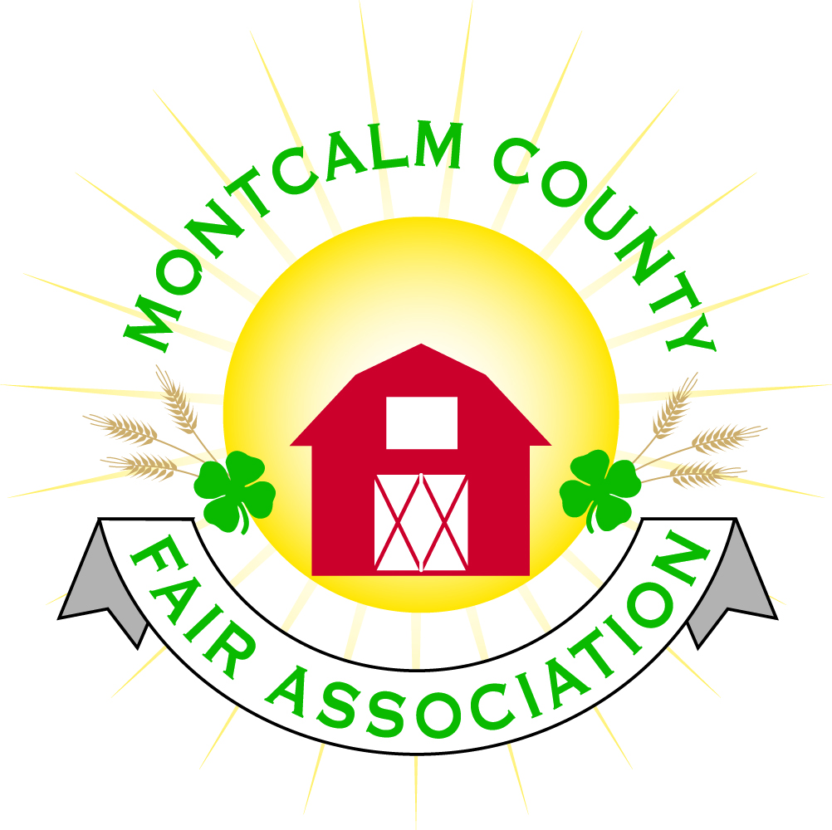
po box 513 • Greenville, MI 48838

Montcalm County Fair Association Board Meeting
5 December 2022
Montcalm County Fairgrounds, Greenville, MI

The meeting was called to order at 7:05 pm by Todd Hetherington and the Pledge of Allegiance and 4-H Pledge were recited.

Board members present:
Officers: President Todd Hetherington, 1st Vice President Jason Nadeau, 2nd Vice President Becka Merren, Treasurer Lisa Johnson, and Secretary Tammi Jahnke

Directors: Brad Heft, Shaun Hyde, Doug Jackson, Amanda Wall, Shirley Dean, Joe Minkel, Tom Aldridge, and Danny Ryan.

Directors Absent: Amber Ryan, and Sunni Haglund.

Others present were:
Katie Johnson – Rental Coordinator
Pending – MSUE PC

Guests: Jackie Nadeau, and Mary Gee.

Installation of Becka Merren for a 3-year term ending 2025 was performed (due to her absence at the 7 November 2022 meeting).

Secretary Minutes from 7 November 2022 presented by Tammi Jahnke. Motion to approve made by Jason Nadeau. Second by Doug Jackson. Motion passed to place minutes on file.

Financials presented through the end of 31 October 2022 by Treasurer Lisa Johnson. Motion to approve financials through the end of October 2022 by Jason Nadeau. Second by Doug Jackson. Motion passed to place financials on file.

Guest Comments
- None.

Extension Office:
- 4-H CCC will be issuing a Devos Children’s Hospital Collection Challenge again in January 2023.

Executive Committee:
- Met prior to meeting MCFA meeting this date. Information shared below under appropriate committee headings.

Budget & Audit Committee:
- Did not meet.

Buildings, Grounds, Camping & Construction Committee:
- Executive Committee were informed of Peasley Trucking’s offer of a (48 or 50ft. ?) semi-trailer for storage of fair inventory such as the haunted barn inventory, which we received as a donation in Fall 2022. Todd will follow-up with Brad Peasley. Need ideas as to placement on the fairgrounds.
- Nelda is interested in cleaning bathhouse once again for Fair Week 2023, for a fee of $599 plus a campsite. Motion by Jason. Second by Amanda. Motion passed.
- Tammi spoke with Jennifer Senn and Jenn advised she is willing to continue chairing the Camping Committee (as well as the website page).

Rental Committee:
- Katie Johnson reported on the rental activities for the month of November 2022 - there were no events. Katie did obtain 4 new contracts (2 Christmas parties one for 2022 & one for 2023, as well as, 2 weddings).
- Rental Committee meet twice in November 2022, Minutes attached.
- 40 new chairs replaced in the Ash Building per minutes.
- Brad made a motion for a 2022-2023 budget allowance of $4,500 to replace the remaining chairs with chairs similar to the ones just purchased and carts to move them more easily. Second by Becka. Motion passed.

Judges:
- Amanda advised she has started the lists of Judges, but that the committee has not met.

Livestock/Agriculture – Bio-Security:
- Copy of Financial report for 2021-2022 was provided by the Livestock/Agriculture Committee.

Concessions, Commercial Exhibits & Grandstand:
- Lisa advised that she has started receiving emails from some of the exhibits we had last year.
- Just for information purpose, contract is up with Jim Troller.
- Todd asked for ideas for grandstand events. Amanda suggested we do not have the same rodeo as 2022.

Fairbook & Showorks
- Changes have been completed.

Awards/Trophies:
- Action Awards needs order by April 2023. Amanda advised that she and Holly Esterling will meet, go through the inventory and make an order.

Marketing/Fundraising/Website/Communications Committee:
- Jackie proposed a Mom 2 Mom sale on the 4th of March 2023. Booth $20 for 10x10. Admission would be charged $4/$2 per person. Set-up would be the night before or early morning on the day of the event. It would also be open to 4-H clubs to do bake sales, etc.
- Katie proposed a corn hole tournament in February 2023 as a fundraiser also, using the same person as we used for Crash Bash 2021.
- Jason made a motion to allow the committee to host both events. Second by Doug Jackson. Motion passed.
- Motion to allow Katie to obtain a beer/wine license for the 4th of February 2023 Corn Hole Tournament made by Jason. Second by Becka. Motion passed.
- Jackie advised that the committee would like to consider also hosting a Pancake Breakfast fundraiser in the event that the 4-H Advisory Council decides not to host one in 2023.
- Jackie asked for pamphlets to advertise our rentals available on the fairgrounds. Todd provided her with one available in the office.
- Todd shared information that the Executive Committee reviewed prior to this meeting. Information regarding companies to design a new website for us that include support and training to maintain it with square availability included. Mindutopia is the only one to provide an actual quote. Discussion took place and a motion was made by Dan to approve a budget of $6,500 for the committee to obtain a website design company, after receiving and reviewing additional information from Mindutopia and/or other web design companies, to redesign our website using our current domain and square for online payments. Second by Doug Jackson. Motion passed.

Accessibility Committee:
- No reports in over a year. Tammi to contact the committee for status.

Old Business:
- None

New Business:
- After discussion by the Directors, Lisa made a motion to choose Tropical Fairadise as the 2023 Fair Theme. Dan Second. Motion passed.
- Motion by Jason to move the January 2023 meeting to the 9th of January. Second Doug. Motion passed.

Motion made by Jason Nadeau to adjourn. Support by Doug. Meeting adjourned at 8:30 pm.

Respectfully submitted by Tammi Jahnke, Secretary

Next Meeting Dates:
Regular Meeting – 9 January 2022 at 7:00 PM
At Ash Building, Montcalm County Fairgrounds,
Greenville, Michigan
ALL Fair Committee Members and interested 4-H Volunteers/Members
are invited to attend.

