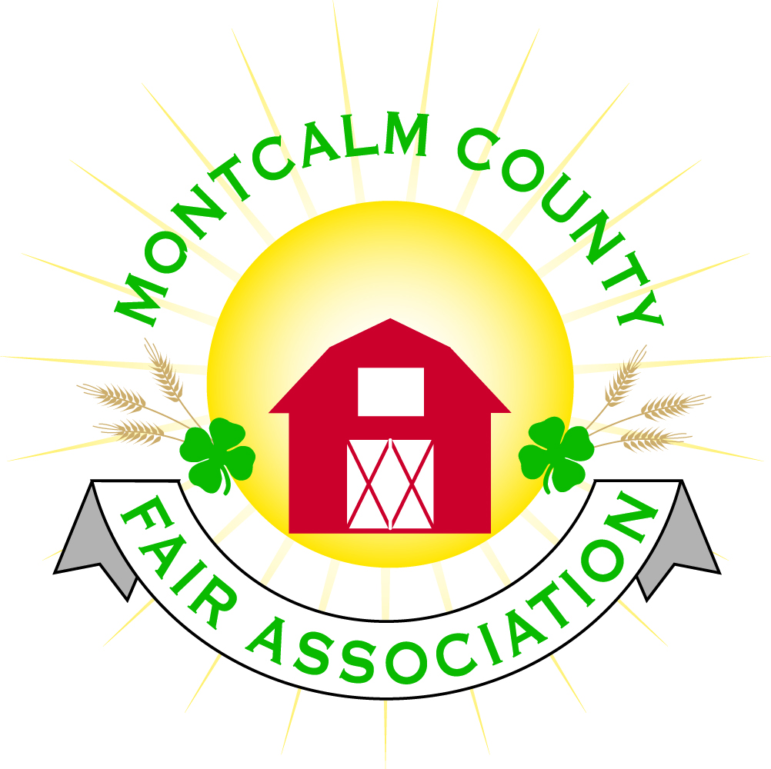
po box 513 • Greenville, MI 48838

Montcalm County Fair Association Board Meeting
6 March 2023
Montcalm County Fairgrounds, Greenville, MI

The meeting was called to order at 7:05 pm by Todd Hetherington and the Pledge of Allegiance and 4-H Pledge were recited.

Board members present:
Officers: President Todd Hetherington, 2nd Vice President Becka Merren, Treasurer Lisa Johnson, and Secretary Tammi Jahnke

Directors: Brad Heft, Shaun Hyde, Doug Jackson, Amber Ryan, Shirley Dean, Joe Minkel, Tom Aldridge, Sunni Haglund and Dan Ryan.

Directors Absent: 1st Vice President Jason Nadeau and Amanda Wall.

MSUE: Sunni Haglund PC, present.

Guests: Jackie Nadaeu, Nickole Chaffin, Jennifer Senn, Michelle Nitengale, Mary Gee, Melissa Eldridge, Karter Senn, Shari Potter, Steve VanHolstyn, Jon Bailey, Jessi Bailey, Brandy Bunting, Braelyn Bunting, Brylee Bunding, Makenzie Mailey, Conner Bailey, and Melissa Dow.

Secretary Minutes from 6 February 2023 presented by Tammi Jahnke. Motion to approve made by Lisa Johnson. Second by Shaun Hyde. Motion passed to place minutes on file.

Financials presented through the end of January 2023 by Treasurer Lisa Johnson. Motion to approve financials through the end of January 2023 by Doug Jackson. Second by Becka Merren. Motion passed to place financials on file.

Guest Comments
- Jennifer gave a report on camping reservations and switching the website over the square based payments.
- Steve VanHolstyn, Montcalm Township Fire Dept. Contact person for our Emergency Action Plan. Chief Cliff Dickinson’s wife is battling cancer, fire department has put together an action plan in the event of her passing. Looking for a venue to host 300+ people and asking for use of the Ash Building, with a waiver of fee or discount of fee for such event. Motion by Tammi Jahnke to allow rental for a memorial service at the 4-H rental rate. Second by Amber Ryan. Discussion took place. Motion passed.

Extension Office:
- Sunni Haglund brought up concerns she is receiving regarding the fact that the Still Exhibit Judging and Animal move-in are all on Sunday. Discussion took place about coordinating it all. Brad Heft to discuss with the 4-H Advisory Council and report back at April 3, 2023 meeting.
- Sunni further shared that there is an opportunity to have a MSU veterinary candidate to do a presentation. Jennifer Senn suggested Sunday the 12th of March 2023 at 2pm at the Ash Building.
- Melissa Dow and Sunni Haglund are in the process of starting an Ag Club within the county. Would like to do a Montcalm County Ag Expo on the 11th of November of 2023.
- 4-H CCC continuing to collect for DeVos Children’s Hospital & negotiating with Lia of Lia’s Line Dancing to set up events again for 2023.

Executive Committee:
- Did not meet.

Budget & Audit Committee:
- Did not meet.

Bylaws:
- Did not meet. Next scheduled to meet on the 13th of March 2023.

Buildings, Grounds, Camping & Construction Committee:
- Met regarding MDARD grant. Work in process.

Rental Committee:
- Katie Johnson was absent from the meeting, however, reported on the rental activities to date for the month of February via email as follows: February was a slow month for rentals taking place, it was great for rentals coming in. Katie booked 2 weddings (1 pending contract) and 2 horse shows. Katie met with probably half a dozen other potential clients who are interested in renting for upcoming weddings or other events. The 2023 schedule filling up nicely per Katie.

Judges:
- Did not meet.

Livestock/Agriculture – Bio-Security:
- Did not meet.

Concessions, Commercial Exhibits & Grandstand:
- Lisa Johnson and Shirley Dean will be setting a meeting in near future.

Fairbook & Showorks
- Michelle Nitengale is working on renewing Showorks. Missed deadline, contacting company to see what can be done to forgive late fees.

Awards/Trophies:
- Amanda Wall absent. No report.

Marketing & Fundraising Committee:
- Shirley Dean brought up concerns regarding the care of the new website. Currently Jennifer Senn, Tarin Minkel and Katie Johnson are going to care for the website as we get it up and running. It was agreed that there will be a committee to run the website in the future.
- Jackie Nadeau passed out Sponsorship forms for review. Amber Ryan made a motion to approve the 2023 Sponsorship form as presented. Shaun Hyde second. Motion passed.
- Shirley Dean advised that she has submitted a grant application to the Greenville Community Foundation to fund the Reading for Rides program. Awaiting response.
- Jackie Nadeau advised that the Carnival will do a Special Needs Day (carnival without lights and sound) this year.

Accessibility Committee:
- See “MDARD grant” under Old Business below.

Kids Day Committee:
- Meeting next week.

Old Business:
- Joe spoke with Meijer and they would allow us to buy the ice from them to sell at a $1 or $2 above our cost at Meijer, if we have a cooler to sell out of. Suggestion is that we look for a donation of coolers or reasonable priced coolers for purchase.
- MDARD grant – Melissa Eldridge, Kim Thomsen, Mary Newman and Michelle Nitengale reviewed the ADA portion of revitalization plan. Michelle Nitengale reviewed the grandstand, handicap parking on west side of livestock area and concrete walkway, and small animal barn. Road areas are sufficient for a wheel chair per Kim Thomsen, but other areas were an issue to address. It is currently estimated that there is already an in-kind match at approximately $12,040. Current estimate to do the ADA update $80k. Lisa Johnson received a quote for $22k for internet/wifi upgrade. $162,040 budget proposed by Melissa. There is the need to establish a SIGMA number (changed in 2017 from CV #, which we have, to SIGMA). Melissa Eldridge has application in order to get SIGMA, needs Todd Hetherington’s signature. Motion made by Tammi Jahnke to give Todd Hetherington permission to sign for the SIGMA number application. Second by Amber Ryan. Motion passed.

New Business:
- None.

Motion made by Doug Jackson to adjourn. Support by Dan Ryan. Meeting adjourned at 8:35 pm.

Respectfully submitted by Tammi Jahnke, Secretary

Next Meeting Dates:
Regular Meeting – 3 April 2023 at 7:00 PM
At Ash Building, Montcalm County Fairgrounds,
Greenville, Michigan
ALL Fair Committee Members and interested 4-H Volunteers/Members
are invited to attend.

