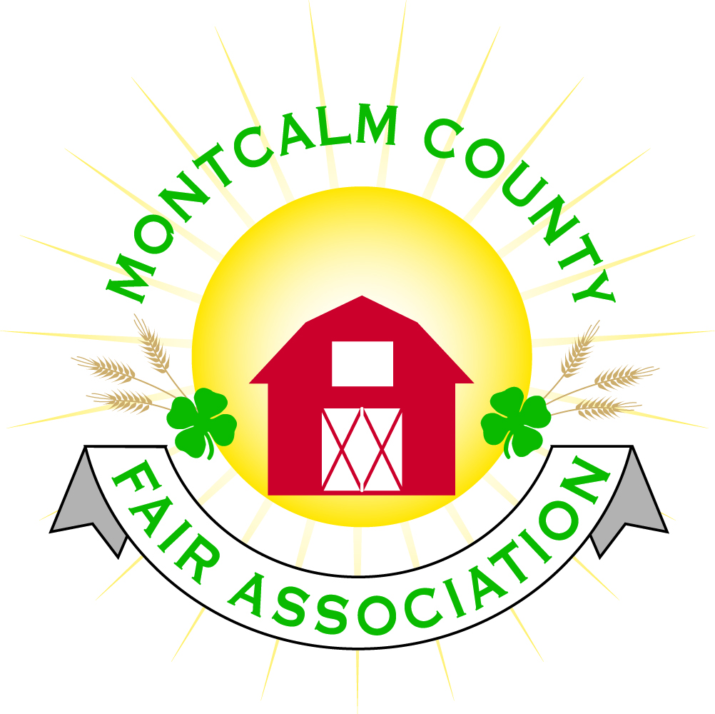
po box 513 • Greenville, MI 48838

Montcalm County Fair Association Board Meeting
11 September 2023
Montcalm County Fairgrounds, Greenville, MI

The meeting was called to order at 7:01 pm by Todd Hetherington and the Pledge of Allegiance and 4-H Pledge were recited.

Board members present:
Officers: President Todd Hetherington, 1st Vice President Jason Nadeau, 2nd Vice President Becka Merren, Treasurer Lisa Johnson, and Secretary Tammi Jahnke

Directors: Brad Heft, Shaun Hyde, , Amber Ryan, Shirley Dean, Joe Minkel, Tom Aldridge, and Sunni Haglund.

Directors Absent: Doug Jackson, Amanda Wall, and Dan Ryan.

Others present were:
Katie Johnson – Rental Coordinator - Absent
Sunni Haglund – MSUE PC

Guests: Jackie Nadeau Michelle Nitengale
Serena Newman Mary Gee
Tammy Hancock Niki Chaffin

Secretary Minutes from 7 August 2023 presented by Tammi Jahnke. Motion to approve made by Sunni Haglund Second by Jason Nadeau. Motion passed to place minutes on file.

Financials presented through the end of August 2023 by Treasurer Lisa Johnson. Motion to approve financials through the end of August 2023 by Jason Nadeau. Second by Shaun Hyde. Motion passed to place financials on file.

Guest Comments
- None

Extension Office:
- Sunni Haglund handed out an Extension Report (attached hereto) and information regarding upcoming workshops for volunteers.
- 4-H CCC – Tammi Jahnke reported that Bake-Off 2023 is scheduled to take place at the fairground and coordinated with the Mom2Mom Sale for the 29th of September 2023.

Executive Committee:
- Did not Meet

Budget & Audit Committee:
- Did not meet.
- Need a meeting to put together a budget and schedule annual audit. Committee will address.

Bylaws:
- Directors met for a workshop on 16 August 2023, but did not have a quorum.
- Final changes completed – see notes on Bylaws for completion of minutes.

Buildings, Grounds, Camping & Construction Committee:
- Zero-turn has been repaired per Todd Hetherington, should last for a while, but still need to prepare for replacement in the future.
- Michelle Nitengale scanned all the plans for barns that she located and provided on a flash drive.
- Mary Gee advised that the National Guard did not get back with her and confirm work on fairgrounds as previously approved, therefore will not be happening.

Rental Committee:
- Katie Johnson proved Brad Heft a report on the rental activities to date for the month of August 2023, one wedding, one horse show, Danish Festival fireworks, 2024 wedding booked, fridge issues and warmer heating rack not heating up. Brian Plank Memorial Classic to be held on 14 October 2023. Kitchen food warmer replacement tabled to the October 2023 meeting.
- Lisa Johnson advised that she is beginning to receive calls with requests for rental storage. Will put on website that RVs can come in on 4th of November 2023.
- Jason Nadeau advised that he has a quote coming for a price on an automatic gate on the grounds. Cameras were also discussed.

Judges:
- No report – Amanda Wall was absent.

Livestock/Agriculture/Bio-Security/MCFAAC:

- Mary Gee, Michelle Nitengale and Niki Chaffin requested approval for the MCFAAC to hold the Brian Plank Memorial Classic at the fairgrounds on the 14th of October 2023, to raise funds for addition to the livestock barn. Sunni Haglund made a motion to approve, Becka Merren second. Motion passed.
- Niki Chaffin asked about cleanup in the livestock area and grounds prior to the Brian Plank Memorial Classic event. Michelle Nitengale stated that her club is going to do some of the cleanup.
- Mary Gee asked if the camping funds goes to the show or to the fair association. Sunni Haglund made a motion to allow camping funds from the Brian Plank Memorial Classic to go to the Brian Plank Memorial Classic fundraiser. Tammi Jahnke second. Motion passed.

Concessions, Commercial Exhibits & Grandstand:
- No reports

Fairbook & Showorks
- The 1st of October 2023 is the deadline for fair book changes, at the November MCFA meeting 2023 the changes need to receive final approval.
- Michelle Nitengale advised a new “to us” server is going to cost approximately and is still working with Floyd. Requested a motion for $3,000 budget towards a new to us server. Jason Nadeau made motion to spend up to $3,000 to purchase a refurbished server. Sunni Haglund second. Motion passed.

Awards/Trophies:
- No report.

Marketing/Fundraising/Website/Communications Committee:
- Jackie Nadeau advised that $5 46.61 has been spent to date on haunted barn. October 14th will be opening night. Jackie made a request to allow workers, up to 7, to camp at the fairgrounds. Jason Nadeau made a motion to allow any workers of the haunted barn to be allowed to camp for free at the fairgrounds during the nights of the haunted barn. Second by Becka Merren. Motion passed.
- Jackie Nadeau is starting a new Instagram account that she will manage.
- Mega Raffle – set for the 20th of January 2024, selling 300 tickets for $30 each. Jackie Nadeau advised that the committee needs approval for a liquor license for said date, so application can be made to the State of Michigan in the month of November 2023. Motion made by Amber Ryan, Second Sunni Haglund. Motion passed.
- Motion by Sunni Haglund to apply for a 50/50 raffle license for the January 2024 Mega Raffle Event, second by Jason Nadeau. Motion passed.

Accessibility Committee:
- See MDARD grant

Kids Day (Youth, Family, Community) Committee:
- No report

Old Business:
- MDARD grant – Michelle Nitengale advised survey is done and work continuing.
- Nominating Committee appointed by Todd Hetherington to fill the upcoming positions/vacancies on the Board of Directors at the Annual Meeting in October 2024 are Sunni Haglund, Shaun Hyde and Becka Merren.
- Policy for when to make and approve the annual Calendar tabled for policy and procedures

New Business:
- None

Motion made by Jason Nadeau to adjourn. Support by Becka. Meeting adjourned at 8:56 pm.

Respectfully submitted by Tammi Jahnke, Secretary

Next Meeting Dates:
Regular Meeting – 2 October 2023 at 7:00 PM
At Ash Building, Montcalm County Fairgrounds,
Greenville, Michigan
ALL Fair Committee Members and interested 4-H Volunteers/Members
are invited to attend.

Annual Meeting – Sunday the 29th of October 2023 at 3pm
Fair Dates – June 23rd through June 29th 2024

