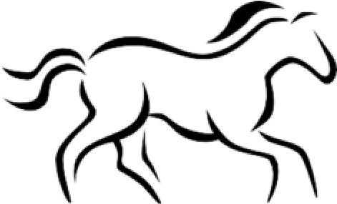
2024 MONTCALM COUNTY FAIR
OFFICAL REGISTARTION
HORSE/PONY

RIDER: CLOVERBUD:
Name of Rider_______________________________________________ Exhibitor Number:_______________ Address____________________________________ ______
Rider’s Age: As Jan 1st_______________Birthdate________________Phone Number_____________________
Club Name: ______________
Fair Requirements
- Registration forms with missing or incomplete information will not be accepted and the rider will not be allowed to show a Horse/Pony at fair.
- Attach a color photo of the animal(s) registered. Photo MUST be a side view showing the entire horse/pony.
Horse/Pony Must not be wearing blankets or any other covering in photo. A colored copy photo on the Coggins is accepted for a photo.
- Attach a current negative EIA (Coggins) test for the animal(s) registered. Coggins must be valid through 08/30/2024
- $ 50.00 stall fee must be included
- Each exhibitor may register two (2) animals. Only 1 may be present on the fairgrounds at a time.
- It is STRONGLY encouraged that exhibitors have their horses vaccinated prior to fair.
Riders and Cloverbud’s Please Complete
Primary Horse /Pony’s Registered Name: ____________________________________________________

Horse/Pony’s Barn Name: __________________________Age:________SEX:________HEIGHT:________
Breed_______________________________Color:_________________________________Markings:_____________________________________________________________________________________________

Please Check All that Apply ________Own ______Lease______Yearling
Secondary: Horse /Pony’s Registered Name:__________________________________________________

Horse/Pony’s Barn Name___________________________Age:________SEX:________HEIGHT:________
Breed_______________________________Color:_________________________________Markings:_____________________________________________________________________________________________

Please Check All that Apply ________Own ______Lease______Yearling

CLOVERBUDS PLEAE COMPLETE
Will you be hauling this horse in for show day? ______Yes ______ NO

Is this animal being shown by another rider during fair? _______Yes ______ NO

If yes, what is the riders name______________________________________________

(Horse Registration Continued on the Back)

I Certify and accept the information as being correct and I understand that a Completed Horse Record Book is required.

Signed__________________________________________ Date_______________________________
(Member or Parent)
Certified By:_____________________________________ Date _______________________________
(Leader Signature)

Fair Horse/pony Exhibitor Code of Conduct
I hereby understand that I am responsible for knowing the rules in the Montcalm County Fair book, the Montcalm County Horse and Pony Rules and the Horse Show Rules and Regulations. Any willful violation of conduct/rules may result immediate expulsion from the Montcalm County Fair book and loss of premiums and ribbons, as stated in the General Rules and Regulations found in the Fair book.

_________________________________________ Date ______________________
Riders Signature (Required)

__________________________________________Date ______________________
Parent or Legal Guardians Signature (Required)

State Delegate Information

State Delegate: Exhibitors must be 13 by January 1st of the current year. All riders must be Intermediate and advanced riders. Exhibitor (if under 18) and Parent/Guardian must sign. Payment for the state show will be collected when announced and participant accepts. Payment is due on the last Saturday of fair week.
______________________________________ Date______________________9*`
Riders Signature (required)

_________________________________ Date____________________________
Parent or Legal Guardian Signature (required)

Due Date May 1st 2024

