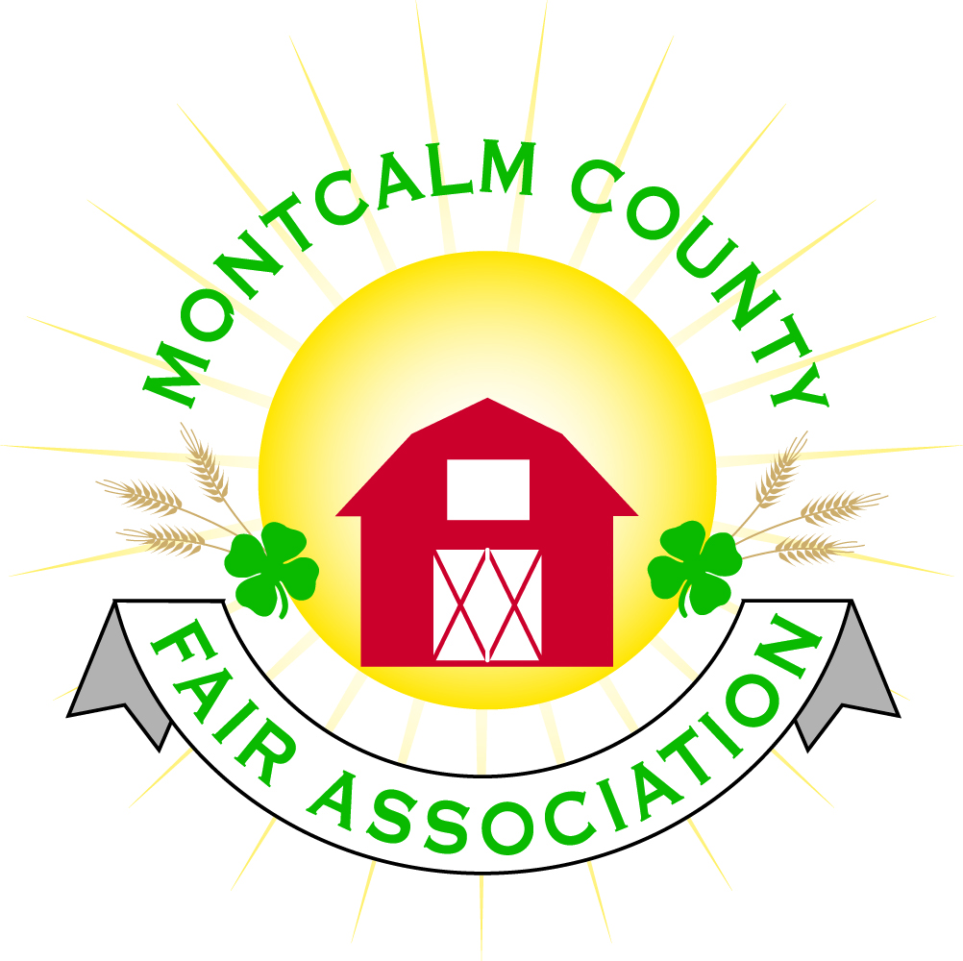
po box 513 • Greenville, MI 48838

Montcalm County Fair Association Board Meeting
April 3, 2017 Ash Building
Montcalm County Fairgrounds, Greenville, MI

The meeting was called to order by President Melissa Eldridge at 7:09pm. Board members present were;
Brian Plank, Jennifer Senn, Jay Smith, Todd Hetherington, Lisa Johnson, Sandy Smith, Lee Rasmussen, Holly Esterling, Mike Tronsen, Melissa Eldridge, Shaun Bartolo Absent: Amy Homich, Roger Coles, Jason Nadeau, Melanie Rodenhouse

Others present were Shari Potter, Kadren Grawburg, Mary Gee, Sherry Brown

Additions to the Agenda: Livestock Committee – will have trainings for kids bringing livestock to fair. Will instruct kids about scales, tags prior to arriving. Tags must be registered. Twenty-five buyers said they never got a picture of their animal. Sherry Brown will lead these trainings.

Motion by Mike Tronsen, support by Lisa Johnson to approve the Secretary’s minutes from the March 6, 2017 meeting. Motion passed.

Motion by Jay Smith, support by Shaun Bartolo to put the financials on file. Motion passed.

Extension Office: Kadren has the Superintendent Applications. She will select in May. The hope is to get 1-2 Junior Superintendents. Fish Creek wanted permission to stain the North Horse Arena, now they would like reimbursement. They will need to request from the Horse Leaders. Discussed Fairgrounds clean up dates and times. They will be 11am to 1PM on 5/13, 5/20, 5/21

Executive Committee – No meeting

Buildings, Grounds & Construction Committee –Mike reported that they measured for the Bathhouse. Inspected for a small animal wash rack. Melissa talked to an engineer regarding the campground. Looking to expand to 210 sites, so the Bathhouse will need to be bigger. Fundraising is approximately at 100K. There is a possibility of getting an MDA grant for 20K, Chem Bank grant for 15K. Sandy asked that the electrical for Vendors be checked out. We will need 8 50amp220v hook-ups.

Budget & Audit Committee – An audit will be scheduled after April 15th.

Judges – Still looking for 1 rabbit and 2 dog judges.

Concessions & Grandstand – Touch of Joy asked to bring a Hot Dog Cart. Seems it will be ok if he wants to put it next to his ice cream stand, but there is really no where he could push it around.

Fairbook – Complete.

ShowWorks: Holly presented the board with some proposals as follows:
ShowWorks Licenses: 1)Administrator/Fairboard owned/Holly Esterling
2)User/Livestock 1/Livestock Committee/Sherry Brown
3)User/Livestock 2/Livestock Committee/Mary Gee
4)User/4H Council/Michelle Nitengale/Still Exhibits
5)User/New Computer/Kadren Grawburg/Small Animals
6)User/New Computer/Additional License/Barb Altizer/HL

Motion by Todd Hetherington to purchase a refurbished desktop with large monitor for $600 and challenge the Horse Leaders to purchase a laptop for their committee. Make Holly’s laptop for Small Animal Committee use. Support by Mike Tronsen. Motion Carried.

ShowWorks Network: Network with Creekside Computer Services/Floyd
Total cost is $3,270.00. (See attached for descriptions)
OR
Cat6 Aerial Installation – Cost is $3,851.56 (See attached for
Description)

No action was taken on the Networking aspect of ShowWorks.

Awards/Trophys – Holly reported that Showmanship buckles will be $125 per buckle, $250 for supreme showman. Total is $1625. No action taken.

Rental Committee- Jay presented their research information & recommendations to the board. There are other venues that allow renters to bring in own alcohol including Greenville Community Center. Certified bartenders that can be hired are Cody & Bekka Davy (husband & wife team). They charge $40/hour and are licensed through the State. Also, Jessica Vaglica with J’s Event Services – licensed through the state.

Options for Rentals:
OPTION#1 – Hire a Catered Bar Service. They must provide a copy of the Off Site Catering license and a copy of their Liquor Liability certificate to be placed on file prior to the event. Rental also provides a Liability Insurance Certificate with the venue listed as an “Additional Insured” along with “Host Liquor” listed on the certificate.

OPTION#2 – Renter purchased the alcohol for their event. Renter hires a State Certified Bartender, who must provide a copy of the Certification, which will be placed on file prior to the event. Rental also provides a Liability Insurance Certificate with the venue listed as an “Additional Insured” along with “Host Liquor” listed on the certificate.

OPTION#3 – This option includes an increase in the Rental Fee of $300. Renter purchases the alcohol for their event. Renter has 2 NON DRINKING/OVER 21 YEAR OLDS (not state certified) controlling the serving of the alcohol from the bar area. Renter also provides a Liability Insurance Certificate with the venue listed as an “Additional Insured” along with “Host Liquor” listed on the certificate. We will have a Staff member (Shari or Brad Heft) on site for the duration of when the alcohol will be served. This staff member will be paid $100 for their time.

Motion by Todd Hetherington to approve all 3 OPTIONS proposed by the Rental Committee, support by Sandy Smith. Motion carried.

Discussion regarding a Keypad for the front door – Jay will work on this.

Marketing Committee: No report

Next Meeting Date – 05/01/17 - Motion to adjourn at 9:37PM.

Respectfully submitted by Sandy Smith, Secretary

