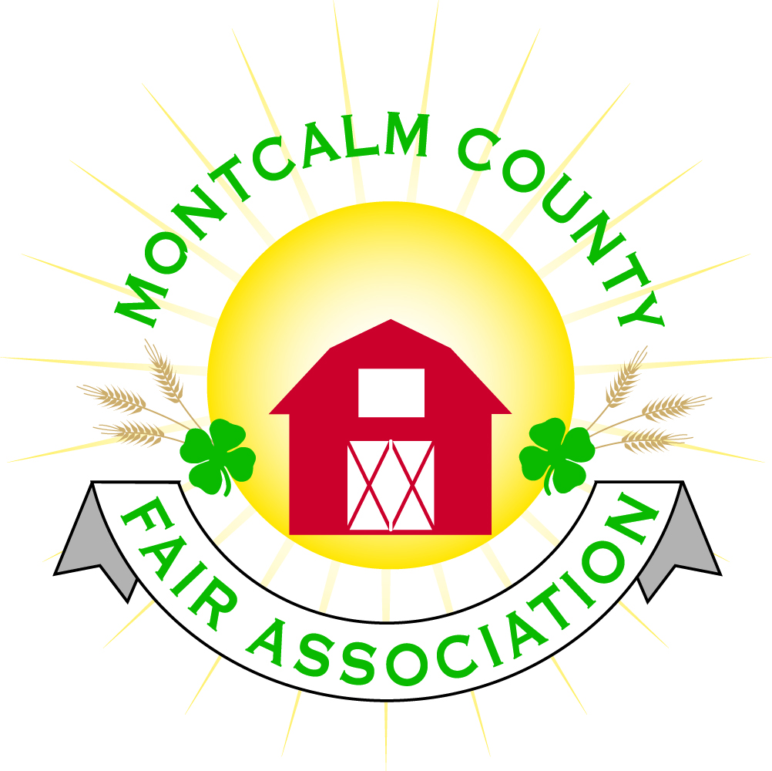
po box 513 • Greenville, MI 48838

Montcalm County Fair Association Board Meeting
June 5, 2017 Ash Building
Montcalm County Fairgrounds, Greenville, MI

The meeting was called to order by Vice-President Brian Plank at 7:08pm. Board members present were;
Brian Plank, Jennifer Senn, Roger Coles, Melanie Rodenhouse, Jason Nadeau, Todd Hetherington, Lisa Johnson, Sandy Smith, Lee Rasmussen, Holly Esterling, Mike Tronsen, Amy Homich, Jay Smith Absent: Melissa Eldridge, Shaun Bartolo

Others present were Kadren Grawburg, Mary Gee, Dave Carter (Sheriff’s Posse), Bill Christensen, Bob Nadeau, Tammi Jahnke, Kim Oennock

Motion by Lisa Johnson, support by Roger Coles to approve the Secretary’s minutes from the May 1, 2017 meeting. Motion carried.

Motion by Sandy Smith, support by Todd Hetherington to put the financials on file. Motion carried.

The Sheriff’s Posse representatives asked whether we need/wanted a written contract with them. With responsibilities and need for security the same as last year, it was agreed we could continue on as we have, with a $1500 donation to the Posse for their volunteer work during the Fair.

Visitors Tammi Jahnke and Kim Oennock expressed their frustration with the changing schedule of service hour clean ups. Several of their club members don’t use email so when changes are made with short notice, word doesn’t always get out to them. Jason said that the majority of the exhibitors and their families that have come out and worked were very easy to work with and that much has been accomplished, but he too, was frustrated with getting an accurate list of those who plan to exhibit at this year’s fair. He needs that list to compare with the list of exhibitors that have completed service hours.

After much additional discussion, Holly made a motion stating she would get Jason an up-to-date list from the Showorks program. The exhibitors that do not get their hours in before fair, will be given jobs to complete their service hours during fair. Support by Lisa. Motion passed with Jason voting no. Holly also volunteer to add a column in the program where completed participation could be tracked and she suggested she would like to organize an ice cream social during fair as a congratulations to all the exhibitors for their work.

Extension Office: Kadren reported there are 22 kids going to Exploration days.

Executive Committee – Brian gave a report of the Executive Committee meeting, which dealt with appeals from 3 4H’ers who were denied to bring their swine to Fair for late registrations by the Livestock Committee. The committee upheld the Livestock Committee’s action. The Committee also passed a motion to pay the new insurance bill for $10K.

Buildings, Grounds & Construction Committee – Mike will set up an appointment with Cindy regarding the handicap access to the bleachers and Melanie agreed to meet with her. Making the bleachers handicap accessible is going to be quite a monumental job. Mike reported that the water wells have been treated and are ready for testing to get the permits. Amy posed the question in regards to who is responsible to keep the horse arenas ready and horse areas spotless for horse shows. Discussion followed on who, and what needs to be done. Also discussion regarding brining the roads before fair.

Budget & Audit Committee – This has not been done. There have been many scheduling conflicts. We will now wait until after Fair.

Judges – Still need a poultry judge.

Membership – NA

Concessions & Grandstand – NA

Fairbook – NA

ShowWorks: Holly reported that equipment has been purchased and the network work is done.

Awards/Trophys –Buckles have been purchased and sponsors secured for all of them except the Llama buckle.

Rental Committee- See attached Facility Report. Motion by Roger Coles to set up a Rental Management Committee Fund. Support by Amy Homich – Motion carried.

Marketing Committee: Fundraising is ongoing. Sandy will keep the Fair Sponsor spreadsheet updated as long as everyone sends her the information. She will invoice sponsors who have not paid.

New Business: Lisa has secured the Greenville Wrestling, assisted by the National Honor Society to do the parking this year. Motion by Lisa, Support by Jay to obtain a Chemical Bank Credit Card reader for the Auction. Motion carried with Amy abstaining.

Next Meeting Date – 06/19/17 - Motion to adjourn at 9:12PM.

Respectfully submitted by Sandy Smith, Secretary

